ORCP-WM-24-06

Call for Comments to the Proposed General Amendments to the Proposed General Amendments to the WESM Manual on Ancillary Services Monitoring on Matters regarding the Reserve Conformance Standards and Related Enforcement Actions (ORCP-WM-24-06)

The Rules Change Committee (RCC) is inviting all WESM Members and interested parties to submit comments to the PEM Board-approved Proposed General Amendments to the WESM Manual on Ancillary Services Monitoring (WESM ASMM) on Matters regarding the Reserve Conformance Standards and Related Enforcement Actions (ORCP-WM-24-06).

The proposed amendments seek to cover the following matters:

- Clarification on, and correction of, the criteria and formulas relating to compliance with the Reserve Conformance Standards (RCS)
- Clarity on the basis of the Ancillary Service Providers in submitting the Request for Reassessment with Notice of Claim
- Clarity in the responsibilities of the Market Operator, the WESM Governance Arm, and the System Operator regarding the data provision, flagging, determination, and reporting of breach.
- Timeline of the completion, consolidation, and submission of reports/results.
The WESM document for amendments is:

- WESM Manual on Ancillary Services Monitoring

BACKGROUND:

The proposed amendments were originally initiated by PEMC on 13 August 2024 by way of the rules change process for urgent amendments. Following the procedures for processing urgent proposals set forth in Section 7 of the Rules Change Manual, the RCC certified the proposal as urgent, immediately deliberated on the proposal on 16 August 2024, and approved it on 22 August 2024.

Activity | Date
RCC Approval | 22 August 2024
PEM Board Approval | 28 August 2024
Effectivity Date of Revised Rules and Manuals | 30 August 2024

The urgent amendments shall remain in effect up to 6 months or until a general amendment on the same matter has been approved by the DOE and becomes continuously in effect, whichever comes first. The updated market rules and manuals could be accessed in this webpage.

DOCUMENTS:

Provided below are the relevant materials for your reference:

- Original Rules Change Proposal submitted by PEMC (ORCP-WM-24-05)
- PEM Board-approved urgent proposal (RCC Resolution No. 2024-05) – Note: Further amendments approved by the PEM Board are provided in the matrix (item 3)
- Matrix of Proposed Amendments for Comments – Annex A of this document (See below. Please write your comments in the proper columns in the matrix.)

Kindly submit your comments (in Word format) through the File a Submission page no later than 18 October 2024 or 30 working days from the date of publication (06 September 2024). Please input in the proper field the e-mail address of your point person(s) who we could further contact regarding activities related to the processing of the proposal. All comments received shall be published in the PEMC website.

[In accomplishing and submitting this form, you give your consent for PEMC to collect, record, organize, and update your personal data as herein provided as part of your information for purposes of rules change process.]

Commenter’s Information

Name | Shara Camille Landicho
Designation | Markets and Commercial Sr. Specialist
Company | SN Aboitiz Power-Benguet, Inc. and SN Aboitiz Power-Magat, Inc.
Company Address | NAC Tower, 32nd Street, Bonifacio Global City, Taguig
Telephone No. | 09989633217
Email Address | regulatory.affairs@snaboitiz.com

WESM Manual on ASM Issue 1.1
Title | Clause | Provision | Proposed Amendment  (PEM Board-approved as Urgent Amendment) | Rationale | SNAP Comments | SNAP Proposed Wording based on Comments | Original Proponent’s Response | RCC Decision
- SNAP would like to confirm the propriety of using non-firm ASPA rates as the basis for penalty, as this may be too excessive considering that non-compliant intervals are also liable for non-payment.
- We would like to suggest a provision in the timeline of assessment to consider potential delays in the transmission of requisite data from MO and the SO, to ensure that ASPs would not have an unnecessarily tight timeline to respond to NC notifications in these instances, especially when the intervals to be reviewed and assessed contains a significant number of data in a per 5-minute interval. We note that investigating a significant bulk of data requires a lot of time and resources, this may be mitigated if PEMC’s NC notifications can be provided in regular shorter intervals instead of transmitting the same in bulk. Moreover, delayed NC notifications also hinders the ASPs to do immediate adjustments and improvements to comply with the AS provisions and will also have a cascading impact to the Annual Performance of the ASPs. If adjustment in the timeline for delayed NC notifications would not be possible, we suggest that PEMC should not immediately deduct or penalize the ASPA for the affected intervals in the preliminary statement.
Section 2 – Definition, References, and Interpretation  2.1 Definitions | g. Enforcement Related Notices - | Notice of Probable Breach –  A notice issued by the Market Operator to the Enforcement and Compliance Office. It specifies the dispatch intervals in which a probable breach of Reserve Conformance Standards is identified. It also specifies the amount adjusted or to be adjusted from the reserve trading amounts due from the System Operator as a result of probable breach flagging. | Notice of Probable Breach –  A notice issued by the Market Operator to the Ancillary Service Providers Enforcement and Compliance Office. It specifies the dispatch intervals in which a probable breach of Reserve Conformance Standards is identified. It also specifies the amount adjusted or to be adjusted from the reserve trading amounts due from the System Operator as a result of probable breach flagging after due assessment and verification. | Deletion of “Probable” to provide clarity in the definition of the notice, as the results have already been assessed by ECO and verified by the ASPs. This already serves as the basis of MO for non-payment reflected in the Preliminary Settlement Statement.  ASPs shall be the recipient of the Notice of Breach as this becomes the basis for filing the Request for Reassessment with Notice of Claim.  Related proposed revision: Sec. 7.3.1 (b), 2nd par, where a copy of the consolidated Notice of Breach shall be furnished by IEMOP to ECO and NGCP under Section 7.3.1 (b), 2nd par. | To provide clarity, it is important to state that ECO was responsible for conducting the assessment and verification process. | A notice issued by the Market Operator to the Ancillary Service Providers It specifies the dispatch intervals in which a breach of Reserve Conformance Standards is identified. It also specifies the amount adjusted or to be adjusted from the reserve trading amounts due from the System Operator after due assessment and verification of the Enforcement and Compliance Office.
Section 2 – Definition, References, and Interpretation  2.1 Definitions | g. Enforcement Related Notices - | Notice of Confirmation of Breach –  A notice issued to the Market Operator, the System Operator, and the Ancillary Services Provider by the WESM Governance Arm after due assessment and verification by the Enforcement and Compliance Office which contains confirmation of the finding/s of breach as initially flagged by the Market Operator. | Notice of Confirmation of Breach –  A notice issued to the Market Operator, the System Operator, and the Ancillary Services Provider by the WESM Governance Arm after due assessment and verification by the Enforcement and Compliance Office which contains confirmation of the finding/s of breach as initially flagged, assessed, and reported by the Enforcement and Compliance Office to the Market Operator. | In reference to revision in Sections 3.1.1 and 7.2 where the responsibility of flagging the probable breach is removed from MO. ECO will flag the breach, validate, assess, and report the results to MO.
 | i. | (NEW) | i. Rated Capacity - The full-load continuous gross capacity of a unit under the specified conditions, as calculated from the electric generator nameplate based on the rated Power Factor.  i. j. xx  j. k. xx  k. l. xx  l. m. xx  m. n. xx  n. o. xx  o. p. xx  p. q. xx  q. r. xx | Reference:  - PGC (2016 Ed.)  - Resolution No. 17, Series of 2023 “A Resolution Adopting the 2023 Revised Rules for the Issuance of Certificates of Compliance (COCs) For Generation Facilities”  Renumbering of the succeeding Terms due to insertion of new term. | We suggest that Rated Capacity should be based on the generator’s latest capability certificate, as tested and certified by NGCP. To ensure that the unit’s maximum capability will be used to determine compliance with RCS for both conventional generator and energy storage systems. | Rated Capacity - The full-load continuous gross capacity of a unit under the specified conditions, as calculated from the electric generator nameplate based on the rated Power Factor, and as indicated in the unit’s latest Generator Capability Certificate.
Section 3 – Responsibilities  3.1 Market Operator | 3.1.1 | The Market Operator shall establish a procedure for the monitoring or flagging of breach in accordance with the Reserve Conformance Standards and the rule pertaining to Reserve Offer Capacity Compliance through the use of an appropriate facility. | The Market Operator shall establish a procedure for the timely gathering and provision of available market data to the WESM Governance Arm that are necessary for the monitoring of compliance monitoring or flagging of breach in accordance with the Reserve Conformance Standards and the rule pertaining to Reserve Offer Capacity Compliance through the use of an appropriate facility. | In reference to revision in Section 7.2 where the responsibility of flagging the probable breach is removed from MO. ECO will flag the breach, validate, assess, and report the results to MO.  MO will instead be in charge of the timely collection and gathering of data, and provision thereof to PEMC for the Reserve Market compliance monitoring purposes.
Section 3 Responsibilities  3.4 Ancillary Services Provider | 3.4.1 | 3.4.1 Ancillary Services Providers shall submit to the System Operator the following real-time data for purposes of monitoring compliance with the Reserve Conformance Standards.  a. Generator mode of operations  b. Dead band setting | 3.4.1 Ancillary Services Providers shall submit to the System Operator the following real-time data for purposes of monitoring compliance with the Reserve Conformance Standards.  a. Generator mode of operations  b. Deadband setting  c. Speed droop characteristic | Addition of Speed Droop characteristic to the required data from the Ancillary Services Providers (ASPs) in reference to Section 5.3.3 and 5.4.4. | May we request clarification as to the guidelines and mode of transmission for these data?
SECTION 5 – Reserve Conformance Standards  5.2 Provision of Data for Monitoring and Reporting | 5.2.1 | The System Operator shall submit to the Market Operator data and reports that may be necessary in initially determining probable breach, such as but not limited to the following:  For other data or reports not enumerated in the foregoing table, the Market Operator and the System Operator shall, from time to time, agree on the manner and schedule of submission. | The System Operator shall submit to and the Market Operator shall submit to the WESM Governance Arm data and reports that may be necessary in initially determining probable breach, such as but not limited to the following:  For other data or reports not enumerated in the foregoing table, the Market Operator, the WESM Governance Arm, and the System Operator shall, from time to time, agree on the manner and schedule of submission.  [Add Footnote] “D” - Day; “D+1”: Next Day | For Clarity: SO and MO will be the data provider; and WGA as recipient of the data for compliance monitoring purposes. For consistency with Section 3.2.2 of the ASM Manual.  The timeline in the ASM Manual for PEMC-ECO to report the results to IEMOP as basis for any reserve amount adjustments is too tight (Sections 7.7.1 and 7.7.2 of the ASM Manual), as any delay would affect PEMC’s ability to generate compliance monitoring results within the timeline set for the issuance of the WESM Preliminary Statement.  To avoid potential issues relating to missing or inconsistent data from the intermediate data transfer through IEMOP.  For clarity.
  Data | Timeline of Provision
  Generator mode of operation  (e.g., Automatic Generation Control, Governor Control Mode, Manual Dispatch Instruction) | Real-Time
  Dead band settings | Real-Time
  Speed droop | Real-Time
  Generator Status | Real-Time
  Dispatch instructions | By 1200H of the next day for all instructions of the current trading day
  Outages | By 1200H of the next day for all instructions of the current trading day
  Power System Frequency | Real-Time
  Control Dead band | Real-Time
  Data | Timeline of Provision | Source
  Generator mode of operation  (e.g., Automatic Generation Control, Governor Control Mode, Manual Dispatch Instruction) | Real-Time  D+1 | Market Operator
  Deadband settings (Based on certification) | Real-Time  As necessary | Market Operator
  Speed droop characteristic (Based on certification) | Real-Time  As necessary | Market Operator
  Generator Status | Real-Time  D+1 | System  Operator
  Dispatch instructions | By 1200H of the next day for all instructions of the current trading day  D+1 | System  Operator
  Outages | By 1200H of the next day for all instructions of the current trading day  D+1 | System  Operator
  Power System Frequency | Real-Time  D+1 | System  Operator
  Control Dead band | Real-Time
  Desired MW/AGC Command | D+1 | System  Operator
  Certified Capacity  (Based on certification) | As necessary | Market Operator
  Day-Ahead Ancillary Service Schedule (DAASS) | D-1 | System  Operator
  BCQ-SO | D+1 | System  Operator
  Actual MW Output | D+1 | System  Operator
  Reserve Type  (Based on certification) | As necessary | Market Operator
SECTION 5 – Reserve Conformance Standards  5.3 Reserve Conformance Standards for Regulating Reserve | 5.3.3 | Reserve facilities scheduled to provide regulating reserve shall also ensure that they meet the following requirements during the relevant dispatch interval:  a. Dead band is 0.15 Hz or lower if operating on GCM or AGC  b. Speed-droop characteristic is 5% or lower; and  c. Provision of reserve is sustainable for the entire dispatch interval. | Reserve facilities scheduled to provide regulating reserve shall also ensure that they meet the following requirements based on the certified settings during the relevant dispatch interval:  a. Deadband is 0 Hz to +/- 0.15 Hz 0.15 Hz or lower if operating on GCM or AGC.  b. Speed-droop Speed droop characteristic is 5% or lower and 1% or lower for Battery Energy Storage System if operating on GCM; and  c. Provision of reserve is sustainable for the entire dispatch interval. | To indicate the correct dead band settings for GCM mode and to delete “or AGC” as there is no dead band requirement for AGC operations.  No speed droop characteristic requirement for AGC since it is automatically controlled by a Supervisory Control and Data Acquisition (SCADA) from the SO Control Center or manual adjustment of load with specific instructions from the SO.  To include the speed droop characteristic for Battery Energy Storage System (BESS)
SECTION 5 – Reserve Conformance Standards  5.3 Reserve Conformance Standards for Regulating Reserve | 5.3.4 | A reserve facility providing regulating reserve that fails to maintain an average response accuracy as set out in Sections 5.6.1 and 5.7.1 or an average response time as set out in Sections 5.6.3 and 5.7.3 in any dispatch interval during the monitoring period shall be flagged as non-compliant. Once flagged as non-compliant, a reserve facility will be assessed further based on the following:  a) Compliance with the response accuracy for each dispatch interval; and  b) Compliance with the response time for each dispatch interval. | A reserve facility providing regulating reserve that fails to maintain an average response accuracy as set out in Sections 5.6.1 and 5.7.1 or an average response time as set out in Sections 5.6.3 and 5.7.3 or Percentage (%) of Compliance as set out in Section 5.7.1 in any dispatch interval during the monitoring period settlement interval shall be flagged as non-compliant. Once flagged as non-compliant, a reserve facility will be assessed further based on the following:  a) Compliance with the response accuracy for each dispatch interval; and  b) Compliance with the response time for each dispatch interval. | To revise the averaging from a monthly period to hourly interval as this proposed approach would calculate the average response accuracy and response time for the reserve facility operating under GCM within each relevant hourly interval, providing a more balanced and granular assessment of compliance.  To distinguish hourly averaging of response accuracy and response time (under GCM) from Percentage of Compliance (under AGC), in relation to the proposed revisions to Section 5.7 “Measuring Reserve Response Compliance of Generators on Automatic Generation Control”. | We would like to clarify whether the evaluation for this provision is on an hourly or settlement interval (5-min interval) basis? The rationale indicated for this proposed change is to revise averaging from a monthly period to “hourly” interval, which seems to be in contrast with the proposed new wording as “settlement interval”
SECTION 5 – Reserve Conformance Standards  5.4 Reserve Conformance Standards for Contingency Reserve | 5.4.4 | Reserve facilities scheduled to provide contingency reserve shall also ensure that they meet the following requirements during the relevant dispatch interval:  a. Dead band is greater than 0.15 Hz but less than 0.30 Hz if operating on GCM or AGC;  b. Speed-droop characteristic is 5% or lower; and  c. Provision of reserve is sustainable for the entire dispatch interval. | Reserve facilities scheduled to provide contingency reserve shall also ensure that they meet the following requirements based on the certified settings during the relevant dispatch interval:  a. Deadband is greater than 0.15 Hz -0.16 Hz to -0.30 Hz but less than 0.30 Hz if operating on GCM or AGC.  b. Speed-droop Speed droop characteristic is 5% or lower and 1% or lower for Battery Energy Storage System, if operating on GCM; and  c. Provision of reserve is sustainable for the entire dispatch interval. | To indicate the correct dead band settings for GCM mode and to delete “or AGC” as there is no dead band requirement for AGC operations.  No speed droop characteristic requirement for AGC since it is automatically controlled by a Supervisory Control and Data Acquisition (SCADA) from the SO Control Center or manual adjustment of load with specific instructions from the SO.  To include the speed droop characteristic for BESS.
SECTION 5 – Reserve Conformance Standards  5.4 Reserve Conformance Standards for Contingency Reserve | 5.4.5 | A reserve facility providing contingency reserve that fails to maintain an average response accuracy as set out in Sections 5.6.1 and 5.7.1 or an average response time as set out in Sections 5.6.3 and 5.7.3 for the entire monitoring period shall be flagged as non-compliant. Once flagged as non-compliant, a reserve facility will be assessed further based on the following:  a) Compliance with the response accuracy for each dispatch interval; and  b) Compliance with the response time for each dispatch interval. | A reserve facility providing contingency reserve that fails to maintain an average response accuracy as set out in Sections 5.6.1 and 5.7.1 or an average response time as set out in Sections 5.6.3 and 5.7.3 or Percentage (%) of Compliance as set out in Section 5.7.1 for the entire monitoring period settlement interval shall be flagged as non-compliant. Once flagged as non-compliant, a reserve facility will be assessed further based on the following:  a) Compliance with the response accuracy for each dispatch interval; and  b) Compliance with the response time for each dispatch interval. | To revise the averaging from a monthly period to hourly interval as this proposed approach would calculate the average response accuracy and response time for the reserve facility operating under GCM within each relevant hourly interval, providing a more balanced and granular assessment of compliance.  To distinguish hourly averaging of response accuracy and response time (under GCM) from Percentage of Compliance (under AGC), in relation to the proposed revisions to Section 5.7 “Measuring Reserve Response Compliance of Generators on Automatic Generation Control”. | We would like to clarify whether the evaluation for this provision is on an hourly or settlement interval (5-min interval) basis? The rationale indicated for this proposed change is to revise averaging from a monthly period to “hourly” interval, which seems to be in contrast with the proposed new wording as “settlement interval”
SECTION 5 – Reserve Conformance Standards  5.5 Reserve Conformance Standards for Dispatchable Reserve | 5.5.3 | After synchronization, the dispatchable reserve facility shall deliver the MW capacity instructed by the System Operator within fifteen (15) minutes from synchronization. | After synchronization, the dispatchable reserve facility shall deliver the MW capacity instructed by the System Operator within fifteen (15) minutes from synchronization and shall generate within the upper and lower dispatch thresholds of +/-1% of the dispatch instruction, or +/- 0.5 MW, whichever is higher. The facility shall sustain and maintain generation in accordance with the active instruction and any succeeding instructions from the System Operator until instructed to shut down. | To add a criterion that in addition to the requirement for DR to generate within 15 minutes from the SO instruction, the reserve facility must follow a dispatch tolerance of +/- 1% (based on SO’s standard practice for monitoring) or +/- 0.5 MW (based on the survey results conducted with DR-ASPs) for the given period and to clearly establish that the facility must sustain/continue to generate to meet the SO instruction until it receives a specific directive to stop generating.  (See Illustration 1 in Annex IV)
SECTION 5 – Reserve Conformance Standards  5.5 Reserve Conformance Standards for Dispatchable Reserve | 5.5.4 | [NEW] | 5.5.4 A dispatchable reserve facility that fails to comply with the real-time dispatch instruction of the System Operator based on the Reserve Schedule due to an outage or unavailability shall be considered in breach of the reserve conformance standards for the dispatch interval that the non-compliance occurs and in all preceding intervals of the same trading day that have Dispatchable Reserve Schedules. | It covers instances where a facility (that is required to be offline) offers for DR but it is, in fact, not available when called to run. It will only be ascertained during the time that it is asked to run by SO.  The dispatchable reserve facility that becomes non-dispatchable real-time or is unable to deliver the MW capacity in real-time due to an outage or other cause/s of unavailability presupposes that it is not also available in the prior intervals (while it was offline).  By being unable to run as DR, it does not serve its purpose, i.e., assuring the grid that it is indeed readily available for dispatch (when needed) in order to replenish the CR whenever a generating unit trips or a loss of a single transmission interconnection occurs.
SECTION 5 – Reserve Conformance Standards  5.5 Reserve Conformance Standards for Dispatchable Reserve | 5.5.4 | A reserve facility that fails to comply with the provisions set out in Sections 5.5.1, 5.5.2, or 5.5.3 at any dispatch interval shall be considered in breach of the reserve conformance standards for dispatchable reserves for that dispatch interval. | 5.5.4 5.5.5 A reserve facility that fails to comply with the provisions set out in Sections 5.5.1, 5.5.2, or 5.5.3 at any dispatch interval shall be considered in breach of the reserve conformance standards for dispatchable reserves for that dispatch interval. | Renumbered to 5.5.5 due to inserted new provision (see above Sec. 5.5.4)
Section 5 – Reserve Conformance Standards  5.6 Measuring Reserve Response Compliance of Generators on Governor Control Mode | 5.6.1 | A reserve facility responding to a frequency-driven event through GCM shall maintain a response accuracy of at least 80% for the entire monitoring period. | A reserve facility responding to a frequency-driven event through GCM shall maintain an average response accuracy of at least 80% for the entire monitoring period relevant settlement interval.  For purposes of averaging under Sections 5.3.4 and 5.4.5, the response accuracy for a dispatch interval shall be capped at 120%. | To revise the requirement from being measured over the entire monitoring period, to being measured within relevant settlement interval. This provides for a more granular and balanced assessment.  Rationale for Capping at 120%:  The 120% capping on the average response accuracy is intended to manage outliers (e.g. overshoot in response accuracy by 200-300%) and setting an upper limit or fixed threshold value of 120% as the reasonable metric in determining accuracy within a settlement interval.
Section 5 – Reserve Conformance Standards  5.6 Measuring Reserve Response Compliance of Generators on Governor Control Mode | 5.6.2 | A reserve facility’s response accuracy via GCM shall be calculated as follows.  $Response Accuracy= \frac{Actual MW Response Capacity}{Expected MW Response Capacity} x 100\%$  Where:  Actual MW Response Capacity  = Highest Actual MW Output – MW Output Prior to Frequency-Driven Event  Expected MW Response Capacity  = Static Gain $x$ Frequency Change  Frequency Change  = Worst Frequency Highest/Lowest – Frequency Prior to Frequency-Driven Event  Frequency Prior to Frequency-Driven Event  = Nominal Frequency + Dead band Setting  $Static Gain= \frac{Scheduled MW Capacity}{Droop Setting x Nominal Frequency} x 100\%$ | A reserve facility’s response accuracy via GCM shall be calculated as follows.  $Response Accuracy= \frac{Actual MW Response Capacity}{Expected MW Response Capacity} x 100\%$  a. When System Frequency falls below the lower deadband:  Actual MW Response Capacity  = Highest Actual MW Output – MW Output Prior to Frequency-Driven Event  Where: The Highest Actual MW Output is the value obtained 20 seconds after the Lowest frequency that occurred during the Frequency-Driven Event  Frequency Change  = Frequency Prior to Frequency-Driven Event - Lowest Frequency During Frequency-Driven Event  Frequency Prior to Frequency-Driven Event  = Nominal Frequency - Dead band Setting  b. When System Frequency breaches the upper deadband:  Actual MW Response Capacity  = Lowest Actual MW Output – MW Output Prior to Frequency-Driven Event  Where: The Lowest Actual MW Output is the value obtained 20 seconds after the highest frequency that occurred during the Frequency-Driven Event  Frequency Change  = Frequency Prior to Frequency-Driven Event - Highest Frequency During Frequency-Driven Event  Expected MW Response Capacity  = Static Gain $x$ Frequency Change  Frequency Change  = Worst Frequency Highest/Lowest – Frequency Prior to Frequency-Driven Event  Frequency Change  = Frequency Prior to Frequency-Driven Event - Highest/Lowest Frequency During Frequency-Driven Event  Frequency Prior to Frequency-Driven Event  = Nominal Frequency + Dead band Setting  $Static Gain= \frac{Scheduled MW Rated Capacity}{Droop Setting x Nominal Frequency} x 100\%$  If the system frequency breaches the upper deadband threshold, the reserve facility needs to react by decreasing generation to correct the frequency and vice versa. In this case, the Actual MW Response Capacity shall be calculated as the difference between the Highest or Lowest Actual MW Output, as the case may be, and the MW Output prior to the Frequency-Driven Event. | Modification of the formula (i.e., addition of the “lowest” Actual MW output on the formula) for Actual MW Response Capacity to use both the highest and lowest actual MW output values, in order to reflect the correct response accuracy for any given Frequency Driven-Event, whether it requires an upward or downward response from Ancillary Services Providers (ASPs).  A frequency-driven event can trigger the need for immediate response from ASPs to either increase or decrease generation, depending on whether the system frequency breaches the upper or lower threshold (facilities’ dead band settings). Using highest actual MW output when the response requires an increase, and the lowest actual MW output when the response requires a decrease, ensures the Actual MW Response Capacity is calculated correctly for the specific event scenario.  Rationale for the 20 seconds time reference:  20 seconds is a time frame that is typically critical for a reserve facility to respond to control signals being sent from SO’s energy management system (EMS).  Transposition in the formula for Frequency Change. This is to ensure consistency with the sign of the resulting Expected Response with the Actual MW Output and to have a non-negative Response Accuracy.  Addition of the word “during” to clarify that the frequency referenced should be the value observed during the frequency-driven event.  (See Illustration 2 in Annex IV)  The Static Gain formula is being revised to use the Rated Capacity instead of Scheduled MW Capacity. During the discussions with the System Operator, it was clarified that the value of static gain, which represents the change of active power output (in MW) per unit change in system frequency (in Hz), should not be variable and must be a fixed value grounded in the ASPs’ Rated Capacity.  (See Illustration 3 in Annex IV)  To provide case scenarios when to use the applicable formula, depending on the system frequency condition. |  | Static Gain = Pmax/(Droop Setting x Nominal Frequency)  a. When System Frequency falls below the lower deadband:  Actual MW Response Capacity  = Highest Actual MW Output – MW Output Prior to Frequency-Driven Event  Where: The Highest Actual MW Output is the value obtained 20 seconds after the Lowest frequency that occurred during the Frequency-Driven Event  Frequency Change  = Frequency Prior to Frequency-Driven Event - Lowest Frequency During Frequency-Driven Event  Frequency Prior to Frequency-Driven Event  = Nominal Frequency - Dead band Setting  For Contingency Reserve Provision: The system frequency must stay below the lower deadband for a period longer than five (5) seconds. Additionally, the frequency change (triangleF) during an event shall be equal to or greater than 0.02Hz for conventional generators and 0.01Hz for ESS facilities for the event to be considered an FDE
Section 5 – Reserve Conformance Standards  5.6 Measuring Reserve Response Compliance of Generators on Governor Control Mode | 5.6.3 | A reserve facility responding to a frequency-driven event or to a dispatch instruction, while on GCM shall have an average response time of not more than five (5) seconds for the entire monitoring period. | A reserve facility responding to a frequency-driven event or to a dispatch instruction, while on GCM shall have an average response time of not more than five (5) seconds for the entire monitoring period relevant settlement interval. | Evaluating the response time during the relevant settlement interval, rather than an entire monitoring period, provides a more accurate and representative assessment of the facility’s performance during the provision of Ancillary Service (AS).
Section 5 – Reserve Conformance Standards  5.7 Measuring Reserve Response Compliance of Generators on Automatic Generation Control | 5.7.1 | A reserve facility responding to a frequency-driven event or to dispatch instructions, through commands received from the System Operator’s Energy Management System (EMS) via AGC shall comply to at least 75% of such AGC commands for the entire monitoring period. | A reserve facility responding to a frequency-driven event or to dispatch instructions, through commands received from the System Operator’s Energy Management System (EMS) via AGC shall comply to at least 75% 90% of such AGC commands for the entire monitoring period relevant settlement interval.  Percentage (%) of Compliance of a reserve facility/unit operating on AGC is given below:  $\% Compliance= \frac{No. of Compliant AGC Commands}{No. of AGC Commands} x 100\%$ | 90% compliance is to be consistent with the standard practice of NGCP-SO in monitoring reserve facilities operating under AGC.  To reflect, for clarity, the formula in getting Percentage (%) of Compliance.  To revise the requirement from being measured over the entire monitoring period, to being measured within each relevant settlement interval. This provides for a more granular and balanced assessment, as proposed in Sections 5.3.4 and 5.4.5.  (See Illustration 4 in Annex IV)
Section 5 – Reserve Conformance Standards  5.7 Measuring Reserve Response Compliance of Generators on Automatic Generation Control | 5.7.2 | A reserve facility is deemed compliant to an AGC command if:  Actual MW Generation > (Desired MW Generation – Control Dead band); and  Actual MW Generation < (Desired MW Generation + Control Dead band). | A reserve facility is deemed compliant to an AGC command if the following conditions are met:  Actual MW Generation > (Desired MW Generation – Control Dead band); and  Actual MW Generation < (Desired MW Generation + Control Dead band).  5.7.2.1 The Actual Generation of the reserve facility shall reach at least 63% of the Desired Generation within 25 seconds from the time the AGC command is issued.  5.7.2.2 Additionally, the Actual Generation of the reserve facility shall reach at least 90% but shall not exceed 130% of the Desired Generation or ± 0.5 MW from the Desired Generation, (whichever requirement is the higher threshold) within 32 seconds from the time AGC command is issued. The facility shall sustain and maintain generation throughout the command in such range set out herein. | Adopted from the System Operator’s standard practice for monitoring the compliance of their contracted AS Providers with the AGC commands.
Section 5 – Reserve Conformance Standards  5.7 Measuring Reserve Response Compliance of Generators on Automatic Generation Control | 5.7.3 | A reserve facility responding to a frequency-driven event, or dispatch instructions, through AGC commands shall also have an average response time of not more than twenty-five (25) seconds for the entire monitoring period. | A reserve facility responding to a frequency-driven event, or dispatch instructions, through AGC commands shall also have an average response time of not more than twenty-five (25) seconds for the entire monitoring period. | No longer applicable in view of the proposed revision in 5.7.2.
Section 5 – Reserve Conformance Standards  5.7 Measuring Reserve Response Compliance of Generators on Automatic Generation Control | 5.7.4 | A reserve facility’s response time is computed from the time of the AGC command until the actual generation reaches control dead band (i.e., desired generation + the dead band). | A reserve facility’s response time is computed from the time of the AGC command until the actual generation reaches control dead band (i.e., desired generation + the dead band). | No longer applicable in view of the proposed revision in 5.7.2.
Section 5 – Reserve Conformance Standards  5.8 Summary Table of Reserve Conformance Standards for Each Reserve Type | 5.8 | 5.8 Summary Table of Reserve Conformance Standards for Each Reserve Type | 5.8 Summary Table of Reserve Conformance Standards for Each Reserve Type  [Add footnote in title: Adopted from the parameters being implemented by the System Operator for its own compliance monitoring of contracted Ancillary Service Providers] | To align the reserve conformance standards for each type of reserves set out in Sections 5.3.3 5.4.4, 5.5.3., 5.6.1 and 5.7.
  For Regulating Reserves
  Response Accuracy | On GCM | At least 80%
  Response Accuracy | On AGC | At least 75%
  Response Time | On GCM | not more than 5 seconds
  Response Time | On AGC | not more than 25 seconds
  Dead band Setting | 0.15 Hz or lower
  Speed droop | 5% or lower
  Sustainability | for the entire dispatch interval
  For Contingency Reserves
  Response Accuracy | On GCM | At least 80%
  Response Accuracy | On AGC | At least 75%
  Response Time | On GCM | not more than 5 seconds
  Response Time | On AGC | not more than 25 seconds
  Dead band Setting | greater than 0.15 Hz but less than 0.30 Hz
  Speed droop | 5% or lower
  Sustainability | for the entire dispatch interval
  For Dispatchable Reserves
  Status | must be offline unless there is a dispatch instruction from the System Operator, or it was scheduled for energy dispatch in the WESM.
  Synchronization | Within 15 minutes upon advice from the System Operator
  Sustainability | After synchronization, the dispatchable reserve facility shall deliver the MW capacity instructed by the System Operator within 15 minutes
  For Regulating Reserves
  Response Accuracy | On GCM | At least 80%
  Response Accuracy | On AGC | At least 75% 90%
  Response Time | On GCM | not more than 5 seconds
  Response Time | On AGC | not more than 25 seconds  At least 63% of the desired generation within 25 seconds;  and at least 90% and not more than 130% of the desired generation or 0.5 MW tolerance whichever is higher within 32 seconds
  Deadband Setting on GCM | 0 Hz to +/-0.15Hz or as per certification
  Speed droop characteristic on GCM | 5% or lower; and  1% or lower for BESS
  Sustainability | for the entire dispatch interval
  For Contingency Reserves
  Response Accuracy | On GCM | At least 80%
  Response Accuracy | On AGC | At least 75% 90%
  Response Time | On GCM | not more than 5 seconds
  Response Time | On AGC | not more than 25 seconds  At least 63% of the desired generation within 25 seconds;  and at least 90% and not more than 130% of the desired generation or 0.5 MW tolerance whichever is higher within 32 seconds
  Deadband Setting on GCM | - 0.16 Hz to - 0.30 Hz or as per certification
  Speed droop characteristic on GCM | 5% or lower; and  1% or lower (for BESS)
  Sustainability | for the entire dispatch interval
  For Dispatchable Reserves
  Status | Must be offline unless there is a dispatch instruction from the System Operator, or it was scheduled for energy dispatch in the WESM.
  Synchronization | Within 15 minutes upon advice from the System Operator
  Sustainability | After synchronization, the dispatchable reserve facility shall deliver the MW capacity instructed by the System Operator within 15 minutes  Must sustain the upper and lower threshold of +/-1% of the dispatch instruction or +/- 0.5 MW whichever is higher, within 15 minutes from synchronization
Section 7 – Monitoring of Compliance with Reserve Conformance Standards  7.2 Flagging of Breach of Reserve Conformance Standards | 7.2.1 | The Market Operator shall, through a dedicated monitoring facility, flag a breach of the Reserve Conformance Standards by the Ancillary Services Provider based on the parameters set in Section 5, and shall notify the System Operator, the Ancillary Services Provider, and the Enforcement and Compliance Office of the same. | The Market Operator Enforcement and Compliance Office shall, through a dedicated monitoring facility, flag a breach of the Reserve Conformance Standards by the Ancillary Services Provider based on the parameters set in Section 5, and shall notify the System Operator, the Ancillary Services Provider, and the Enforcement and Compliance Office of the same. | ECO to flag the probable breach of the RCS as essential part of the monitoring process.  Related revision: See Section 3.1.1 above on the responsibility of the Market Operator | The ECO should provide the Notices of Non-Compliance (NCNs) daily. In the event of any delays, the timeline for providing responses to the notices of compliance should be adjusted accordingly.
Section 7 – Monitoring of Compliance with Reserve Conformance Standards  7.2 Flagging of Breach of Reserve Conformance Standards | 7.2.2 | The Market Operator and the System Operator shall provide copies of the data and information to the Enforcement and Compliance Office which will be used by the latter as basis for the validation or confirmation of breach of the Reserve Conformance in accordance with the procedures set out in Section 7.5. The Enforcement and Compliance Office shall generate monitoring results for reconciliation with the results generated by the Market Operator. | The Market Operator and the System Operator shall provide copies of the data and information to the Enforcement and Compliance Office which will be used by the latter as basis for the shall conduct validation, verification, and assessment or confirmation of breach of the Reserve Conformance Standards in accordance with the procedures set out in Section 7.5. The Enforcement and Compliance Office shall generate monitoring results for reconciliation with the results generated by the Market Operator within twenty-five (25) business days after the end of the covered monitoring period. The Reserve Conformance Standards monitoring report shall include the specific intervals, resource unit/s, the type of reserve that is found in breach, and such other relevant information as may be appropriate.  The Enforcement and Compliance Office shall furnish the System Operator a copy of the monitoring results for any feedback or confirmation of the results or findings. | ECO to proceed with the validation, verification, and assessment and reporting based on the flagged probable breach as essential part of the monitoring process.  Added reporting timeline consistent with Sec. 7.7.2 of the ASMM  Added contents of the ECO’s RCS Monitoring Report to be submitted to MO. These are information necessary in the Notice of Breach to be provided by MO to ASPs in Section 7.3.2  Delete reference to Section 7.5 as the validation / assessment referred to therein is done only when there is request for reassessment with Notice of Claim file by ASP.  Per PEM Board Resolution No. 2024-75-04  Approving the IEMOP’s proposal to transfer the responsibility of consolidating the RCS monitoring results (of ECO and SO) from IEMOP to PEMC-ECO; ECO will then submit the consolidated report to IEMOP.  In this section (7.2.2), a corresponding change in timeline is proposed to be made:  - To adjust the period for generation of results by ECO (but not to be submitted yet to IEMOP); rather the results will be furnished to SO for feedback or confirmation first, before the same is consolidated; and  - harmonize it with the period for consolidation of reports by ECO and submission thereof to MO under Section 7.2.3
Section 7 – Monitoring of Compliance with Reserve Conformance Standards  7.2 Flagging of Breach of Reserve Conformance Standards | 7.2.3 | The Market Operator shall consolidate the initial monitoring results relating to compliance with the Reserve Conformance Standards for the relevant billing period on or before the end of the month of the covered billing period. It shall then confer with the System Operator and the Enforcement and Compliance Office its findings referred to in Section 7.2.1. They shall endeavor to reconcile and/or confirm the results of monitoring within five (5) calendar days after the end of the billing period. | The Enforcement and Compliance Office Market Operator shall consolidate its own the initial monitoring result and the confirmation or report of the System Operator, if any, relating to compliance with the Reserve Conformance Standards for the relevant billing period on or before the end of the month of the covered billing period. It shall then confer with the System Operator and the Enforcement and Compliance Office its findings referred to in Section 7.2.1. They shall endeavor to reconcile and/or confirm the results of monitoring within five (5) calendar days after the end of the billing period not later than the 25th day of the month following the covered monitoring period. For instance, the results for August Billing Period shall be consolidated on or before 25 September. | Proposed revision: MO will no longer reconcile the reports of ECO, NGCP, and its own monitoring report - to streamline the process and prevent any potential conflicts during the reconciliation of results.  In lieu of the reconciliation activity, IEMOP will consolidate the RCS monitoring results of ECO and the confirmation or report of NGCP-SO, if any, before it issues the Preliminary Settlement Statement.  Per PEM Board Resolution No. 2024-75-04:  Approving the IEMOP’s proposal to transfer the responsibility of consolidating the RCS monitoring results (of ECO and SO) from IEMOP to PEMC-ECO; ECO will then submit the consolidated report to IEMOP.
Section 7 – Monitoring of Compliance with Reserve Conformance Standards  7.2 Flagging of Breach of Reserve Conformance Standards | 7.2.6 | If no feedback or confirmation is received from the System Operator or no reconciliation is made after the lapse of the period set in Section 7.2.3, the Market Operator shall proceed with the finalization of the monitoring breach of the reserve conformance standards. | If no feedback, or confirmation, or report is received from the System Operator or no reconciliation is made after the lapse of the period set in Section 7.2.3, the Enforcement and Compliance Office shall submit to the Market Operator the monitoring results. The Market Operator shall thereafter proceed with the settlement adjustment as set out in Section 7.2.7 based on the monitoring report submitted by the Enforcement and Compliance Office on compliance of the Ancillary Services Providers with the finalization of the monitoring breach of the reserve conformance standards. | Revised to remove “reconciliation” consistent with the proposed revision in Section 7.2.3 and 7.2.6.  For clarity.  Per PEM Board Resolution No. 2024-75-04:  Approving the IEMOP’s proposal to transfer the responsibility of consolidating the RCS monitoring results (of ECO and SO) from IEMOP to PEMC-ECO; ECO will then submit the consolidated report to IEMOP.
Section 7 – Monitoring of Compliance with Reserve Conformance Standards  7.3 Settlement Amount Due from the System Operator after Monitoring | 7.3.1 | Upon reconciliation or confirmation of the results of the monitoring of the Reserve Conformance Standards following the procedure referred to in Section 7.2, the Market Operator shall:  a. calculate the settlement amount due from the System Operator taking into account the finding of breach of the reserve conformance standards on or before the due date for the issuance of preliminary settlement statements, as set in the Billing and Settlement Manual. For this purpose, the Market Operator is authorized to automatically deduct from the settlement amount the reserve amount to the Ancillary Services Provider pertaining to the intervals where an initial determination of breach was flagged; and  b. send the Notice of Probable Breach to the Enforcement and Compliance Office, which shall perform the necessary validation and assessment and shall issue the Compliance Monitoring and Assessment Report, as set out in Section 7.5 and Section 7.6. | Upon receipt of the monitoring report of the Enforcement and Compliance Office, reconciliation or confirmation of the results of the monitoring of the Reserve Conformance Standards following the procedure referred to in Section 7.2 7.2.6, the Market Operator shall:  a. calculate the settlement amount due from the System Operator taking into account the finding of breach of the reserve conformance standards on or before the due date for the issuance of preliminary settlement statements, as set in the Billing and Settlement Manual. For this purpose, the Market Operator is authorized to automatically deduct from the settlement amount the reserve amount to the Ancillary Services Provider pertaining corresponding to the number of intervals where an initial determination of breach was flagged with findings of breach of the Reserve Conformance Standards; and  b. send the Notice of Probable Breach to the Enforcement and Compliance Office, which shall perform the necessary validation and assessment and shall issue the Compliance Monitoring and Assessment Report, as set out in Section 7.5 and Section 7.6. send the preliminary settlement statement to the Ancillary Services Providers which shall include the Notice of Breach in accordance with the timeline provided in the Billing and Settlement Manual. | Revised to remove “reconciliation” consistent with the proposed revision in Section 7.2.3 and 7.2.6.  Per PEM Board Resolution No. 2024-75-04:  Approving the IEMOP’s proposal to transfer the responsibility of consolidating the RCS monitoring results (of ECO and SO) from IEMOP to PEMC-ECO; ECO will then submit the consolidated report to IEMOP.  A corresponding change is made in this Section (1st par) to align it with the proposed revision of IEMOP – as the IEMOP will no longer receive a separate report from SO; rather a consolidated report from ECO under Sec. 7.2.3 and 7.2.6, as revised.  Typo correction.  For clarity on what will be issued by MO to ASP, i.e., Preliminary Settlement Statement and Notice of Breach. The latter serves as the basis for the filing of Request for Reassessment with Notice of Claim.  IEMOP: to ensure the provision of the Notice along with the prelim statement. This can be included in the settlement data made available in the CRSS for ASPs to access/download
Section 7 – Monitoring of Compliance with Reserve Conformance Standards  7.3 Settlement Amount Due from the System Operator after Monitoring | 7.3.2 | The Notice of Probable Breach of the Reserve Conformance Standards shall contain, at a minimum, the specific intervals, resource unit/s, the type of reserve that is found in breach and the amount that is not considered in determining the reserve amount due, and thus, not paid to the Ancillary Services Providers as a consequence of the breach. | The Notice of Probable Breach of the Reserve Conformance Standards shall contain, at a minimum, the specific intervals, resource unit/s, the type of reserve that is found in breach and the amount that is not considered in determining the reserve amount due, and thus, not paid to the Ancillary Services Providers as a consequence of the breach. | Related to Revision in Section 2.1 (g). Definition of “Notice of Breach”  To provide clarity in the definition of the notice, as the results have already been assessed by ECO and verified by the ASPs. This already serves as the basis of MO for non-payment reflected in the Preliminary Settlement Statement.
Section 7 – Monitoring of Compliance with Reserve Conformance Standards  7.4. Request for Reassessment with Notice of Claim by Ancillary Services Providers | 7.4.1 | The Ancillary Service Provider may file a Request for Reassessment with Notice of Claim with the Enforcement and Compliance Office not later than ten (10) calendar days from receipt of the Preliminary Settlement Statement from the Market Operator. A copy thereof shall be furnished by the Ancillary Service Provider to the System Operator and the Market Operator. | The Ancillary Service Provider may file a Request for Reassessment with Notice of Claim with the Enforcement and Compliance Office not later than ten (10) calendar days from receipt of the Preliminary Settlement Statement and Notice of Breach from the Market Operator. A copy thereof shall be furnished by the Ancillary Service Provider to the System Operator and the Market Operator. | Related to revision in Section 7.3.1. above.  The Notice of Breach shall accompany the Preliminary Settlement Statement. Such notice serves as the basis of ASP for the filing of Request for Reassessment with Notice of Claim.
Section 7 – Monitoring of Compliance with Reserve Conformance Standards  7.5 Validation and Assessment | 7.5.3 | 7.5.3 The assessment, validation, and verification of the information gathered in relation to the request shall be completed not later than the end of the billing month following the covered monitoring period. For instance, if the request for reassessment pertains to the August Billing Period, the validation and assessment shall be completed on or before 25 September. | 7.5.3 The assessment, validation, and verification of the information gathered in relation to the request shall be completed within fifteen (15) days from receipt of the Request for Reassessment with Notice of Claim not later than the end of the billing month following the covered monitoring period. For instance, if the request for reassessment pertains to the August Billing Period, the validation and assessment shall be completed on or before 25 September. | Amended provisions as affected by the 30-day window for completing the validation and assessment of the reserve conformance standards (RCS) monitoring.
Section 7 – Monitoring of Compliance with Reserve Conformance Standards  7.6 Compliance Monitoring and Assessment Reports | 7.6.1 | If Notice of Probable Breach is received by Enforcement and Compliance Office, and no Request for Reassessment with Notice of Claim is filed by the concerned Ancillary Services Provider within the allowable period to file the same under Section 7.4.1, the Enforcement and Compliance Office shall issue a Compliance Monitoring and Assessment Report based on its monitoring and assessment, and after reconciliation of the findings with the Market Operator. The said report and a Notice of Specified Penalty shall be issued not later than the end of the month following the covered monitoring period. For instance, if the Notice of Probable Breach pertains to the August Billing Period, the compliance monitoring and assessment report shall be issued on or before 30 September. | If Notice of Probable Breach is received by Enforcement and Compliance Office, and no Request for Reassessment with Notice of Claim is filed by the concerned Ancillary Services Provider within the allowable period to file the same under Section 7.4.1, the Enforcement and Compliance Office shall issue a Compliance Monitoring and Assessment Report based on its monitoring and assessment, and after reconciliation of the findings with the Market Operator. The said report and a Notice of Specified Penalty shall be issued not later than within sixty (60) business days from the end of the month following the covered monitoring period. For instance, if the Notice of Probable Breach pertains to the August Billing Period, the compliance monitoring and assessment report for August Billing Period shall be issued on or before 30 October. | Related to Revision in Section 2.1 (g). Definition of “Notice of Breach”  A corresponding change is also made in reference to Section 7.3.1  To provide clarity in the definition of the notice, as the results have already been assessed by ECO and verified by the ASPs. This already serves as the basis of MO for non-payment reflected in the Preliminary Settlement Statement.  Revised to remove “reconciliation” consistent with the proposed revision in Section 7.2.3 and 7.2.6.  Amended provisions as affected by the 30-day window for completing the validation and assessment of the reserve conformance standards (RCS) monitoring.  Related to revisions proposed by IEMOP and approved per PEM Board Resolution No. 2024-75-04.
Section 7 – Monitoring of Compliance with Reserve Conformance Standards  7.6 Compliance Monitoring and Assessment Reports | 7.6.3 | If there is a finding of breach based on the validation and assessment conducted by the Enforcement and Compliance Office, the Compliance Monitoring and Assessment Report shall likewise be accompanied by the following:  a. A Notice of Confirmation. Such notice shall indicate a statement confirming a finding of breach, as determined by the Market Operator under Section 7.2.  b. A Notice of Specified Penalty. This notice shall indicate the penalty, as computed under Section 8 of this Manual, and shall be served upon the Ancillary Services Provider in accordance with the provisions of this Manual. | If there is a finding of breach based on the validation and assessment conducted by the Enforcement and Compliance Office, the Compliance Monitoring and Assessment Report shall likewise be accompanied by the following:  a. A Notice of Confirmation. Such notice shall indicate a statement confirming a finding of breach, as determined by the Market Operator Enforcement and Compliance Office under Section 7.2.  b. A Notice of Specified Penalty. This notice shall indicate the penalty, as computed under Section 8 of this Manual, and shall be served upon the Ancillary Services Provider in accordance with the provisions of this Manual. | ECO shall determine the findings of the breach under Section 7.2.  Correction: It is the ECO which issues the Notice of Confirmation, not MO.
Section 7 – Monitoring of Compliance with Reserve Conformance Standards  7.6 Compliance Monitoring and Assessment Reports | 7.6.4 | If the Enforcement and Compliance Office found, after due validation and assessment, that no breach was committed by the Ancillary Service Provider, the Compliance Monitoring and Assessment Report shall indicate such findings and shall be accompanied by the Notice of Reserve Amount Adjustment. The Notice of Reserve Amount Adjustment shall indicate the amount to be adjusted by the Market Operator in favor of the Ancillary Services Provider. | If the Enforcement and Compliance Office found, after due validation and assessment, that no breach was committed by the Ancillary Service Provider, the Compliance Monitoring and Assessment Report shall indicate such findings and shall be accompanied by the Notice of Reserve Amount Adjustment. The Notice of Reserve Amount Adjustment shall indicate the amount to be adjusted by the Market Operator in favor of the Ancillary Services Provider. | For correction.  ECO will only reassess the intervals with findings of beach and come up with the final compliance monitoring results but will not determine the corresponding amount to be adjusted. Such amount adjustment will be computed and determined by the Market Operator (and not by ECO).
Section 11 Appendices  Appendix II: Process Flowchart for Reserve Conformance Standards (RCS) Monitoring | Appendix II |  | [See Separate File for Appendix II] | To reflect the changes in Appendix II or the process flowchart for RCS, particularly on the following procedures:  Flagging and determination of breach of RCS should be performed by ECO instead of MO.  MO will no longer reconcile the findings of ECO, NGCP, and its own findings. ECO will consolidate the report of ECO and the confirmation, feedback, or report, if any, of the SO.  MO will issue a Notice of Breach to ASP in addition to the Preliminary Settlement Statement.  Amended provisions as affected by the 30-day window for completing the validation and assessment of the reserve conformance standards (RCS) monitoring.
Section 11 Appendices  Appendix IV:  Sample Illustration on the Monitoring of Compliance with Reserve Conformance Standards | Appendix IV | [NEW] |  | Immediate reference for the interpretation or application of the formula

Appendix II (Original Flowchart / Provision)
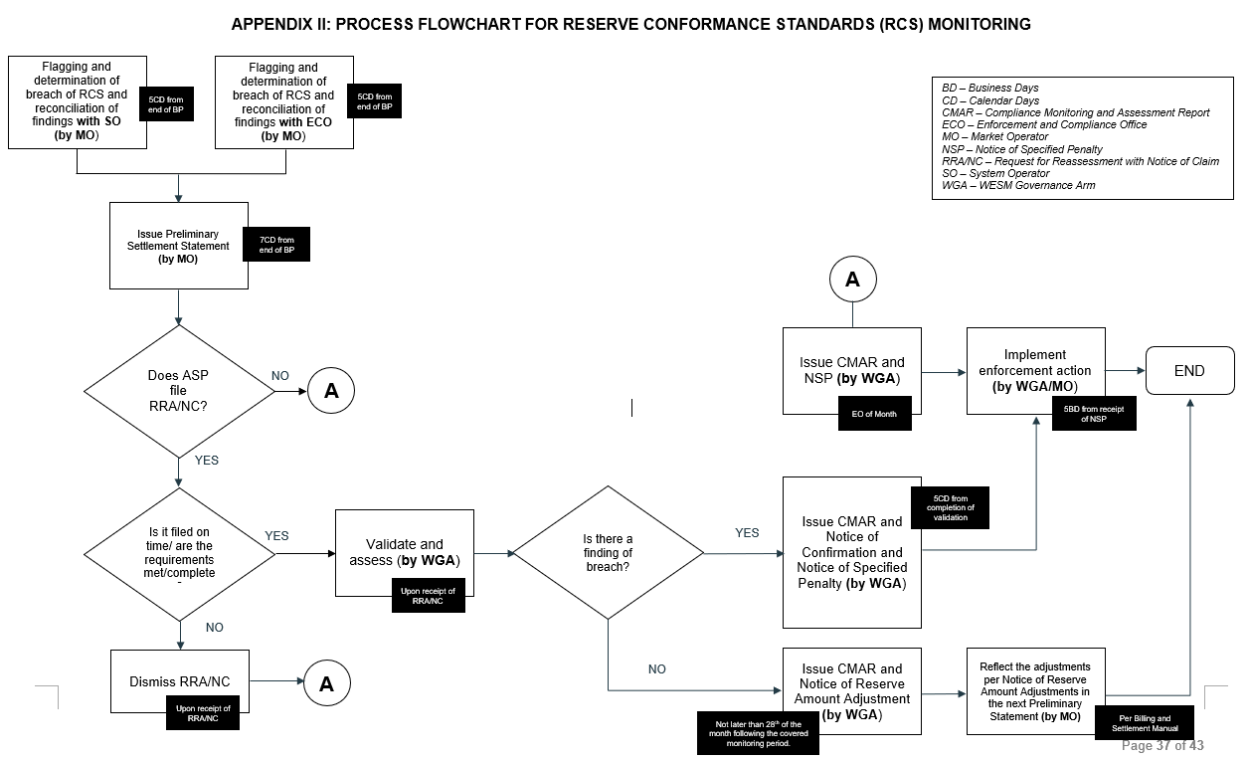
Appendix II (Proposed Amendment)

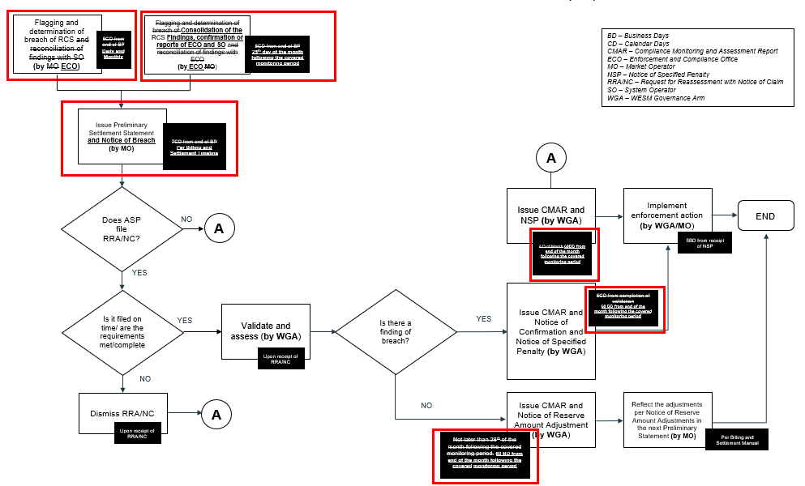
APPENDIX IV: Sample Illustration on the Monitoring of Compliance with Reserve Conformance Standards (RCS)

- Illustration depicting Sustainability for an Ancillary Service Facility with a Dispatchable Reserve (DR) Schedule
TIME_INTERVAL | TIME_INTERVAL | INSTRUCTION | MW_FROM | MW_TO | CATEGORY
01RESOURCE_G02 | 1/14/2024 17:21 | CUT - IN | 0 | 8 | DISPATCHABLE RESERVE
01RESOURCE_G02 | 1/14/2024 20:43 | CUT - OUT | 8 | 0 | DISPATCHABLE RESERVE
01RESOURCE_G01 | 1/15/2024 11:03 | ON LINE | 0 | 6 | DISPATCHABLE RESERVE
01RESOURCE_G01 | 1/15/2024 11:33 | INCREASE LOAD | 6 | 8 | DISPATCHABLE RESERVE
01RESOURCE_G01 | 1/15/2024 15:29 | CUT-OUT ASPA DISPATCH | 8 | 0 | DISPATCHABLE RESERVE
01RESOURCE_G02 | 1/15/2024 17:18 | ASPA DISPATCH | 0 | 8 | DISPATCHABLE RESERVE

Fig. 1.0 Table of Sample Dispatch Instruction Report with Active Instructions
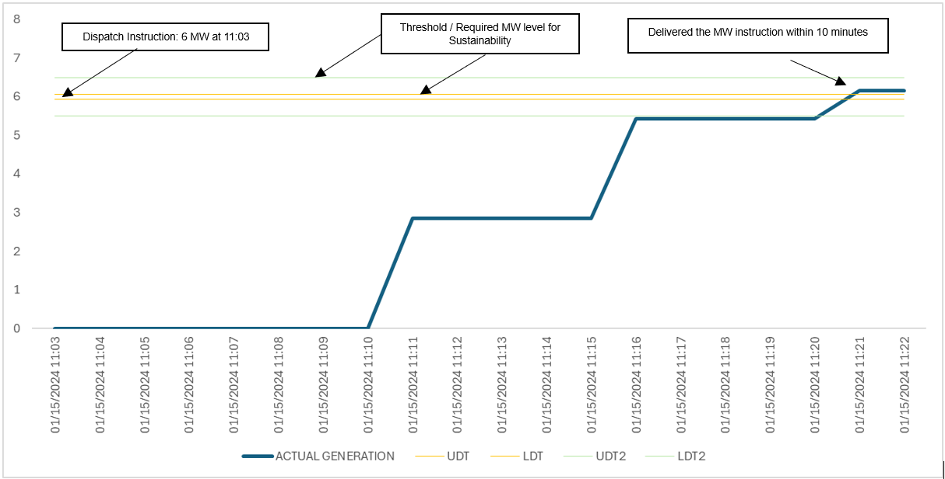
Fig. 2.0 Provision of DR instruction during synchronization

Observation:
- 01RESOURCE_G01 was offline prior to instruction (Status requirement: COMPLIANT)
- 01RESOURCE_G01 synchronized at 11:11 (within Interval 11:15) or 8 minutes after the instruction (Synchronization requirement: COMPLIANT)
- 01RESOURCE_G01 delivered the 6 MW instruction at 11:21 (within interval 11:25) or 10 minutes after synchronization (Sustainability requirement: COMPLIANT).
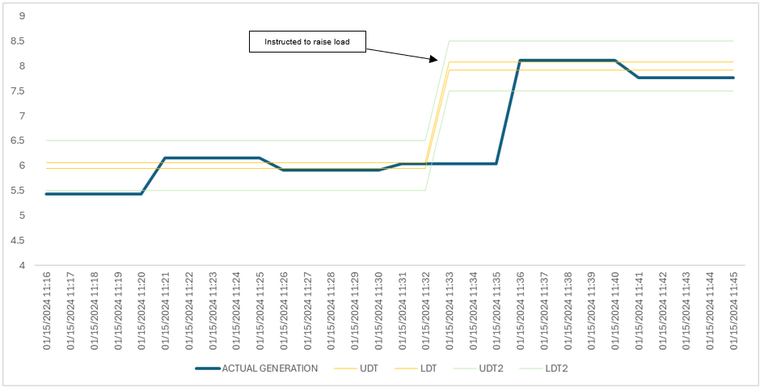
Fig. 3.0 Provision of DR instruction within Threshold as Sustainability Measure

Observation:
- 01RESOURCE_G01 was able to sustain active instruction from 11:25 to 11:30 (Sustainability requirement: COMPLIANT).
- 01RESOURCE_G01 received another instruction to raise load from 6 MW to 8 MW at 11:33 (within Interval 11:35); At 11:36 (within interval 11:40) 01RESOURCE_G01 delivered the 8 MW instruction. (Sustainability requirement: FOR FURTHER ASSESSMENT).
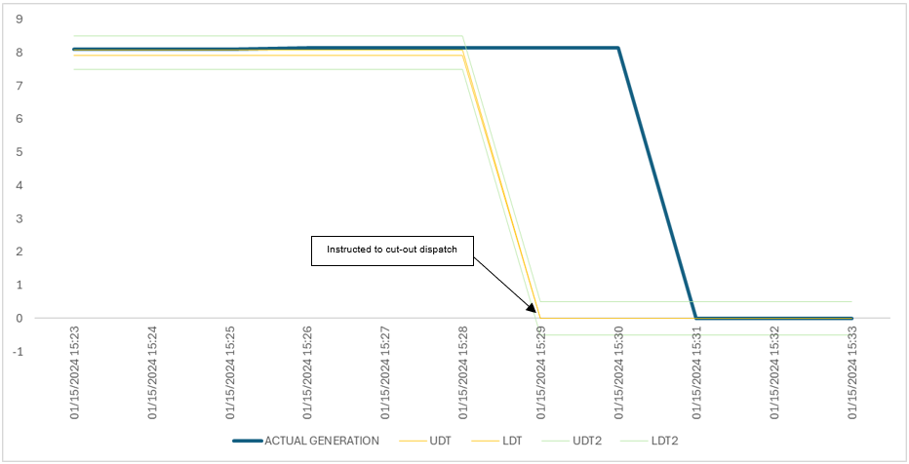
Fig. 4.0 Shutdown procedure after the provision of DR instruction

Observation:
- 01RESOURCE_G01 was able to sustain active instruction from 11:33 to 15:25 (Sustainability requirement: COMPLIANT).
- 01RESOURCE_G01 received another instruction at 15:29 to shut down; At 15:31, the unit was offline. (Sustainability requirement: FOR FURTHER ASSESSMENT).

- Illustration on the determination of Response Accuracy using Highest and Lowest Actual MW Output depending on the System Frequency Condition
Scenario 1: The System Frequency falls below the lower deadband threshold, the reserve facility needs to react by increasing generation to correct the frequency.

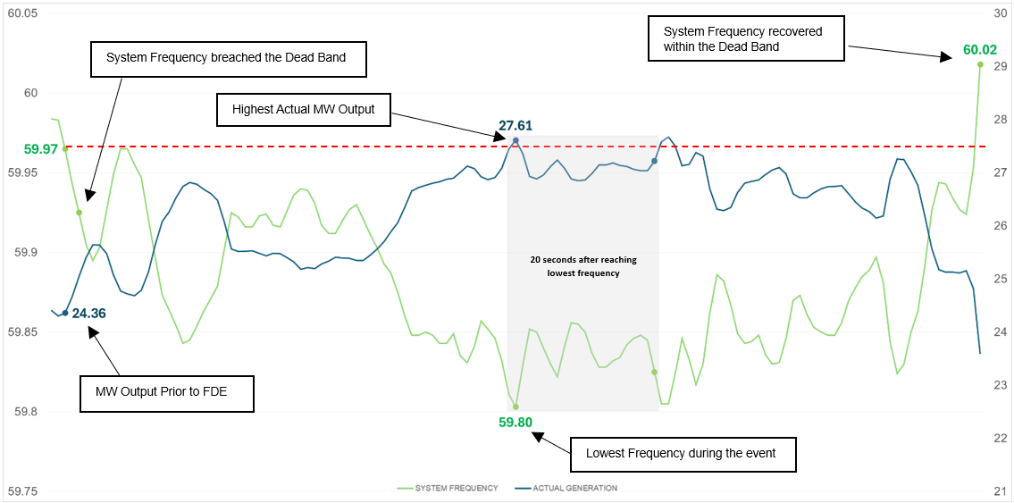
Fig 5.0 Sample Illustration when System Frequency breached lower Deadband

For example, the following are the reserve facility’s certified characteristics:
- Droop Setting: 4.5%
- Deadband Settings: 0.03 Hz
- Rated Capacity: 65.4 MW

Given:
- Highest Actual MW Output: 27.61 MW (within the 20-second period after the lowest frequency)
- MW Output Prior to FDE: 24.36 MW
- Lowest Frequency during FDE: 59.80 Hz

Computation:
Actual MW Response Capacity  = Highest Actual MW Output – MW Output Prior to Frequency-Driven Event  = 27.61 MW – 24.36 MW  = 3.25 MW  $Static Gain$  $= \frac{Rated Capacity}{Droop Setting x Nominal Frequency}$  $= \frac{65.4 MW}{4.5 \% x 60 Hz} x 100\%$  $= 24.22 MW/Hz$  Frequency Prior to Frequency-Driven Event  = Nominal Frequency + Deadband Setting  = 60 Hz - 0.03 Hz  = 59.97 Hz | Frequency Change  = Frequency Prior to Frequency-Driven Event - Lowest Frequency During Frequency-Driven Event  = 59.97 Hz – 59.80 Hz  = 0.17 Hz  Expected MW Response Capacity  = Static Gain $x$ Frequency Change  = 24.22 MW/Hz x 0.17 Hz  = 4.12 MW  $Response Accuracy$  $= \frac{Actual MW Response Capacity}{Expected MW Response Capacity} x 100\%$  $= \frac{3.25 MW}{4.12 MW} x 100\%$  $= 78.88 \%$ (NON-COMPLIANT)
Scenario 2: The System Frequency breaches the upper deadband threshold, the reserve facility needs to react by decreasing generation to correct the frequency.
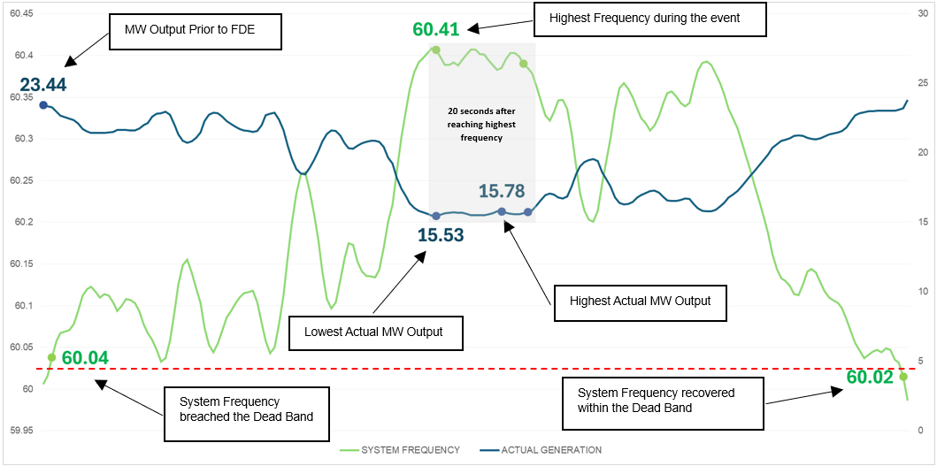
Fig 6.0 Sample Illustration when System Frequency breached Upper Deadband

For this example, the following are the reserve facility’s certified characteristics:
- Droop Setting: 4.5%
- Deadband Settings: 0.03 Hz
- Rated Capacity: 65.4 MW
Given:
- Highest Actual MW Output: 15.78 MW (within the 20-second period)
- Lowest Actual MW Output: 15.53 MW (within the 20-second period)
- MW Output Prior to FDE: 23.44 MW
- Highest Frequency during FDE: 60.41 Hz
Computation:
Actual MW Response Capacity  = Lowest Actual MW Output – MW Output Prior to Frequency-Driven Event  = 15.53 MW – 23.44 MW  = - 7.91 MW  $Static Gain$  $= \frac{Rated Capacity}{Droop Setting x Nominal Frequency}$  $= \frac{65.4 MW}{4.5 \% x 60 Hz} x 100\%$  $= 24.22 MW/Hz$  Frequency Prior to Frequency-Driven Event  = Nominal Frequency + Deadband Setting  = 60 Hz + 0.03 Hz  = 60.03 Hz | Frequency Change  = Frequency Prior to Frequency-Driven Event - Highest Frequency During Frequency-Driven Event  = 60.03 Hz - 60.41Hz  = -0.38 Hz  Expected MW Response Capacity  = Static Gain $x$ Frequency Change  = 24.22 MW/Hz x -0.38 Hz  = -9.20 MW  $Response Accuracy$  $= \frac{Actual MW Response Capacity}{Expected MW Response Capacity} x 100\%$  $= \frac{- 7.91 MW}{-9.20 MW} x 100\%$  $= 85.99\%$ (COMPLIANT)

- Illustration for the determination of Percentage (%) of Compliance of ASP on AGC
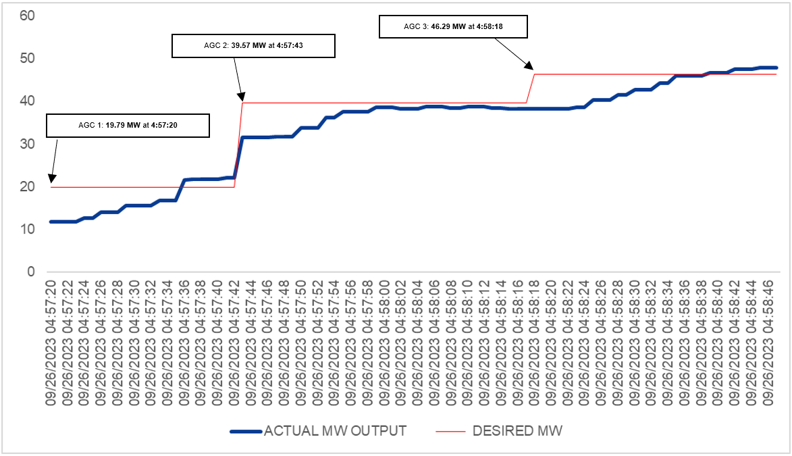
Fig 7.0 Sample series of AGC Commands

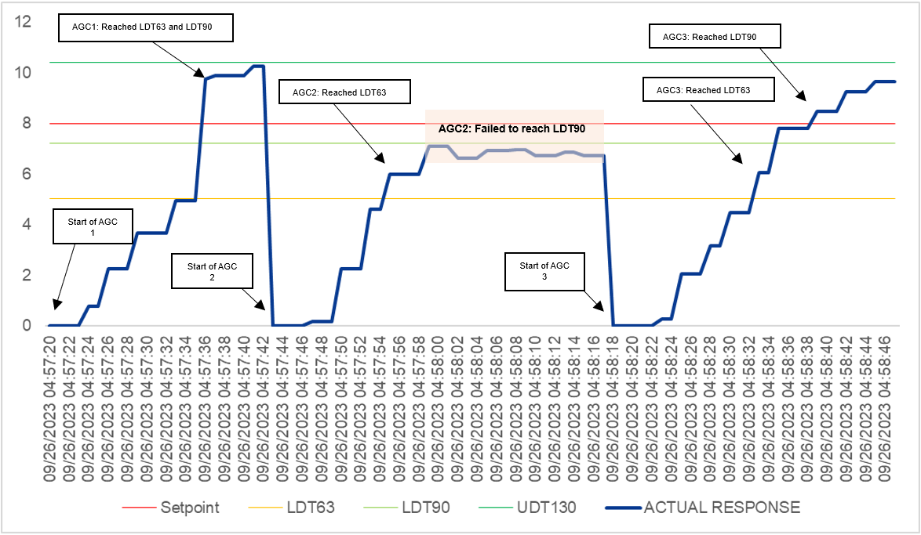
Fig 8.0 Equivalent Setpoint and Actual Response

Summary of illustration on Figure 8:
- AGC 1 LDT63 and LDT90 were reached within 16 seconds
- AGC 2 LDT63 reached within 12 seconds
- AGC 2 failed to reach LDT90
- AGC 3 LDT63 reached within 15 seconds
- AGC 3 LDT63 reached within 17 seconds
Since required levels of AGC Command 1 and AGC Command 3 have been reached within the required duration as stated in section 5.7, therefore, AGC Command 1 and AGC Command 3 are compliant

On the other hand, the generator failed to reach all the required levels of AGC Command 2, therefore, AGC Command 2 is non-compliant.

There is a total of 3 Commands in the above example

Total Commands = 3
Total Compliant Commands = 2

$\% Compliance= \frac{No. of Compliant AGC Commands}{No. of AGC Commands} x 100 \%$

$\% Compliance= \frac{2}{3} x 100 \%$
$\% Compliance= 66.67 \%$ (NON COMPLIANT)

