ORCP-WM-24-06B

Call for Comments to the Proposed Revisions to the Urgent Amendments to the Ancillary Services Monitoring Manual regarding the Reserve Conformance Standards and Related Enforcement Actions (ORCP-WM-24-06B)

The Rules Change Committee (RCC) is inviting all WESM Members and interested parties to submit comments to the PEM Board-approved Proposed Revisions to the Urgent Amendments to the Ancillary Services Monitoring Manual regarding the Reserve Conformance Standards and Related Enforcement Actions (ORCP-WM-24-06B).

The proposed amendments seek to cover the following matters:

- Changes in timeline and procedure for monitoring compliance with the Reserve Conformance Standards and enforcement thereof to streamline the process, enhance submission/documentation by Ancillary Service Providers (ASPs), and lead to a more comprehensive and quality assessment by ECO; and
- Additional technical considerations in monitoring Response Accuracy on Governor Control Mode (GCM). PEMC-ECO seeks to resolve technical issues identified during the August-November 2024 monitoring period to ensure fair assessment of the compliance of the ASPs.

These are further to the amendments (ORCP-WM-24-06) that were earlier approved by the PEM Board, as follows:

- Clarification on, and correction of, the criteria and formulas relating to compliance with the Reserve Conformance Standards (RCS)
- Clarity in the responsibilities of the Market Operator, the WESM Governance Arm, and the System Operator regarding the data provision, flagging, determination, and reporting of breach.

The WESM document for amendment is the WESM Manual on Ancillary Services Monitoring (ASMM).

BACKGROUND:

The proposed amendments were initiated by PEMC on 19 November 2024 by way of the rules change process for urgent amendments to address the concerns arising from the implementation of the ASMM, as amended effective 30 August 2024. Following the procedures for processing urgent proposals set forth in Section 7 of the Rules Change Manual, the RCC certified the proposal as urgent and deliberated on the proposal on 22 November 2024. Thereafter, the proposal was approved by the RCC and PEM Board, as follows:

Activity | Date
RCC Approval | 06 December 2024
PEM Board Approval | 10 December 2024
Effectivity Date of Revised Manual | 12 December 2024

The urgent amendments shall remain in effect up to 6 months or until a general amendment on the same matter has been approved by the DOE and becomes continuously in effect, whichever comes first. The updated market rules and manuals could be accessed in this webpage.

The subject proposal also includes several of the earlier approved urgent amendments on the ASM on 30 August 2024 that were published for comments as general amendments until 18 October 2024. The comments received for this recent proposed amendment will supersede the comments received in October 2024.

DOCUMENTS:

Provided below are the relevant materials for your reference:

- Original Rules Change Proposal submitted by PEMC (ORCP-WM-24-06B)
- PEM Board-approved urgent proposal (RCC Resolution No. 2024-08)
- Matrix of Proposed Amendments for Comments – Annex A of this document (See below. Please write your comments in the proper columns in the matrix.)

Kindly submit your comments (in Word format) through the File a Submission page no later than 03 February 2025 or 30 working days from the date of publication (16 December 2024).

Please input in the proper field the e-mail address of your point person(s) who we could further contact regarding activities related to the processing of the proposal. All comments received shall be published in the PEMC website.

Thank you.

For the Rules Change Committee.

[In accomplishing and submitting this form, you give your consent for PEMC to collect, record, organize, and update your personal data as herein provided as part of your information for purposes of rules change process.]

Commenter’s Information

Name | [Signature over Name]
Designation
Company
Company Address
Telephone No.
Email Address

WESM Manual on ASM Issue 1.1
Title | Clause | ANCILLARY SERVICES MONITORING MANUAL 1.0 Provision | Proposed Amendment  (PEM Board-approved as Urgent Amendment reflected on WESM ASMM Issue 1.2) | Rationale | Comments | Proposed Wording based on Comments | Original Proponent’s Response | RCC Decision
Please write your general comment here, if any:
Section 2 – Definition, References, and Interpretation  2.1 Definitions | g. Enforcement Related Notices - | Notice of Probable Breach –  A notice issued by the Market Operator to the Enforcement and Compliance Office. It specifies the dispatch intervals in which a probable breach of Reserve Conformance Standards is identified. It also specifies the amount adjusted or to be adjusted from the reserve trading amounts due from the System Operator as a result of probable breach flagging. | Notice of Probable Breach –  A notice issued by the Market Operator Enforcement and Compliance Office to the Ancillary Service Providers. It specifies the dispatch intervals in which a probable breach of Reserve Conformance Standards is identified. It also specifies the amount adjusted or to be adjusted from the reserve trading amounts due from the System Operator as a result of probable breach flagging after due assessment and verification. | The Notice of Breach, currently issued alongside IEMOP's Preliminary Settlement Statement, will now be issued by ECO upon finding of breach of RCS, aligning it with the proposed elimination of outright deductions/adjustments after the RCS Monitoring Results. No deductions will be effected until the Request for Readjustment (RRA; as remedy of ASP) has been availed of and/or completed.  The Notice of Breach, which serves as notification to the ASPs of the results, and as trigger, as well, for filing RRA, will retain its purpose. With the current proposal, the ECO will issue the Notice of Breach based on its RCS Monitoring Results.
Section 2 – Definition, References, and Interpretation  2.1 Definitions | g. Enforcement Related Notices - | Notice of Reserve Amount Adjustment –  A notice issued by the WESM Governance Arm to the Market Operator, the System Operator, and the Ancillary Services Provider that serves as a directive to, and basis of the Market Operator to cause the revision or adjustment in the settlement statement on account of the findings of the Enforcement and Compliance Office concerning compliance with the Reserve Conformance Standards. | Notice of Reserve Amount Adjustment –  A notice issued by the WESM Governance Arm to the Market Operator, the System Operator, and the Ancillary Services Provider that serves as a directive to, and basis of the Market Operator to cause the revision or adjustment in the settlement statement on account of the findings of the Enforcement and Compliance Office concerning compliance with the Reserve Conformance Standards. | For deletion.  As per the current proposal, no deductions or adjustments will be made until the RRA has been exhausted or completed. Thus, no notice of reserve amount adjustments will be necessary after revalidation/ reassessment, as initial RCS monitoring results did not trigger any deductions.
Section 2 – Definition, References, and Interpretation  2.1 Definitions | g. Enforcement Related Notices - | Notice of Confirmation of Breach –  A notice issued to the Market Operator, the System Operator, and the Ancillary Services Provider by the WESM Governance Arm after due assessment and verification by the Enforcement and Compliance Office which contains confirmation of the finding/s of breach as initially flagged by the Market Operator. | Notice of Confirmation of Breach –  A notice issued to the Market Operator, the System Operator, and the Ancillary Services Provider by the WESM Governance Arm after due assessment and verification by the Enforcement and Compliance Office which contains confirmation of the finding/s of breach as initially flagged, assessed, and reported by the Enforcement and Compliance Office to the Market Operator. | For deletion.  As per the current proposal, no deductions or adjustments will be made until the RRA has been exhausted or completed. Thus, no notice of breach confirmation will be necessary after revalidation/reassessment, as initial RCS monitoring results did not trigger any deductions.
 | i. | (NEW) | i. Rated Capacity - The full-load continuous gross capacity of a unit under the specified conditions, as calculated from the electric generator nameplate based on the rated Power Factor. | Reference:  - PGC (2016 Ed.)  - Resolution No. 17, Series of 2023 “A Resolution Adopting the 2023 Revised Rules for the Issuance of Certificates of Compliance (COCs) For Generation Facilities”
Section 2 – Definition, References, and Interpretation  2.1 Definitions | i. | i. Request for Reassessment with Notice of Claim – refers to a request of an Ancillary Service Provider for an independent or separate evaluation, validation, and assessment of its claim relative to a finding of breach of Reserve Conformance Standards, accompanied by a request to recalculate and/or adjust the settlement amount on account of the reassessed findings. | i. j. Request for Reassessment with Notice of Claim – refers to a request of an Ancillary Service Provider for an independent or separate evaluation, validation, and assessment of its claim relative to a finding of breach of Reserve Conformance Standards, accompanied by a request to recalculate and/or adjust the settlement amount on account of the reassessed findings.  j. k. Reserve - xxx | The proposed revision removes the phrase 'With Notice of Claim' since deductions are deferred until the RRA process is completed. Consequently, ASPs seeking reassessment, under the current proposal, are merely requesting reconsideration of breach findings, without claiming payment adjustments or add-backs.  Renumbering due to insertion of new term
Section 2 – Definition, References, and Interpretation  2.1 Definitions | k. | k. Reserve Amount Adjustment – the amount to be debited or credited to/from a WESM Member as a line-item adjustment to the reserve trading amount in connection with the results of the monitoring and assessment of the compliance of the Ancillary Services Providers with the reserve conformance standards. | k l. Reserve Amount Adjustment – the amount to be debited or credited to/ from a WESM Member as a line-item adjustment to or deduction from the reserve trading amount in connection with the final results or findings of breach of the monitoring and assessment of the compliance of the Reserve Conformance Standards the Ancillary Services Providers with the reserve conformance standards.  l. m. Reserve Conformance Standards - xxx | The term “final” is added to signify that the proceedings have completed the initial RCS monitoring and assessment, as well as any subsequent revalidation or reassessment. Only thereafter will IEMOP apply the reserve amount adjustment in the Preliminary Settlement Statement, based on the finalized results.  Renumbering due to insertion of new term.
Section 2 – Definition, References, and Interpretation  2.1 Definitions | n. | (new) | n. Reserve Conformance Standards Non-Compliance List – contains a list of all intervals with breach of the Reserve Conformance Standards occurring within a specified billing period, including date and dispatch interval with breach, affected resource unit, reserve type and other relevant details pertaining to the non-compliance. | To include in the “Definition of Terms” the type of report required for submission to IEMOP after considering RRA results and final RCS monitoring findings, serving as the basis for definitive one-time settlement adjustments.
Section 2 – Definition, References, and Interpretation  2.1 Definitions |  | m. Reserve Facility - xxx  n. Reserve Offer - xxx  o. Reserve Offer Capacity Compliance - xxx  p. Reserve Schedule - xxx  q. WESM Reserve Market - xxx | m o. Reserve Facility - xxx  n p. Reserve Offer - xxx  o q. Reserve Offer Capacity Compliance - xxx  p r. Reserve Schedule - xxx  q s. WESM Reserve Market - xxx | Renumbering of the succeeding terms in the “Definition of Terms” in view of the inserted / new defined term.
Section 3 – Responsibilities  3.1 Market Operator | 3.1.1 | The Market Operator shall establish a procedure for the monitoring or flagging of breach in accordance with the Reserve Conformance Standards and the rule pertaining to Reserve Offer Capacity Compliance through the use of an appropriate facility. | The Market Operator shall establish a procedure for the timely gathering and provision of available market data to the WESM Governance Arm that are necessary for the monitoring of compliance monitoring or flagging of breach in accordance with the Reserve Conformance Standards and the rule pertaining to Reserve Offer Capacity Compliance through the use of an appropriate facility. | In reference to revision in Section 7.2 where the responsibility of flagging the probable breach is removed from MO. ECO will flag the breach, validate, assess, and report the results to MO.  MO will instead be in charge of the timely collection and gathering of data, and provision thereof to PEMC for the Reserve Market compliance monitoring purposes.
Section 3 Responsibilities  3.4 Ancillary Services Provider | 3.4.1 | 3.4.1 Ancillary Services Providers shall submit to the System Operator the following real-time data for purposes of monitoring compliance with the Reserve Conformance Standards.  a. Generator mode of operations  b. Dead band setting | 3.4.1 Ancillary Services Providers shall submit to the System Operator the following real-time data for purposes of monitoring compliance with the Reserve Conformance Standards.  a. Generator mode of operations  b. Dead band setting  c. Speed droop characteristic | Deletion of the term “real-time” to describe the required data of the System Operator from the Ancillary Services Providers that will be used for monitoring compliance with the Reserve Conformance Standards.  Addition of Speed Droop characteristic to the required data from the Ancillary Services Providers (ASPs) in reference to Section 5.3.3 and 5.4.4.
SECTION 5 – Reserve Conformance Standards  5.2 Provision of Data for Monitoring and Reporting | 5.2.1 | The System Operator shall submit to the Market Operator data and reports that may be necessary in initially determining probable breach, such as but not limited to the following:  For other data or reports not enumerated in the foregoing table, the Market Operator and the System Operator shall, from time to time, agree on the manner and schedule of submission. | The System Operator shall submit to and the Market Operator shall submit to the WESM Governance Arm data and reports that may be necessary in initially determining probable breach, such as but not limited to the following:  For other data or reports not enumerated in the foregoing table, the Market Operator, the WESM Governance Arm, and the System Operator shall, from time to time, agree on the manner and schedule of submission.  [Add Footnote] “D” - Day; “D+1”: Next Day | Ensuring all relevant data are considered to achieve more precise and reliable results, and to avoid any discrepancies. This approach also helps to effectively monitor and identify any potential breaches of regulations or market rules.  Final BCQ-MO provision from monthly to every 15th of the month, as agreed with MO.  Additional data are added for clarity and consistency and to reflect current practice.  For clarity.
  Data | Timeline of Provision
  Generator mode of operation  (e.g., Automatic Generation Control, Governor Control Mode, Manual Dispatch Instruction) | Real-Time
  Dead band settings | Real-Time
  Speed droop | Real-Time
  Generator Status | Real-Time
  Dispatch instructions | By 1200H of the next day for all instructions of the current trading day
  Outages | By 1200H of the next day for all instructions of the current trading day
  Power System Frequency | Real-Time
  Control Dead band | Real-Time
  Data | Timeline of Provision | Source
  Generator mode of operation  (e.g., Automatic Generation Control, Governor Control Mode, Manual Dispatch Instruction) | Real-Time  D+1 | Market Operator
  Deadband settings (Based on certification) | Real-Time  As necessary | Market Operator
  Speed droop characteristic (Based on certification) | Real-Time  As necessary | Market Operator
  Rated Capacity  (Based on declared/tested capacity) | As necessary | System  Operator
  Generator Status | Real-Time  D+1 | System  Operator
  Dispatch instructions | By 1200H of the next day for all instructions of the current trading day  D+1 | System  Operator
  Outages | By 1200H of the next day for all instructions of the current trading day  D+1 | System  Operator
  Power System Frequency | Real-Time  D+1 | System  Operator
  Control Dead band | Real-Time
  Desired MW/AGC Command | D+1 | System  Operator
  Certified Capacity  (Based on certification) | As necessary | Market Operator
  Day-Ahead Ancillary Service Schedule (DAASS) | D-1 | System  Operator
  BCQ-SO | D+1 | System  Operator
  Final BCQ-MO | Every 15th of the following month | Market Operator
  Actual MW Output | D+1 | System  Operator
  Reserve Type  (Based on certification) | As necessary | Market Operator
SECTION 5 – Reserve Conformance Standards  5.3 Reserve Conformance Standards for Regulating Reserve | 5.3.3 | Reserve facilities scheduled to provide regulating reserve shall also ensure that they meet the following requirements during the relevant dispatch interval:  a. Dead band is 0.15 Hz or lower if operating on GCM or AGC  b. Speed-droop characteristic is 5% or lower; and  c. Provision of reserve is sustainable for the entire dispatch interval. | Reserve facilities scheduled to provide regulating reserve shall also ensure that they meet the following requirements based on the certified settings during the relevant dispatch interval:  a. Dead band is 0 Hz to +/- 0.15 Hz 0.15 Hz or lower if operating on GCM or AGC.  b. Speed-droop Speed droop characteristic is 5% or lower and 1% or lower for Battery Energy Storage System if operating on GCM; and  c. Provision of reserve is sustainable for the entire dispatch interval. | To indicate the correct dead band settings for GCM mode and to delete “or AGC” as there is no dead band requirement for AGC operations.  No speed droop characteristic requirement for AGC since it is automatically controlled by a Supervisory Control and Data Acquisition (SCADA) from the SO Control Center or manual adjustment of load with specific instructions from the SO.  To include the speed droop characteristic for Battery Energy Storage System (BESS)
SECTION 5 – Reserve Conformance Standards  5.3 Reserve Conformance Standards for Regulating Reserve | 5.3.4 | A reserve facility providing regulating reserve that fails to maintain an average response accuracy as set out in Sections 5.6.1 and 5.7.1 or an average response time as set out in Sections 5.6.3 and 5.7.3 in any dispatch interval during the monitoring period shall be flagged as non-compliant. Once flagged as non-compliant, a reserve facility will be assessed further based on the following:  a) Compliance with the response accuracy for each dispatch interval; and  b) Compliance with the response time for each dispatch interval. | A reserve facility providing regulating reserve that fails to maintain an average response accuracy as set out in Sections 5.6.1 and 5.7.1 or an average response time as set out in Sections 5.6.3 and 5.7.3 or Percentage (%) of Compliance as set out in sections 5.7.1 in any dispatch interval during the monitoring period settlement interval shall be flagged as non-compliant. Once flagged as non-compliant, a reserve facility will be assessed further based on the following:  a) Compliance with the response accuracy for each dispatch interval; and  b) Compliance with the response time for each dispatch interval. | To revise the averaging from a monthly period to hourly interval as this proposed approach would calculate the average response accuracy and response time for the reserve facility operating under GCM within each relevant hourly interval, providing a more balanced and granular assessment of compliance.  To distinguish hourly averaging of response accuracy and response time (under GCM) from Percentage of Compliance (under AGC), in relation to the proposed revisions to Section 5.7 “Measuring Reserve Response Compliance of Generators on Automatic Generation Control”.
SECTION 5 – Reserve Conformance Standards  5.3 Reserve Conformance Standards for Regulating Reserve | 5.3.5 | Considering the provisions of Section 5.3.4, the relevant reserve facility that fails to meet either: (a) the required response accuracy of at least 80% or 75% or (b) the required response time of not more than five (5) or twenty-five (25) seconds, as applicable in accordance with Sections 5.6 and 5.7 at any dispatch interval will be considered breach of the reserve conformance standards for regulating reserves for that dispatch interval. | Considering the provisions of Section 5.3.4, the relevant reserve facility that fails to meet either: (a) the required response accuracy of at least 80% or 75 90% or (b) the required response time of not more than five (5) or twenty-five (25) seconds, as applicable in accordance with Sections 5.6 and 5.7 at any dispatch interval will be considered breach of the reserve conformance standards for regulating reserves for that dispatch interval. | To be consistent with Section 5.7 and 5.8  90% compliance is to be consistent with the standard practice of NGCP-SO in monitoring reserve facilities operating under AGC
SECTION 5 – Reserve Conformance Standards  5.4 Reserve Conformance Standards for Contingency Reserve | 5.4.4 | Reserve facilities scheduled to provide contingency reserve shall also ensure that they meet the following requirements during the relevant dispatch interval:  a. Dead band is greater than 0.15 Hz but less than 0.30 Hz if operating on GCM or AGC;  b. Speed-droop characteristic is 5% or lower; and  c. Provision of reserve is sustainable for the entire dispatch interval. | Reserve facilities scheduled to provide contingency reserve shall also ensure that they meet the following requirements based on the certified settings during the relevant dispatch interval:  a. Dead band is greater than 0.15 Hz -0.16 Hz to -0.30 Hz but less than 0.30 Hz - 0.15 Hz to - 0.30 Hz if operating on GCM or AGC.  b. Speed-droop Speed droop characteristic is 5% or lower and 1% or lower for Battery Energy Storage System, if operating on GCM; and  c. Provision of reserve is sustainable for the entire dispatch interval. | To indicate the correct dead band settings for GCM mode and to delete “or AGC” as there is no dead band requirement for AGC operations.  No speed droop characteristic requirement for AGC since it is automatically controlled by a Supervisory Control and Data Acquisition (SCADA) from the SO Control Center or manual adjustment of load with specific instructions from the SO.  To include the speed droop characteristic for BESS.
SECTION 5 – Reserve Conformance Standards  5.4 Reserve Conformance Standards for Contingency Reserve | 5.4.5 | A reserve facility providing contingency reserve that fails to maintain an average response accuracy as set out in Sections 5.6.1 and 5.7.1 or an average response time as set out in Sections 5.6.3 and 5.7.3 for the entire monitoring period shall be flagged as non-compliant. Once flagged as non-compliant, a reserve facility will be assessed further based on the following:  a) Compliance with the response accuracy for each dispatch interval; and  b) Compliance with the response time for each dispatch interval. | A reserve facility providing contingency reserve that fails to maintain an average response accuracy as set out in Sections 5.6.1 and 5.7.1 or an average response time as set out in Sections 5.6.3 and 5.7.3 or Percentage (%) of Compliance as set out in sections 5.7.1 for the entire monitoring period settlement interval shall be flagged as non-compliant. Once flagged as non-compliant, a reserve facility will be assessed further based on the following:  a) Compliance with the response accuracy for each dispatch interval; and  b) Compliance with the response time for each dispatch interval. | To revise the averaging from a monthly period to hourly interval as this proposed approach would calculate the average response accuracy and response time for the reserve facility operating under GCM within each relevant hourly interval, providing a more balanced and granular assessment of compliance.  To distinguish hourly averaging of response accuracy and response time (under GCM) from Percentage of Compliance (under AGC), in relation to the proposed revisions to Section 5.7 “Measuring Reserve Response Compliance of Generators on Automatic Generation Control”.
SECTION 5 – Reserve Conformance Standards  5.4 Reserve Conformance Standards for Contingency Reserve | 5.4.6 | Considering the provisions of Section 5.4.5, the relevant reserve facility that fails to meet either: (a) the required response accuracy of at least 80% or 75% or (b) the required response time of not more than five (5) or twenty-five (25) seconds, as applicable in accordance with Section 5.6 and Section 5.7 at any dispatch interval will be considered breach of the reserve conformance standards for contingency reserves for that dispatch interval. | Considering the provisions of Section 5.4.5, the relevant reserve facility that fails to meet either: (a) the required response accuracy of at least 80% or 75% 90% or (b) the required response time of not more than five (5) or twenty-five (25) seconds, as applicable in accordance with Section 5.6 and Section 5.7 at any dispatch interval will be considered breach of the reserve conformance standards for contingency reserves for that dispatch interval. | To be consistent with Section 5.7  90% compliance is to be consistent with the standard practice of NGCP-SO in monitoring reserve facilities operating under AGC
SECTION 5 – Reserve Conformance Standards  5.5 Reserve Conformance Standards for Dispatchable Reserve | 5.5.3 | After synchronization, the dispatchable reserve facility shall deliver the MW capacity instructed by the System Operator within fifteen (15) minutes from synchronization. | After synchronization, the dispatchable reserve facility shall deliver the MW capacity instructed by the System Operator within fifteen (15) minutes from synchronization and shall generate within the upper and lower dispatch thresholds of +/-1% of the dispatch instruction, or +/- 0.5 MW, whichever is higher. The facility shall sustain and maintain generation in accordance with the active instruction and any succeeding instructions from the System Operator until instructed to shut down.  Footnote: (See Illustration 1 of Appendix IV) | To add a criterion that in addition to the requirement for DR to generate within 15 minutes from the SO instruction, the reserve facility must follow a dispatch tolerance of +/- 1% (based on SO’s standard practice for monitoring) or +/- 0.5 MW (based on the survey results conducted with DR-ASPs) for the given period and to clearly establish that the facility must sustain/continue to generate to meet the SO instruction until it receives a specific directive to stop generating.  (See Illustration 1 in Annex C) Clerical revision to specify reference to the relevant illustration in Appendix IV.
SECTION 5 – Reserve Conformance Standards  5.5 Reserve Conformance Standards for Dispatchable Reserve | 5.5.4 | [NEW] | 5.5.4 A dispatchable reserve facility that fails to comply with the real-time dispatch instruction of the System Operator based on the Reserve Schedule due to an outage or unavailability shall be considered in breach of the reserve conformance standards for the dispatch interval that the non-compliance occurs and in all preceding intervals of the same trading day that have Dispatchable Reserve Schedules. | It covers instances where a facility (that is required to be offline) offers for DR but it is, in fact, not available when called to run. It will only be ascertained during the time that it is asked to run by SO.  The dispatchable reserve facility that becomes non-dispatchable real-time or is unable to deliver the MW capacity in real-time due to an outage or other cause/s of unavailability presupposes that it is not also available in the prior intervals (while it was offline).  By being unable to run as DR, it does not serve its purpose, i.e., assuring the grid that it is indeed readily available for dispatch (when needed) in order to replenish the CR whenever a generating unit trips or a loss of a single transmission interconnection occurs.
SECTION 5 – Reserve Conformance Standards  5.5 Reserve Conformance Standards for Dispatchable Reserve | 5.5.4 | A reserve facility that fails to comply with the provisions set out in Sections 5.5.1, 5.5.2, or 5.5.3 at any dispatch interval shall be considered in breach of the reserve conformance standards for dispatchable reserves for that dispatch interval. | 5.5.4 5.5.5 A reserve facility that fails to comply with the provisions set out in Sections 5.5.1, 5.5.2, or 5.5.3 at any dispatch interval shall be considered in breach of the reserve conformance standards for dispatchable reserves for that dispatch interval. | Renumbered to 5.5.5 due to inserted new provision (see above Sec. 5.5.4)
Section 5 – Reserve Conformance Standards  5.6 Measuring Reserve Response Compliance of Generators on Governor Control Mode | 5.6.1 | A reserve facility responding to a frequency-driven event through GCM shall maintain a response accuracy of at least 80% for the entire monitoring period. | A reserve facility responding to a frequency-driven event through GCM shall maintain an average response accuracy of at least 80% for the entire monitoring period relevant settlement interval.  For purposes of averaging under Sections 5.3.4 and 5.4.5, the response accuracy for a dispatch interval shall be capped at 120%. | To revise the requirement from being measured over the entire monitoring period, to being measured within relevant settlement interval. This provides for a more granular and balanced assessment.  Rationale for Capping at 120%:  The 120% capping on the average response accuracy is intended to manage outliers (e.g. overshoot in response accuracy by 200-300%) and setting an upper limit or fixed threshold value of 120% as the reasonable metric in determining accuracy within a settlement interval.
Section 5 – Reserve Conformance Standards  5.6 Measuring Reserve Response Compliance of Generators on Governor Control Mode | 5.6.2 | A reserve facility’s response accuracy via GCM shall be calculated as follows.  $$Response Accuracy= \frac{Actual MW Response Capacity}{Expected MW Response Capacity} x 100\%$$  Where:  Actual MW Response Capacity  = Highest Actual MW Output – MW Output Prior to Frequency-Driven Event  Expected MW Response Capacity  = Static Gain $x$ Frequency Change  Frequency Change  = Worst Frequency Highest/Lowest – Frequency Prior to Frequency-Driven Event  Frequency Prior to Frequency-Driven Event  = Nominal Frequency + Dead band Setting  $$Static Gain= \frac{Scheduled MW Capacity}{Droop Setting x Nominal Frequency} x 100\%$$ | A reserve facility’s response accuracy via GCM shall be calculated as follows.  $$Response Accuracy= \frac{Actual MW Response Capacity}{Expected MW Response Capacity} x 100\%$$  Footnote: (See Illustration 2 of Appendix IV)  a. When System Frequency falls below the lower deadband:  Actual MW Response Capacity  = Highest Actual MW Output – MW Output Prior to Frequency-Driven Event  Where: The Highest Actual MW Output is the value obtained 20 seconds after the Lowest frequency that occurred during the Frequency-Driven Event  Frequency Change  = Frequency Prior to Frequency-Driven Event - Lowest Frequency During Frequency-Driven Event  Frequency Prior to Frequency-Driven Event  = Nominal Frequency - Dead band Setting  b. When System Frequency breaches the upper deadband:  Actual MW Response Capacity  = Lowest Actual MW Output – MW Output Prior to Frequency-Driven Event  Where: The Lowest Actual MW Output is the value obtained 20 seconds after the highest frequency that occurred during the Frequency-Driven Event  Frequency Change  = Frequency Prior to Frequency-Driven Event - Highest Frequency During Frequency-Driven Event  Expected MW Response Capacity  = Static Gain $x$ Frequency Change  Frequency Change  = Worst Frequency Highest/Lowest – Frequency Prior to Frequency-Driven Event  Frequency Prior to Frequency-Driven Event  = Nominal Frequency + Dead band Setting  $$Static Gain= \frac{Scheduled MW Rated Capacity}{Droop Setting x Nominal Frequency} x 100\%$$  For purposes of computing static gain, the determination of rated capacity shall be established by reference to: (a) the rated capacity as appearing in WESM registration records; or (b) the declared capacity from which the reserve facility was tested during the ancillary services certification. In the event of any discrepancy, the latter shall prevail for this purpose.  If the system frequency breaches the upper deadband threshold, the reserve facility needs to react by decreasing generation to correct the frequency and vice versa. In this case, the Actual MW Response Capacity shall be calculated as the difference between the Highest or Lowest Actual MW Output, as the case may be, and the MW Output prior to the Frequency-Driven Event.  The event will qualify as Frequency-Driven Event, for this purpose, if  - the event lasts for more than five (5) seconds; and  - the frequency deviation exceeds the deadband setting by 0.02 Hz for conventional generating units and 0.01 Hz for battery energy storage systems.  In cases where the Expected MW Response Capacity, as calculated based on the formula, exceeds the Reserve Schedule, reserve facilities are authorized to operate within their scheduled reserves for ancillary service provision, subject to System Operator's re-dispatch instructions. In such instances, the System Operator shall include details of re-dispatch instructions in its dispatch instruction report.  Footnote: (See Illustration 3 of Appendix IV) | Clerical revision to specify reference to the relevant illustration in Illustration 2 of Appendix IV in Annex C.  Modification of the formula (i.e., addition of the “lowest” Actual MW output on the formula) for Actual MW Response Capacity to use both the highest and lowest actual MW output values, in order to reflect the correct response accuracy for any given Frequency Driven-Event, whether it requires an upward or downward response from Ancillary Services Providers (ASPs).  Rationale for the 20 seconds time reference: 20 seconds is a time frame that is typically critical for a reserve facility to respond to control signals being sent from SO’s energy management system (EMS).  NGCP-SO suggested retaining this practice (20-second horizon) for the Reserve Market to maintain consistency with the assessment of the ASPA based on current practice. NGCP may study this further and consider it for inclusion in another amendment, if warranted.  Transposition in the formula for Frequency Change. This is to ensure consistency with the sign of the resulting Expected Response with the Actual MW Output and to have a non-negative Response Accuracy.  Addition of the word “during” to clarify that the frequency referenced should be the value observed during the frequency-driven event.  (See Illustration 2 of Appendix IV in Annex C)  Added for clarity the basis or “reference” in obtaining the rated capacity to be used in the formula for static gain.  Given that the Expected MW Response Capacity can sometimes exceed both the Certified Capacity and the Reserve Schedule, it is crucial that the Response Accuracy should be calculated using the Reserve Schedule as reference in such cases, acknowledging that the reserve facilities are only required to operate within their reserve schedule when providing ancillary service. (See Illustration 3 of Appendix IV in Annex C)
Section 5 – Reserve Conformance Standards  5.6 Measuring Reserve Response Compliance of Generators on Governor Control Mode | 5.6.3 | A reserve facility responding to a frequency-driven event or to a dispatch instruction, while on GCM shall have an average response time of not more than five (5) seconds for the entire monitoring period. | A reserve facility responding to a frequency-driven event or to a dispatch instruction, while on GCM shall have an average response time of not more than five (5) seconds for the entire monitoring period relevant settlement interval. | Evaluating the response time during the relevant settlement interval, rather than an entire monitoring period, provides a more accurate and representative assessment of the facility’s performance during the provision of Ancillary Service (AS).
Section 5 – Reserve Conformance Standards  5.7 Measuring Reserve Response Compliance of Generators on Automatic Generation Control | 5.7.1 | A reserve facility responding to a frequency-driven event or to dispatch instructions, through commands received from the System Operator’s Energy Management System (EMS) via AGC shall comply to at least 75% of such AGC commands for the entire monitoring period. | A reserve facility responding to a frequency-driven event or to dispatch instructions, through commands received from the System Operator’s Energy Management System (EMS) via AGC shall comply to at least 75% 90% of such AGC commands for the entire monitoring period relevant settlement interval.  Percentage (%) of Compliance of a reserve facility/unit operating on AGC is given below:  $$\% Compliance= \frac{No. of Compliant AGC Commands}{No. of AGC Commands} x 100\%$$  Footnote: (See Illustration 4 of Appendix IV) | Clerical revision to specify reference to the relevant illustration in Appendix IV.  90% compliance is to be consistent with the standard practice of NGCP-SO in monitoring reserve facilities operating under AGC.  To reflect, for clarity, the formula in getting Percentage (%) of Compliance.  To revise the requirement from being measured over the entire monitoring period, to being measured within each relevant settlement interval. This provides for a more granular and balanced assessment, as proposed in Sections 5.3.4 and 5.4.5.  (See Illustration 4 of Appendix IV in Annex C)
Section 5 – Reserve Conformance Standards  5.7 Measuring Reserve Response Compliance of Generators on Automatic Generation Control | 5.7.2 | A reserve facility is deemed compliant to an AGC command if:  Actual MW Generation > (Desired MW Generation – Control Dead band); and  Actual MW Generation < (Desired MW Generation + Control Dead band). | A reserve facility is deemed compliant to an AGC command if the following conditions are met:  Actual MW Generation > (Desired MW Generation – Control Dead band); and  Actual MW Generation < (Desired MW Generation + Control Dead band).  5.7.2.1 The Actual Generation of the reserve facility shall reach at least 63% of the Desired Generation within 25 seconds from the time the AGC command is issued.  5.7.2.2 Additionally, the Actual Generation of the reserve facility shall reach at least 90% but shall not exceed 130% of the Desired Generation or ± 0.5 MW from the Desired Generation, (whichever requirement is the higher threshold) within 32 seconds from the time AGC command is issued. The facility shall sustain and maintain generation throughout the command in such range set out herein. | Adopted from the System Operator’s standard practice for monitoring the compliance of their contracted AS Providers with the AGC commands.
Section 5 – Reserve Conformance Standards  5.7 Measuring Reserve Response Compliance of Generators on Automatic Generation Control | 5.7.3 | A reserve facility responding to a frequency-driven event, or dispatch instructions, through AGC commands shall also have an average response time of not more than twenty-five (25) seconds for the entire monitoring period. | A reserve facility responding to a frequency-driven event, or dispatch instructions, through AGC commands shall also have an average response time of not more than twenty-five (25) seconds for the entire monitoring period. | No longer applicable in view of the proposed revision in 5.7.2.
Section 5 – Reserve Conformance Standards  5.7 Measuring Reserve Response Compliance of Generators on Automatic Generation Control | 5.7.4 | A reserve facility’s response time is computed from the time of the AGC command until the actual generation reaches control dead band (i.e., desired generation + the dead band). | A reserve facility’s response time is computed from the time of the AGC command until the actual generation reaches control dead band (i.e., desired generation + the dead band). | No longer applicable in view of the proposed revision in 5.7.2.
Section 5 – Reserve Conformance Standards  5.8 Summary Table of Reserve Conformance Standards for Each Reserve Type | 5.8 | 5.8 Summary Table of Reserve Conformance Standards for Each Reserve Type | 5.8 Summary Table of Reserve Conformance Standards for Each Reserve Type  [Add footnote in title: Adopted from the parameters being implemented by the System Operator for its own compliance monitoring of contracted Ancillary Service Providers] | To align the reserve conformance standards for each type of reserves set out in Sections 5.3.3 5.4.4, 5.5.3., 5.6.1 and 5.7.
  For Regulating Reserves
  Response Accuracy | On GCM | At least 80%
  Response Accuracy | On AGC | At least 75%
  Response Time | On GCM | not more than 5 seconds
  Response Time | On AGC | not more than 25 seconds
  Dead band Setting | 0.15 Hz or lower
  Speed droop | 5% or lower
  Sustainability | for the entire dispatch interval
  For Contingency Reserves
  Response Accuracy | On GCM | At least 80%
  Response Accuracy | On AGC | At least 75%
  Response Time | On GCM | not more than 5 seconds
  Response Time | On AGC | not more than 25 seconds
  Dead band Setting | greater than 0.15 Hz but less than 0.30 Hz
  Speed droop | 5% or lower
  Sustainability | for the entire dispatch interval
  For Dispatchable Reserves
  Status | must be offline unless there is a dispatch instruction from the System Operator, or it was scheduled for energy dispatch in the WESM.
  Synchronization | Within 15 minutes upon advice from the System Operator
  Sustainability | After synchronization, the dispatchable reserve facility shall deliver the MW capacity instructed by the System Operator within 15 minutes
  For Regulating Reserves
  Response Accuracy | On GCM | At least 80%
  Response Accuracy | On AGC | At least 75% 90%
  Response Time | On GCM | not more than 5 seconds
  Response Time | On AGC | not more than 25 seconds  At least 63% of the desired generation within 25 seconds;  and at least 90% and not more than 130% of the desired generation or 0.5 MW tolerance whichever is higher within 32 seconds
  Deadband Setting on GCM | 0 Hz to +/-0.15Hz or as per certification
  Speed droop characteristic on GCM | 5% or lower; and  1% or lower for BESS
  Sustainability | for the entire dispatch interval
  For Contingency Reserves
  Response Accuracy | On GCM | At least 80%
  Response Accuracy | On AGC | At least 75% 90%
  Response Time | On GCM | not more than 5 seconds
  Response Time | On AGC | not more than 25 seconds  At least 63% of the desired generation within 25 seconds;  and at least 90% and not more than 130% of the desired generation or 0.5 MW tolerance whichever is higher within 32 seconds
  Deadband Setting on GCM | - 0.16 - 0.15 Hz to - 0.30 Hz or as per certification
  Speed droop characteristic on GCM | 5% or lower; and  1% or lower (for BESS)
  Sustainability | for the entire dispatch interval
  For Dispatchable Reserves
  Status | Must be offline unless there is a dispatch instruction from the System Operator, or it was scheduled for energy dispatch in the WESM.
  Synchronization | Within 15 minutes upon advice from the System Operator
  Sustainability | After synchronization, the dispatchable reserve facility shall deliver the MW capacity instructed by the System Operator within 15 minutes  Must sustain the upper and lower threshold of +/-1% of the dispatch instruction or +/- 0.5 MW whichever is higher, within 15 minutes from synchronization
Section 7 Monitoring Compliance with Reserve Conformance Standards | 7.2 | 7.2 Flagging of Breach of Reserve Conformance Standards | 7.2 Flagging of Probable Breach of Reserve Conformance Standards | Change in Sub-section Title.  To make a clear distinction between breach (as initially flagged by the system) and the breach (after due validation, verification, and assessment).
Section 7 – Monitoring of Compliance with Reserve Conformance Standards  7.2 Flagging of Breach of Reserve Conformance Standards | 7.2.1 | The Market Operator shall, through a dedicated monitoring facility, flag a breach of the Reserve Conformance Standards by the Ancillary Services Provider based on the parameters set in Section 5, and shall notify the System Operator, the Ancillary Services Provider, and the Enforcement and Compliance Office of the same. | The Market Operator Enforcement and Compliance Office shall, through a dedicated monitoring facility, flag a breach of the Reserve Conformance Standards by the Ancillary Services Provider based on the parameters set in Section 5, and shall notify the System Operator, the Ancillary Services Provider, and the Enforcement and Compliance Office of the same. | ECO to flag the probable breach of the RCS as essential part of the monitoring process.  Related revision: See Section 3.1.1 above on the responsibility of the Market Operator
Section 7 – Monitoring of Compliance with Reserve Conformance Standards  7.2 Flagging of Breach of Reserve Conformance Standards | 7.2.2 | The Market Operator and the System Operator shall provide copies of the data and information to the Enforcement and Compliance Office which will be used by the latter as basis for the validation or confirmation of breach of the Reserve Conformance in accordance with the procedures set out in Section 7.5. The Enforcement and Compliance Office shall generate monitoring results for reconciliation with the results generated by the Market Operator. | The Market Operator and the System Operator shall provide copies of the data and information to the Enforcement and Compliance Office which will be used by the latter as basis for the shall conduct validation, verification, and assessment or confirmation of breach of the Reserve Conformance Standards in accordance with the procedures set out in Section 7.5. The Enforcement and Compliance Office shall generate monitoring results for reconciliation with the results generated by the Market Operator within twenty-five (25) business days after the end of the covered monitoring period. The Reserve Conformance Standards monitoring report shall include the specific intervals, resource unit/s, the type of reserve that is found in breach, and such other relevant information as may be appropriate.  The Enforcement and Compliance Office shall furnish the System Operator a copy of the monitoring results for any feedback or confirmation of the results or findings. | For Deletion and Transfer with changes to Section 7.3.3  This section refers to flagging of probable breach. This should be covered by the subsequent procedure of validation, assessment, and reporting of results  Transfer to Section 7.3.3 (with modification) for coherence. Further, we propose to delete the 2nd paragraph, in view of the NGCP’s comment to remove its responsibility to submit its own RCS monitoring report for consolidation. (See related comment on Section 7.2.3)  Consequently, there is no need to furnish SO with the copy of ECO’s initial RCS monitoring results for feedback.  Section 7.1 – Monitoring of RCS  Section 7.2 – Flagging of Probable Breach of RCS  Section 7.3 – Validation, Assessment, and Reporting Results  Section 7.4 – Request for Reassessment by Ancillary Services Providers  Section 7.5 – Revalidation and Reassessment  Section 7.6 – Compliance Monitoring and Assessment Reports  Section 7.7 – Action on Non-Compliance Report
Section 7 – Monitoring of Compliance with Reserve Conformance Standards  7.2 Flagging of Breach of Reserve Conformance Standards | 7.2.3 | The Market Operator shall consolidate the initial monitoring results relating to compliance with the Reserve Conformance Standards for the relevant billing period on or before the end of the month of the covered billing period. It shall then confer with the System Operator and the Enforcement and Compliance Office its findings referred to in Section 7.2.1. They shall endeavor to reconcile and/or confirm the results of monitoring within five (5) calendar days after the end of the billing period. | The Enforcement and Compliance Office Market Operator shall consolidate its own the initial monitoring result and the confirmation or report of the System Operator, if any, relating to compliance with the Reserve Conformance Standards for the relevant billing period on or before the end of the month of the covered billing period. It shall then confer with the System Operator and the Enforcement and Compliance Office its findings referred to in Section 7.2.1. They shall endeavor to reconcile and/or confirm the results of monitoring within five (5) calendar days after the end of the billing period not later than the 25th day of the month following the covered monitoring period. For instance, the results for August Billing Period shall be consolidated on or before 25 September. | For deletion.  Agreeing with NGCP-SO’s proposal to remove this responsibility to submit its own monitoring results for consolidation by ECO. This would simplify the process and avoid discrepancies that may arise from any possible different findings.
Section 7 – Monitoring of Compliance with Reserve Conformance Standards  7.2 Flagging of Breach of Reserve Conformance Standards | 7.2.4 | If the performance of a reserve facility of an Ancillary Services Provider affects both its compliance under the Ancillary Services Procurement Agreement and the Reserve Market, the System Operator and the Market Operator shall jointly determine the extent of breach committed and be able to allocate or determine which part of the reserve amount adjustments and penalty corresponds to the contractual obligation and to the reserve market compliance. | 7.2.4 7.2.2 If the performance of a reserve facility of an Ancillary Services Provider affects both its compliance under the Ancillary Services Procurement Agreement and the Reserve Market, the System Operator and the Market Operator shall jointly determine the extent of breach committed and be able to allocate or determine which part of the reserve amount adjustments and penalty corresponds to the contractual obligation and to the reserve market compliance. | Renumbered as 7.2.2 due to changes in the preceding sections.
Section 7 – Monitoring of Compliance with Reserve Conformance Standards  7.2 Flagging of Breach of Reserve Conformance Standards | 7.2.5 | If it becomes impossible to allocate the exact amount for settlement adjustments or penalty in accordance with the preceding paragraph, by reason of indivisibility of the breach committed by Ancillary Services Provider, the same shall be determined based on the scheduled capacity for reserves under the Ancillary Services Procurement Agreement and the Reserve Market. | 7.2.5 7.2.3 If it becomes impossible to allocate the exact amount for settlement adjustments or penalty in accordance with the preceding paragraph, by reason of indivisibility of the breach committed by Ancillary Services Provider, the same shall be determined based on the scheduled capacity for reserves under the Ancillary Services Procurement Agreement and the Reserve Market. | Renumbered as 7.2.3 due to changes in the preceding sections.
Section 7 – Monitoring of Compliance with Reserve Conformance Standards  7.2 Flagging of Breach of Reserve Conformance Standards | 7.2.6 | If no feedback or confirmation is received from the System Operator or no reconciliation is made after the lapse of the period set in Section 7.2.3, the Market Operator shall proceed with the finalization of the monitoring breach of the reserve conformance standards. | If no feedback, or confirmation, or report is received from the System Operator or no reconciliation is made after the lapse of the period set in Section 7.2.3, the Enforcement and Compliance Office shall submit to the Market Operator the monitoring results. The Market Operator shall thereafter proceed with the settlement adjustment as set out in Section 7.2.7 based on the monitoring report submitted by the Enforcement and Compliance Office on compliance of the Ancillary Services Providers with the finalization of the monitoring breach of the reserve conformance standards. | For deletion in alignment with the proposal to:  - Remove the responsibility of NGCP-SO to provide feedback, confirmation, or report received from ECO or provide report based on its own monitoring of the RCS.  - defer the reporting to IEMOP until the RRA is resolved
Section 7 – Monitoring of Compliance with Reserve Conformance Standards  7.2 Flagging of Breach of Reserve Conformance Standards | 7.2.7 | The finding of breach of reserve conformance standards, as determined in accordance with Section 7.2 hereof, shall have the effect of non-payment of the reserve amount to the Ancillary Services Provider for the intervals found in breach for which purpose, the Market Operator is herein authorized to automatically deduct the reserve amount for the intervals found in breach from the settlement amount specified in Section 7.3.1 (a). | The finding of breach of reserve conformance standards, as determined in accordance with Section 7.2 hereof, shall have the effect of non-payment of the reserve amount to the Ancillary Services Provider for the intervals found in breach for which purpose, the Market Operator is herein authorized to automatically deduct the reserve amount for the intervals found in breach from the settlement amount specified in Section 7.3.1 (a). | For deletion.  Transferred with changes to Section 7.6.3 in alignment with the proposal to defer the reporting to IEMOP and the non-payment of reserve trading amounts until the RRA is resolved.
Section 7 – Monitoring of Compliance with Reserve Conformance Standards | 7.3 | 7.3 Settlement Amount Due from the System Operator After Monitoring | 7.3 Settlement Amount Due from the System Operator After Monitoring Validation, Assessment, and Reporting Results | Change in Sub-Section Title  This entire sub-section section is proposed to be removed, aligning with the deferred reporting to IEMOP and non-payment of reserve trading amount payments until RRA resolution.  Instead, the section will be replaced with compliance monitoring procedures outlining validation, assessment, and reporting results to ensure coherence.  Section 7.1 – Monitoring of RCS  Section 7.2 – Flagging of Probable Breach of RCS  Section 7.3 – Validation, Assessment, and Reporting Results  Section 7.4 – Request for Reassessment by Ancillary Services Providers  Section 7.5 – Revalidation and Reassessment  Section 7.6 – Compliance Monitoring and Assessment Reports  Section 7.7 – Action on Non-Compliance Report
Section 7 – Monitoring of Compliance with Reserve Conformance Standards  7.3 Settlement Amount Due from the System Operator after Monitoring | 7.3.1 | 7.3.1 Upon reconciliation or confirmation of the results of the monitoring of the Reserve Conformance Standards following the procedure referred to in Section 7.2, the Market Operator shall:  a. calculate the settlement amount due from the System Operator taking into account the finding of breach of the reserve conformance standards on or before the due date for the issuance of preliminary settlement statements, as set in the Billing and Settlement Manual. For this purpose, the Market Operator is authorized to automatically deduct from the settlement amount the reserve amount to the Ancillary Services Provider pertaining to the intervals where an initial determination of breach was flagged; and  b. send the Notice of Probable Breach to the Enforcement and Compliance Office, which shall perform the necessary validation and assessment and shall issue the Compliance Monitoring and Assessment Report, as set out in Section 7.5 and Section 7.6. | 7.3.1 Upon receipt of the monitoring report of the Enforcement and Compliance Office, reconciliation or confirmation of the results of the monitoring of the Reserve Conformance Standards following the procedure referred to in Section 7.2 7.2.6, the Market Operator shall:  a. calculate the settlement amount due from the System Operator taking into account the finding of breach of the reserve conformance standards on or before the due date for the issuance of preliminary settlement statements, as set in the Billing and Settlement Manual. For this purpose, the Market Operator is authorized to automatically deduct from the settlement amount the reserve amount to the Ancillary Services Provider pertaining corresponding to the number of intervals where an initial determination of breach was flagged with findings of breach of the Reserve Conformance Standards; and  b. send the Notice of Probable Breach to the Enforcement and Compliance Office, which shall perform the necessary validation and assessment and shall issue the Compliance Monitoring and Assessment Report, as set out in Section 7.5 and Section 7.6. send the preliminary settlement statement to the Ancillary Services Providers which shall include the Notice of Breach in accordance with the timeline provided in the Billing and Settlement Manual. | For deletion.  Transferred to Section 7.7.1, aligning with the deferred reporting to IEMOP and non-payment of reserve trading amount payments until RRA resolution.
Section 7 – Monitoring of Compliance with Reserve Conformance Standards  7.3 Settlement Amount Due from the System Operator after Monitoring | 7.3.1 | (new) | 7.3.1 The Enforcement and Compliance Office shall conduct daily validations, verifications, and assessments of Ancillary Service Providers’ compliance, utilizing submissions from said Ancillary Service Providers, data and information from the Market Operator, System Operator, and other relevant agencies or entities. | To add specific guidelines for validation, verification, assessment, and reporting of results to ASPs.  7.3.1 – daily verification and assessment  7.3.2 – request for additional documents from ASPs  7.3.3 – generation of the RCS monitoring results after due assessment and validation  7.3.4 – providing RCS monitoring results to ASPs
Section 7 – Monitoring of Compliance with Reserve Conformance Standards  7.3 Settlement Amount Due from the System Operator after Monitoring | 7.3.2 | (new) | 7.3.2 The Enforcement and Compliance Office may also request additional documents or information from Ancillary Service Providers, to clarify or substantiate their explanations or reasons, as necessary. For this purpose, the Enforcement and Compliance Office may establish and require use of a designated reply format, template, or tool to ensure accuracy, completeness, and consistency of responses. | To add specific guidelines for validation, verification, assessment, and reporting of results to ASPs.  7.3.1 – daily verification and assessment  7.3.2 – request for additional documents from ASPs  7.3.3 – generation of the RCS monitoring results after due assessment and validation  7.3.4 – providing RCS monitoring results to ASPs
Section 7 – Monitoring of Compliance with Reserve Conformance Standards  7.3 Settlement Amount Due from the System Operator after Monitoring | 7.2.2 | 7.2.2 The Enforcement and Compliance Office shall conduct validation, verification, and assessment of breach of the Reserve Conformance Standards. The Enforcement and Compliance Office shall generate monitoring results within twenty-five (25) business days after the end of the covered monitoring period. The Reserve Conformance Standards monitoring report shall include the specific intervals, resource unit/s, the type of reserve that is found in breach, and such other relevant information as may be appropriate.  The Enforcement and Compliance Office shall furnish the System Operator a copy of the monitoring results for any feedback or confirmation of the results or findings  *Transferred with changes from Section 7.2.2 | 7.2.2 7.3.3 The Enforcement and Compliance Office shall conduct complete its validation, verification, and assessment of breach and shall generate the results of the monitoring of the Reserve Conformance Standards at the end of the calendar month following the covered monitoring period, unless force majeure events necessitate an extension to accomplish the monitoring results. The Enforcement and Compliance Office shall generate monitoring results within twenty-five (25) business days after the end of the covered monitoring period. The Reserve Conformance Standards monitoring report shall include the specific intervals, resource unit/s, the type of reserve that is found in breach, and such other relevant information as may be appropriate.  The Enforcement and Compliance Office shall furnish the System Operator a copy of the monitoring results for any feedback or confirmation of the results or findings | Transferred with changes from Section 7.2.2  To add specific guidelines for validation, verification, assessment, and reporting of results to ASPs.  7.3.1 – daily verification and assessment  7.3.2 – request for additional documents from ASPs  7.3.3 – generation of the RCS monitoring results after due assessment and validation  7.3.4 – providing RCS monitoring results to ASPs  On the deadline for generating results (originally set under Section 7.2.2 every 25th of the month):  Extending the deadline for generating the initial RCS monitoring results until the end of the following month will provide additional time for comprehensive assessment. This adjustment allows for a more detailed explanation on the part of ASPs during the monitoring activity, and thorough evaluation on the part ECO, as deductions/adjustments are, after all, deferred pending the RRA resolution by the ECO ensuring higher quality final RCS monitoring results.  As recommended by IEMOP, used “force majeure” (instead of “extraordinary circumstances” as initially proposed by PEMC) as ground for extending the timeline to submit RCS Non-Compliance List to IEMOP.
Section 7 – Monitoring of Compliance with Reserve Conformance Standards  7.3 Settlement Amount Due from the System Operator after Monitoring | 7.3.4 | (new) | 7.3.4 The Ancillary Service Providers shall be notified within the period specified in Section 7.3.3 of any non-compliance with Reserve Conformance Standards for their respective reserve facilities through the issuance of a Notice of Breach. | To add specific guidelines for validation, verification, assessment, and reporting of results to ASPs.  7.3.1 – daily verification and assessment  7.3.2 – request for additional documents from ASPs  7.3.3 – generation of the RCS monitoring results after due assessment and validation  7.3.4 – providing RCS monitoring results to ASPs
Section 7 – Monitoring of Compliance with Reserve Conformance Standards  7.3 Settlement Amount Due from the System Operator after Monitoring | 7.3.5 | 7.3.2 The Notice of Probable Breach of the Reserve Conformance Standards shall contain, at a minimum, the specific intervals, resource unit/s, the type of reserve that is found in breach and the amount that is not considered in determining the reserve amount due, and thus, not paid to the Ancillary Services Providers as a consequence of the breach. | 7.3.2 7.3.5 The Notice of Probable Breach of the Reserve Conformance Standards shall contain, at a minimum, the specific intervals, resource unit/s, the type of reserve that is found in breach, and the grounds for breach determination. and the amount that is not considered in determining the reserve amount due, and thus, not paid to the Ancillary Services Providers as a consequence of the breach. | Related to proposed change in Section 2.1-Definition of Terms, Item (g) Notice of Breach where the notice is issued by ECO instead of IEMOP.  Propose to delete the reference to the unpaid amount, as this information is not pertinent to the current stage of proceedings.  Renumbered due to inserted (new) provisions.
Section 7 – Monitoring of Compliance with Reserve Conformance Standards | 7.4 | Request for Reassessment with Notice of Claim by Ancillary Services Providers | Request for Reassessment with Notice of Claim by Ancillary Services Providers | Change in Sub-Section Title.  The proposed revision removes the phrase 'With Notice of Claim' since deductions are deferred until the RRA process is completed. Consequently, ASPs seeking reassessment, under the current proposal, are merely requesting reconsideration of breach findings, without claiming payment adjustments or add-backs.
Section 7 – Monitoring of Compliance with Reserve Conformance Standards  7.4. Request for Reassessment with Notice of Claim by Ancillary Services Providers | 7.4.1 | The Ancillary Service Provider may file a Request for Reassessment with Notice of Claim with the Enforcement and Compliance Office not later than ten (10) calendar days from receipt of the Preliminary Settlement Statement from the Market Operator. A copy thereof shall be furnished by the Ancillary Service Provider to the System Operator and the Market Operator.  The Request for Reassessment with Notice of Claim shall be filed online or through a facility that may be developed by the Enforcement and Compliance Office for this purpose. | The Ancillary Service Provider may file a Request for Reassessment with Notice of Claim with the Enforcement and Compliance Office not later than ten (10) calendar days from receipt of the Preliminary Settlement Statement and Notice of Breach from the Market Operator. Enforcement and Compliance Office. A copy thereof shall be furnished by the Ancillary Service Provider to the System Operator and the Market Operator.  The Request for Reassessment with Notice of Claim shall be filed online or through a facility that may be developed by the Enforcement and Compliance Office for this purpose. | Global change: RRA/NC to RRA only.  To modify the trigger for filing RRA/NC, i.e., the Notice of Breach from ECO instead of the Preliminary Settlement Statement of IEMOP
Section 7 – Monitoring of Compliance with Reserve Conformance Standards  7.4. Request for Reassessment with Notice of Claim by Ancillary Services Providers | 7.4.2 | The Request for Reassessment with Notice of Claim shall indicate the following:  a. Date of receipt of the Preliminary Settlement Statement from the Market Operator;  b. The specific intervals, resource unit/s, and the type of reserve covered by the request;  c. The ground/s for reassessment;  d. The correct data or value in case the ground for reassessment includes data variance or discrepancies, including the source of the data to be used in the recalculation;  e. Data, information, records, or documents to support the request or claim; and  f. The amount being claimed and sought to be adjusted in favor of the Ancillary Service Provider. | The Request for Reassessment with Notice of Claim shall indicate the following:  a. Date of receipt of the Preliminary Settlement Statement Notice of Breach from the Market Operator Enforcement and Compliance Office;  b. The specific intervals, resource unit/s, and the type of reserve covered by the request;  c. The ground/s for reassessment;  d. The correct data or value in case the ground for reassessment includes data variance or discrepancies, including the source of the data to be used in the recalculation; and  e. Data, information, records, or documents to support the request or claim.; and  f. The amount being claimed and sought to be adjusted in favor of the Ancillary Service Provider. | Global change: RRA/NC to RRA only.  To modify the reckoning period for filing RRA/NC, i.e., from receipt of the Notice of Breach from ECO.  Propose to delete the requirement to specify the amount claimed or sought to be adjusted as this information is no longer pertinent to the current stage of proceedings.
Section 7 – Monitoring of Compliance with Reserve Conformance Standards  7.4. Request for Reassessment with Notice of Claim by Ancillary Services Providers | 7.4.3 | The Request for Reassessment with Notice of Claim shall be accompanied by a certification under oath attesting to the authenticity of the documents submitted in relation thereto. A scanned copy of the notarized certification may be submitted in lieu of the printed copy as an integral part of the request. However, the Enforcement and Compliance Office may, as it deems necessary, request a printed copy of such notarized certification or any documents filed in relation thereto.  The Enforcement and Compliance Office shall, for this purpose, establish or prescribe a format or template that may be accomplished by the Ancillary Services Provider in filing the said request. | The Request for Reassessment with Notice of Claim shall be accompanied by a certification under oath attesting to the authenticity of the documents submitted in relation thereto. A scanned copy of the notarized certification may be submitted in lieu of the printed copy as an integral part of the request. However, the Enforcement and Compliance Office may, as it deems necessary, request a printed copy of such notarized certification or any documents filed in relation thereto.  The Enforcement and Compliance Office shall, for this purpose, establish or prescribe a format or template that may be accomplished by the Ancillary Services Provider in filing the said request. | Global change: RRA/NC to RRA only.
Section 7 – Monitoring of Compliance with Reserve Conformance Standards  7.4. Request for Reassessment with Notice of Claim by Ancillary Services Providers | 7.4.4 | The filing of Request for Reassessment with Notice of Claim beyond the period allowed under Section 7.4.1 or the failure to comply with the requirements set out in Section 7.4.2 and 7.4.3 shall cause the outright dismissal thereof | The filing of Request for Reassessment with Notice of Claim beyond the period allowed under Section 7.4.1 or the failure to comply with the requirements set out in Section 7.4.2 and 7.4.3 shall cause the outright dismissal thereof. | Global change: RRA/NC to RRA only.
Section 7 – Monitoring of Compliance with Reserve Conformance Standards | 7.5 | Validation and Assessment | Validation and Assessment Revalidation and Reassessment | Change in Sub-section title for coherence with the steps.  Section 7.1 – Monitoring of RCS  Section 7.2 – Flagging of Probable Breach of RCS  Section 7.3 – Validation, Assessment, and Reporting Results  Section 7.4 – Request for Reassessment by Ancillary Services Providers  Section 7.5 – Revalidation and Reassessment  Section 7.6 – Compliance Monitoring and Assessment Reports  Section 7.7 – Action on Non-Compliance Report
Section 7 – Monitoring of Compliance with Reserve Conformance Standards  7.5 Validation and Assessment | 7.5.1 | Upon receipt of the Request for Reassessment with Notice of Claim, the Enforcement and Compliance Office shall validate and assess the findings of breach or claim of Ancillary Services Provider. | Upon receipt of the Request for Reassessment with Notice of Claim, the Enforcement and Compliance Office shall validate and assess the findings of breach or claim of Ancillary Services Provider. | Global change: RRA/NC to RRA only.
Section 7 – Monitoring of Compliance with Reserve Conformance Standards  7.5 Validation and Assessment | 7.5.3 | 7.5.3 The assessment, validation, and verification of the information gathered in relation to the request shall be completed not later than the end of the billing month following the covered monitoring period. For instance, if the request for reassessment pertains to the August Billing Period, the validation and assessment shall be completed on or before 25 September. | 7.5.3 The assessment, validation, and verification of the information gathered in relation to the request shall be completed within fifteen days from receipt of the Request for Reassessment with Notice of Claim not later than the end of the billing month following the covered monitoring period. For instance, if the request for reassessment pertains to the August Billing Period, the validation and assessment shall be completed on or before 25 September. | Global change: RRA/NC to RRA only.
Section 7 – Monitoring of Compliance with Reserve Conformance Standards  7.6 Compliance Monitoring and Assessment Reports | 7.6.1 | If Notice of Probable Breach is received by Enforcement and Compliance Office, and no Request for Reassessment with Notice of Claim is filed by the concerned Ancillary Services Provider within the allowable period to file the same under Section 7.4.1, the Enforcement and Compliance Office shall issue a Compliance Monitoring and Assessment Report based on its monitoring and assessment, and after reconciliation of the findings with the Market Operator. The said report and a Notice of Specified Penalty shall be issued not later than the end of the month following the covered monitoring period. For instance, if the Notice of Probable Breach pertains to the August Billing Period, the compliance monitoring and assessment report shall be issued on or before 30 September. | If Notice of Probable Breach is received by Enforcement and Compliance Office, and no Request for Reassessment with Notice of Claim is filed by the concerned Ancillary Services Provider within the allowable period to file the same under Section 7.4.1, the Enforcement and Compliance Office shall issue a Compliance Monitoring and Assessment Report based on its monitoring and assessment, and after reconciliation of the findings with the Market Operator. The said report and a Notice of Specified Penalty shall be issued not later than within sixty (60) business days from the end of the month following the covered monitoring period. For instance, if the Notice of Probable Breach pertains to the August Billing Period, the compliance monitoring and assessment report for August Billing Period shall be issued on or before 30 October. | Global change: RRA/NC to RRA only.
Section 7 – Monitoring of Compliance with Reserve Conformance Standards  7.6 Compliance Monitoring and Assessment Reports | 7.6.2 | The Enforcement and Compliance Office shall, after due validation and assessment conducted in relation to the Request for Reassessment with Notice of Claim, prepare the Compliance Monitoring and Assessment Report which shall:  a. contain or provide, among others, a finding whether the concerned Ancillary Service Provider is compliant with the Market Rules or Market Manuals;  b. contain the amount to be adjusted or revised, if any, in the settlement for the particular billing period;  c. be issued to the concerned Ancillary Services Provider with respect to each reserve facility or plant that is subject of monitoring, as applicable; and  d. be issued within five (5) calendar days from completion of validation and assessment as prescribed under Section 7.5.3. | The Enforcement and Compliance Office shall, after due validation and assessment conducted in relation to the Request for Reassessment with Notice of Claim, prepare the Compliance Monitoring and Assessment Report which shall:  a. contain or provide, among others, a finding whether the concerned Ancillary Service Provider is compliant with the Market Rules or Market Manuals;  b. contain the amount to be adjusted or revised, if any, in the settlement for the particular billing period;  c. b. be issued to the concerned Ancillary Services Provider with respect to each reserve facility or plant that is subject of monitoring, as applicable; and  d. c. be issued within five (5) calendar days from completion of validation and assessment revalidation and reassessment as prescribed under Section 7.5.3. | Global change: RRA/NC to RRA only.
Section 7 – Monitoring of Compliance with Reserve Conformance Standards  7.6 Compliance Monitoring and Assessment Reports | 7.2.7 | 7.2.7 The finding of breach of reserve conformance standards, as determined in accordance with Section 7.2 hereof, shall have the effect of non-payment of the reserve amount to the Ancillary Services Provider for the intervals found in breach for which purpose, the Market Operator is herein authorized to automatically deduct the reserve amount for the intervals found in breach from the settlement amount specified in Section 7.3.1 (a).  *Transferred with changes from Section 7.2.7 | 7.2.7 7.6.3 The finding of breach of reserve conformance standards, as determined in accordance with Sections 7.2 7.3, 7.4 and 7.5 hereof, shall have the effect of non-payment of the reserve trading amount to the Ancillary Services Provider for the intervals found in breach for which purpose, the Market Operator is herein authorized to automatically deduct the reserve amount for the intervals found in breach from the settlement amount specified in accordance with Section 7.73.1 (a) of this Manual. This rule applies only to breaches of Reserve Conformance Standards occurring in spot reserve transactions. | Transferred with changes from Section 7.2.7 with modification in alignment with the proposal to defer the reporting to IEMOP and the non-payment of reserve trading amounts until the RRA is resolved.  Modification: There has been a change in the rule reference due to other revisions. Additionally, the word "automatically" has been removed, as the deduction occurs after 60 days or following the reassessment.  The last sentence is added to add more clarity as to the scope of the breach findings and the consequent non-payment, i.e., it must be related to spot reserve transactions only. In other words, the contracted reserves must be filtered out as these will be covered in the compliance monitoring by the System Operator.
Section 7 – Monitoring of Compliance with Reserve Conformance Standards  7.6 Compliance Monitoring and Assessment Reports | 7.6.3 | 7.6.3 If there is a finding of breach based on the validation and assessment conducted by the Enforcement and Compliance Office, the Compliance Monitoring and Assessment Report shall likewise be accompanied by the following:  a. A Notice of Confirmation. Such notice shall indicate a statement confirming a finding of breach, as determined by the Market Operator under Section 7.2.  b. A Notice of Specified Penalty. This notice shall indicate the penalty, as computed under Section 8 of this Manual, and shall be served upon the Ancillary Services Provider in accordance with the provisions of this Manual. | 7.6.3 7.6.4 If there is a finding of breach based on the validation and assessment conducted by the Enforcement and Compliance Office, the Compliance Monitoring and Assessment Report shall likewise be accompanied by the following: a Notice of Specified Penalty. Said notice shall indicate the penalty, as computed under Section 8 of this Manual, and shall be served upon the Ancillary Services Provider in accordance with the provisions of this Manual.  a. A Notice of Confirmation. Such notice shall indicate a statement confirming a finding of breach, as determined by the Enforcement and Compliance Office under Section 7.2.  b. A Notice of Specified Penalty. This notice shall indicate the penalty, as computed under Section 8 of this Manual, and shall be served upon the Ancillary Services Provider in accordance with the provisions of this Manual. | For deletion of Notice of Confirmation.  As per the current proposal, no deductions or adjustments will be made until the RRA has been exhausted or completed. Thus, no notice of breach confirmation will be necessary after revalidation/reassessment, as initial RCS monitoring results did not trigger any deductions.  Renumbered due to inserted new provision.
Section 7 – Monitoring of Compliance with Reserve Conformance Standards  7.6 Compliance Monitoring and Assessment Reports | 7.6.4 | 7.6.4 If the Enforcement and Compliance Office found, after due validation and assessment, that no breach was committed by the Ancillary Service Provider, the Compliance Monitoring and Assessment Report shall indicate such findings and shall be accompanied by the Notice of Reserve Amount Adjustment. The Notice of Reserve Amount Adjustment shall indicate the amount to be adjusted by the Market Operator in favor of the Ancillary Services Provider. | 7.6.4 7.6.5 If the Enforcement and Compliance Office found, after due validation and assessment, that no breach was committed by the Ancillary Service Provider, the Compliance Monitoring and Assessment Report shall indicate such findings. and shall be accompanied by the Notice of Reserve Amount Adjustment. The Notice of Reserve Amount Adjustment shall indicate the amount to be adjusted by the Market Operator in favor of the Ancillary Services Provider. | For deletion of Notice of Reserve Amount Adjustment.  As per the current proposal, no deductions or adjustments will be made until the RRA has been exhausted or completed. Thus, no notice of reserve amount adjustments will be necessary after revalidation/ reassessment, as initial RCS monitoring results did not trigger any deductions.  Renumbered due to inserted new provision.
Section 7 – Monitoring of Compliance with Reserve Conformance Standards  7.6 Compliance Monitoring and Assessment Reports | 7.6.5 | 7.6.5 The Compliance Monitoring and Assessment Report and the notices specified in the preceding sections shall be issued by the Enforcement and Compliance Office within the period provided under Section 7.6.2 (d) to the Ancillary Services Provider, Market Operator, and System Operator. | 7.6.5 7.6.6 The Compliance Monitoring and Assessment Report and the notices specified in the preceding sections Notice of Specified Penalty shall be issued by the Enforcement and Compliance Office within the period provided under Section 7.6.2 (d) (c) to the Ancillary Services Provider, Market Operator, and System Operator. | No more reference to other notices (Notice of Confirmation or Notice of Reserve Amount Adjustment) except NSP.  MO need not be furnished with the copy thereof as MO will receive a separate report (RCS Non-Compliance List under Section 7.6.7) for adjustment purposes.  Renumbered due to inserted new provision.
Section 7 – Monitoring of Compliance with Reserve Conformance Standards  7.6 Compliance Monitoring and Assessment Reports | (new) | (new) | 7.6.7 The Enforcement and Compliance Office shall likewise issue a Reserve Conformance Standards Non-Compliance List for one billing period to the Market Operator within the timeframe specified in Section 7.5.3. | Propose to add this Final RCS Monitoring Report which shall serve as the basis for IEMOP's adjustments in the Preliminary Settlement Statement.
Section 7 – Monitoring of Compliance with Reserve Conformance Standards  7.6 Compliance Monitoring and Assessment Reports | 7.6.6 | 7.6.6 No request for reconsideration or appeal of the findings concerning compliance with the Reserve Conformance Standards shall be filed with, or entertained by, the Enforcement and Compliance Office. | 7.6.6 7.6.8 No request for reconsideration or appeal of the findings concerning compliance with the Reserve Conformance Standards shall be filed with, or entertained by, the Enforcement and Compliance Office. | Renumbered due to inserted/new provision.
Section 7 – Monitoring of Compliance with Reserve Conformance Standards  7.7 - Action on Notice of Reserve Amount Adjustment | 7.7 | Action on Notice of Reserve Amount Adjustment | Action on Notice of Reserve Amount Adjustment Non-Compliance Report | Change in Sub-section title for coherence with the steps.  Section 7.1 – Monitoring of RCS  Section 7.2 – Flagging of Probable Breach of RCS  Section 7.3 – Validation, Assessment, and Reporting Results  Section 7.4 – Request for Reassessment by Ancillary Services Providers  Section 7.5 – Revalidation and Reassessment  Section 7.6 – Compliance Monitoring and Assessment Reports  Section 7.7 – Action on Non-Compliance Report
Section 7 – Monitoring of Compliance with Reserve Conformance Standards  7.7 - Action on Notice of Reserve Amount Adjustment | 7.7.1 | The Market Operator shall reflect in the settlement statement the adjustment as specified in the Notice of Reserve Amount Adjustment received from the Enforcement and Compliance Office under Section 7.6.4 hereof. | The Market Operator shall reflect in the settlement statement the adjustment as specified in the Notice of Reserve Amount Adjustment Reserve Conformance Standards Non-Compliance List received from the Enforcement and Compliance Office under Section 7.6.4 7.6.7 hereof. Upon receipt of the monitoring report of the Enforcement and Compliance office referred to in Section 7.2.6, thereof, the Market Operator shall:  a) calculate the settlement amount due from the System Operator taking into account the finding of breach of the reserve conformance standards on or before the due date for the issuance of preliminary settlement statements, as set in the Billing and Settlement Manual. For this purpose, the Market Operator is authorized to automatically deduct from the settlement amount the reserve amount corresponding to the number of intervals with findings of breach of the Reserve Conformance Standards; and  b) send the preliminary settlement statement to the Ancillary Services Providers which shall include the Notice of Breach in accordance with the timeline provided in the Billing and Settlement Manual. | Combine Section 7.7.1 and Section 7.3.1 with modification.  Modification: (a) The word "automatically" has been removed, as the deduction occurs after 60 days or following the reassessment; and (b) the Notice of Breach will no longer accompany the Preliminary Settlement Statement, as it will now be issued by ECO based on the proposal.  With the completion of the initial RCS Monitoring and RRA resolution already at this stage, the non-payment of reserve trading amount payments may be effected under this provision.
Section 7 – Monitoring of Compliance with Reserve Conformance Standards  7.7 - Action on Notice of Reserve Amount Adjustment | 7.7.2 | The reserve amount adjustment shall be accounted for, and reflected in, the immediately succeeding Preliminary Statement, provided that the Notice of Reserve Amount Adjustment is received by the Market Operator at least four (4) calendar days prior to the issuance of that Preliminary Statement; otherwise, the same shall be deferred until the next billing period. For instance, the Notice of Reserve Amount Adjustment is received by the Market Operator on 28 August or four (4) calendar days before the issuance of the Preliminary Statement on 01 September, the adjustment shall be reflected in said Preliminary Statement. If the Notice is received on 31 August 2023, the same will be accounted for in the Preliminary Statement to be issued on 02 October. | The reserve amount adjustment shall be accounted for, and reflected in, the immediately succeeding Preliminary Statement, provided that the Notice of Reserve Amount Adjustment Reserve Conformance Standards Non-Compliance List is received by the Market Operator at least four (4) calendar days prior to the issuance of that Preliminary Statement three (3) calendar days after the end of a billing period following the covered monitoring period; otherwise, the same shall be deferred until the next billing period. For instance, the Notice of Reserve Amount Adjustment Reserve Conformance Standards Non-Compliance List is received by the Market Operator on 28 August or four (4) calendar days before the issuance of the Preliminary Statement on 01 September, the adjustment shall be reflected in said Preliminary Statement. If the Notice is received on 31 August, the same will be accounted for in the Preliminary Statement to be issued on 02 October. | To modify that report upon which IEMOP would base its adjustment.  To anchor the timeline to a specific/definite date, namely the end of a billing period.
Section 7 – Monitoring of Compliance with Reserve Conformance Standards  7.7 - Action on Notice of Reserve Amount Adjustment | 7.7.3 | The Market Operator shall, for monitoring purposes, notify the Enforcement and Compliance Office of the status of implementation of the Notice of Reserve Amount Adjustments including other information relevant to the enforcement of the reserve conformance standards on a monthly basis. | The Market Operator shall, for monitoring purposes, notify the Enforcement and Compliance Office of the status of implementation of the Notice of Reserve Amount Adjustments Reserve Conformance Standards Non-Compliance List including other information relevant to the enforcement of the reserve conformance standards on a monthly basis. | To modify that report upon which IEMOP would base its adjustment and status reporting.
Section 8 – Penalties And Sanctions  8.2 – Notice of Specified Penalty | 8.2.1 | A Notice of Specified Penalty shall be served on the concerned Ancillary Services Provider upon issuance of the Compliance Monitoring and Assessment Report by the Enforcement and Compliance Office or within the timeline specified under Sections 6.4.1 (d) and 7.6.2 (d). | A Notice of Specified Penalty shall be served on the concerned Ancillary Services Provider upon issuance of the Compliance Monitoring and Assessment Report by the Enforcement and Compliance Office or within the timeline specified under Sections 6.4.1 (d) and 7.6.2 (d) (c). | To align with the change in Section 7.6.2
Section 8 – Penalties And Sanctions  8.4 Non-Payment of Penalties and Non-Compliance with Remedial Measures | 8.4.1 | A penalty interest shall be additionally imposed upon the concerned Ancillary Services Provider in case of non-payment by the Ancillary Services Providers of the financial penalties imposed on it as a consequence of a Breach.  For this purpose, the prevailing legal interest rate shall apply in computing the amount stated in (a) and (b) above and shall be computed from the date the payment becomes due up to the actual payment of penalty. | A penalty interest shall be additionally imposed upon the concerned Ancillary Services Provider in case of non-payment by the Ancillary Services Providers of the financial penalties imposed on it as a consequence of a Breach.  For this purpose, the prevailing legal interest rate shall apply in computing the amount stated in (a) and (b) in Section 8.1.2 (d) above and shall be computed from the date the payment becomes due up to the actual payment of penalty. | Change/correction in rule reference.
Section 8 – Penalties And Sanctions  8.4 Non-Payment of Penalties and Non-Compliance with Remedial Measures | 8.4.2 | A penalty of One Hundred Thousand Pesos (PHP 100,000) shall be imposed in case of non-compliance by an Ancillary Services Provider with the remedial measures required to be implemented by it under a Notice of Specified Penalty or other notices issued under Section 7.4 of this Manual. | A penalty of One Hundred Thousand Pesos (PHP 100,000) shall be imposed in case of non-compliance by an Ancillary Services Provider with the remedial measures required to be implemented by it under a Notice of Specified Penalty or other notices issued under Section 7.4 of this Manual or other relevant notices issued in reference to Section 8.3 of this Manual. | To align with the change pertaining to removal of Notice of Reserve Amount Adjustments.  Propose to replace it with other pertinent notices in reference to the implementation of remedial measures (under Section 8.3)
Section 10 – Transitory Provision | 10 | The provisions pertaining to the imposition and amount of sanctions and/or penalties as a consequence of breach shall be subject to a six-month relaxation period, without prejudice to extension, with the end in view of encouraging participation and compliance of Ancillary Services Providers. This notwithstanding, the provision on non-payment of reserve trading amounts under Section 7.2.7 and 7.3.1 of this Manual shall be binding upon the commercial operation of the WESM Reserve Market. | The provisions pertaining to the imposition and amount of sanctions and/or penalties as a consequence of breach shall be subject to a six-month relaxation period, without prejudice to extension, with the end in view of encouraging participation and compliance of Ancillary Services Providers. This notwithstanding, the provision on non-payment of reserve trading amounts under Section 7.2.7 and 7.3.1 7.6.3 and 7.7.1 of this Manual shall be binding upon the commercial operation of the WESM Reserve Market. | To align with changes made on Section 7.2.7 and 7.3.1 (transferred to Sections 7.6.3 and 7.7.1)
Section 11 Appendices  Appendix II: Process Flowchart for Reserve Conformance Standards (RCS) Monitoring | Appendix II |  | (SEE ANNEX B) | To reflect the changes in Appendix II or the process flowchart for RCS, particularly on the following procedures:  - ECO will no longer consolidate the RCS findings, confirmation or reports of SO  - MO will no longer issue the preliminary statement and notice of breach.  - Notice of breach will be issued by ECO and will be the reference of ASPs in filling the Request of Re-assessment.  ECO will no longer issue the Notice of Confirmation and the Notice of Reserve amount adjustment.
Section 11 Appendices  Appendix IV:  Sample Illustration on the Monitoring of Compliance with Reserve Conformance Standards | Appendix IV | (new) | (SEE ANNEX C)  1. Illustration depicting Sustainability for an Ancillary Service Facility with a Dispatchable Reserve (DR) Schedule  2. Illustration on the determination of Response Accuracy using Highest and Lowest Actual MW Output depending on the System Frequency Condition  3. Illustration for Capping the Expected MW Response Capacity to Reserve Schedule  4. 3.Illustration for the determination of Percentage (%) of Compliance of ASP on AGC | Immediate reference for the interpretation or application of the formula  Additional Sample Illustrations on the Monitoring of Compliance with Reserve Conformance Standards (RCS)  Renumbering of succeeding illustration

Appendix II (Original Flowchart / Provision)
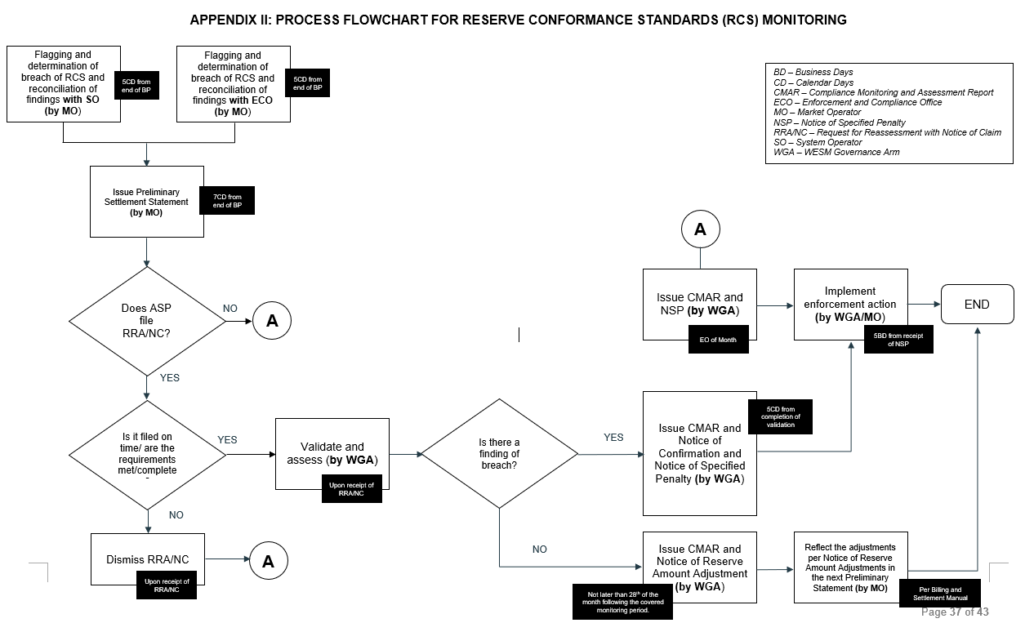
Appendix II (Proposed Amendment)
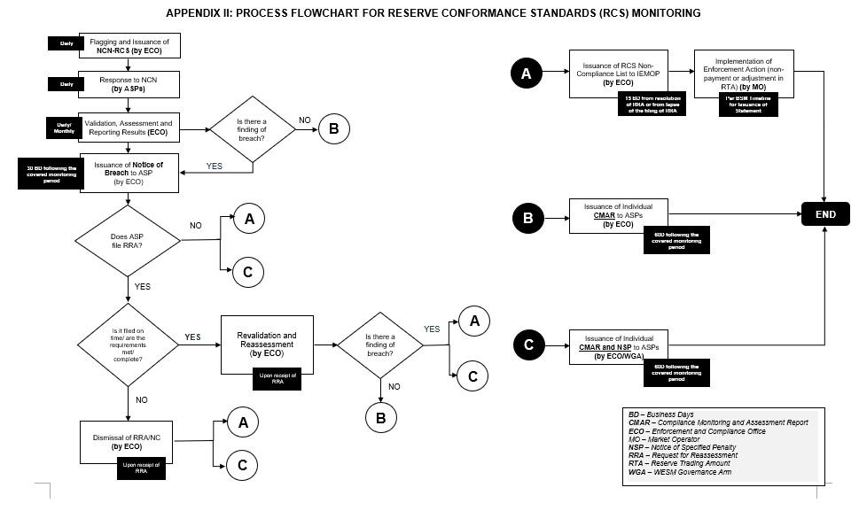

APPENDIX IV: Sample Illustration on the Monitoring of Compliance with Reserve Conformance Standards (RCS)

- Illustration depicting Sustainability for an Ancillary Service Facility with a Dispatchable Reserve (DR) Schedule
TIME_INTERVAL | TIME_INTERVAL | INSTRUCTION | MW_FROM | MW_TO | CATEGORY
01RESOURCE_G02 | 1/14/2024 17:21 | CUT - IN | 0 | 8 | DISPATCHABLE RESERVE
01RESOURCE_G02 | 1/14/2024 20:43 | CUT - OUT | 8 | 0 | DISPATCHABLE RESERVE
01RESOURCE_G01 | 1/15/2024 11:03 | ON LINE | 0 | 6 | DISPATCHABLE RESERVE
01RESOURCE_G01 | 1/15/2024 11:33 | INCREASE LOAD | 6 | 8 | DISPATCHABLE RESERVE
01RESOURCE_G01 | 1/15/2024 15:29 | CUT-OUT ASPA DISPATCH | 8 | 0 | DISPATCHABLE RESERVE
01RESOURCE_G02 | 1/15/2024 17:18 | ASPA DISPATCH | 0 | 8 | DISPATCHABLE RESERVE

Fig. 1.0 Table of Sample Dispatch Instruction Report with Active Instructions
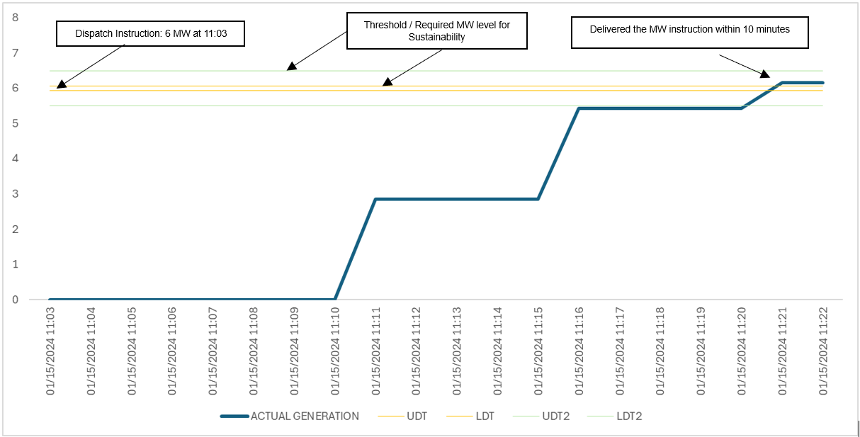
Fig. 2.0 Provision of DR instruction during synchronization

Observation:
- 01RESOURCE_G01 was offline prior to instruction (Status requirement: COMPLIANT)
- 01RESOURCE_G01 synchronized at 11:11 (within Interval 11:15) or 8 minutes after the instruction (Synchronization requirement: COMPLIANT)
- 01RESOURCE_G01 delivered the 6 MW instruction at 11:21 (within interval 11:25) or 10 minutes after synchronization (Sustainability requirement: COMPLIANT).
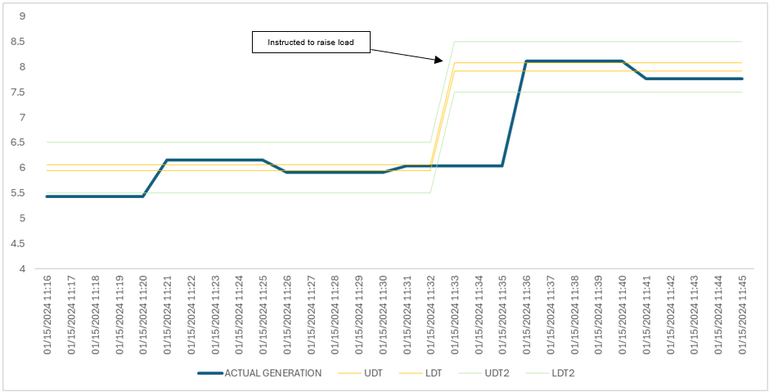
Fig. 3.0 Provision of DR instruction within Threshold as Sustainability Measure

Observation:
- 01RESOURCE_G01 was able to sustain active instruction from 11:25 to 11:30 (Sustainability requirement: COMPLIANT).
- 01RESOURCE_G01 received another instruction to raise load from 6 MW to 8 MW at 11:33 (within Interval 11:35); At 11:36 (within interval 11:40) 01RESOURCE_G01 delivered the 8 MW instruction. (Sustainability requirement: FOR FURTHER ASSESSMENT).
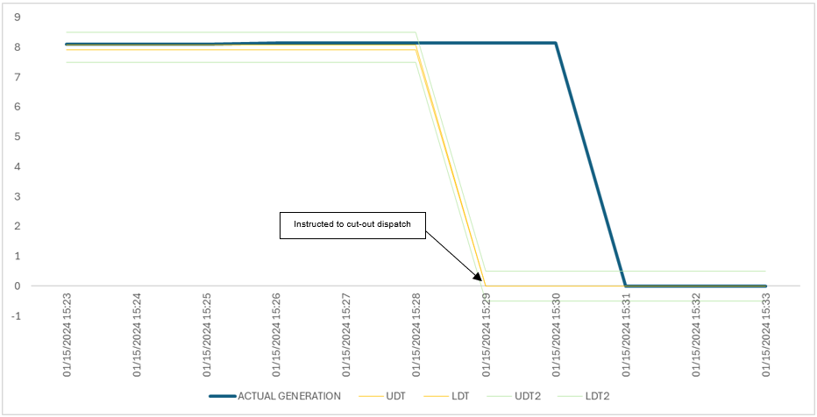
Fig. 4.0 Shutdown procedure after the provision of DR instruction

Observation:
- 01RESOURCE_G01 was able to sustain active instruction from 11:33 to 15:25 (Sustainability requirement: COMPLIANT).
- 01RESOURCE_G01 received another instruction at 15:29 to shut down; At 15:31, the unit was offline. (Sustainability requirement: FOR FURTHER ASSESSMENT).

- Illustration on the determination of Response Accuracy using Highest and Lowest Actual MW Output depending on the System Frequency Condition
Scenario 1: The System Frequency falls below the lower deadband threshold, the reserve facility needs to react by increasing generation to correct the frequency.

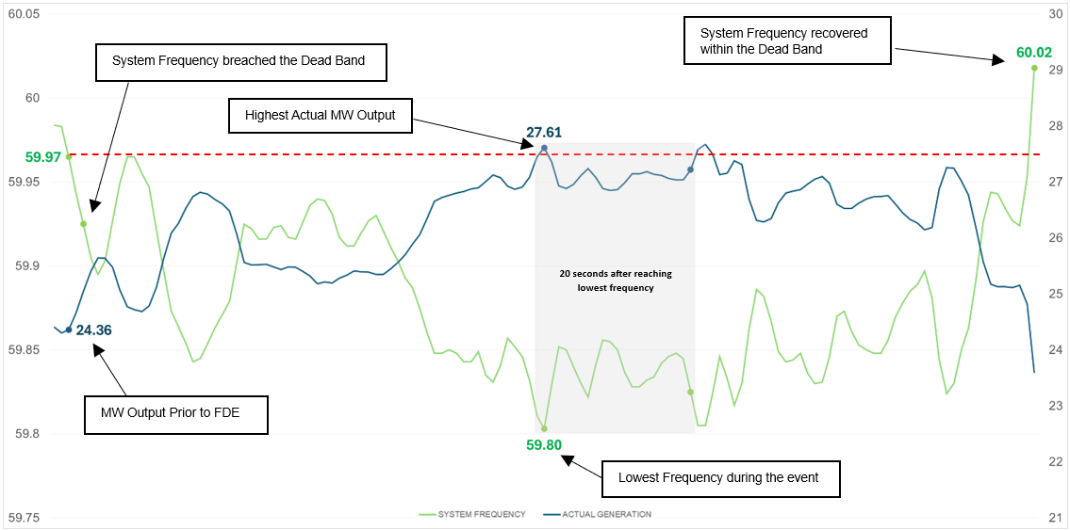
Fig 5.0 Sample Illustration when System Frequency breached lower Deadband

For example, the following are the reserve facility’s certified characteristics:
- Droop Setting: 4.5%
- Deadband Settings: 0.03 Hz
- Rated Capacity: 65.4 MW

Given:
- Highest Actual MW Output: 27.61 MW (within the 20-second period after the lowest frequency)
- MW Output Prior to FDE: 24.36 MW
- Lowest Frequency during FDE: 59.80 Hz

Computation:
Actual MW Response Capacity  = Highest Actual MW Output – MW Output Prior to Frequency-Driven Event  = 27.61 MW – 24.36 MW  = 3.25 MW  $$Static Gain$$  $$= \frac{Rated Capacity}{Droop Setting x Nominal Frequency}$$  $$= \frac{65.4 MW}{4.5 \% x 60 Hz} x 100\%$$  $$= 24.22 MW/Hz$$  Frequency Prior to Frequency-Driven Event  = Nominal Frequency + Deadband Setting  = 60 Hz - 0.03 Hz  = 59.97 Hz | Frequency Change  = Frequency Prior to Frequency-Driven Event - Lowest Frequency During Frequency-Driven Event  = 59.97 Hz – 59.80 Hz  = 0.17 Hz  Expected MW Response Capacity  = Static Gain $x$ Frequency Change  = 24.22 MW/Hz x 0.17 Hz  = 4.12 MW  $$Response Accuracy$$  $$= \frac{Actual MW Response Capacity}{Expected MW Response Capacity} x 100\%$$  $$= \frac{3.25 MW}{4.12 MW} x 100\%$$  $= 78.88 \%$ (NON-COMPLIANT)
Scenario 2: The System Frequency breaches the upper deadband threshold, the reserve facility needs to react by decreasing generation to correct the frequency.
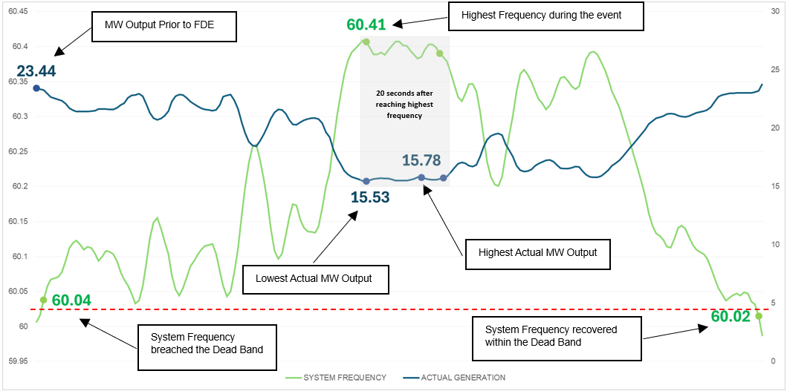
Fig 6.0 Sample Illustration when System Frequency breached Upper Deadband

For this example, the following are the reserve facility’s certified characteristics:
- Droop Setting: 4.5%
- Deadband Settings: 0.03 Hz
- Rated Capacity: 65.4 MW
Given:
- Highest Actual MW Output: 15.78 MW (within the 20-second period)
- Lowest Actual MW Output: 15.53 MW (within the 20-second period)
- MW Output Prior to FDE: 23.44 MW
- Highest Frequency during FDE: 60.41 Hz
Computation:
Actual MW Response Capacity  = Lowest Actual MW Output – MW Output Prior to Frequency-Driven Event  = 15.53 MW – 23.44 MW  = - 7.91 MW  $$Static Gain$$  $$= \frac{Rated Capacity}{Droop Setting x Nominal Frequency}$$  $$= \frac{65.4 MW}{4.5 \% x 60 Hz} x 100\%$$  $$= 24.22 MW/Hz$$  Frequency Prior to Frequency-Driven Event  = Nominal Frequency + Deadband Setting  = 60 Hz + 0.03 Hz  = 60.03 Hz | Frequency Change  = Frequency Prior to Frequency-Driven Event - Highest Frequency During Frequency-Driven Event  = 60.03 Hz - 60.41Hz  = -0.38 Hz  Expected MW Response Capacity  = Static Gain $x$ Frequency Change  = 24.22 MW/Hz x -0.38 Hz  = -9.20 MW  $$Response Accuracy$$  $$= \frac{Actual MW Response Capacity}{Expected MW Response Capacity} x 100\%$$  $$= \frac{- 7.91 MW}{-9.20 MW} x 100\%$$  $= 85.99\%$ (COMPLIANT)

- Illustration for the Capping the Expected MW Response Capacity to Reserve Schedule

In cases where the Expected MW Response Capacity exceeds the Reserve Schedule, the Expected MW Response shall be capped at the Reserve Schedule. The formula for Response Accuracy is as follows:

$$Response Accuracy= \frac{Actual MW Response Capacity}{Expected MW Response Capacity} x 100\%$$

The following values are examples to illustrate the scenario:

Certified Capacity | Reserve Schedule | Actual MW Response | Expected MW Response
30 | 10 | 25 | 50

As a result, the Response Accuracy will differ based on the said conditions:

Response Accuracy Calculation:

Response Accuracy % 1:
= (25 / 50) × 100 = 50% (NON-COMPLIANT)
Response Accuracy % 2: (Capping the Expected MW Response Capacity to Reserve Schedule)
= (25 / 10) × 100 = 250% (COMPLIANT)

Response Accuracy % 1 | Response Accuracy % 2
50% | 250%

- Illustration for the determination of Percentage (%) of Compliance of ASP on AGC
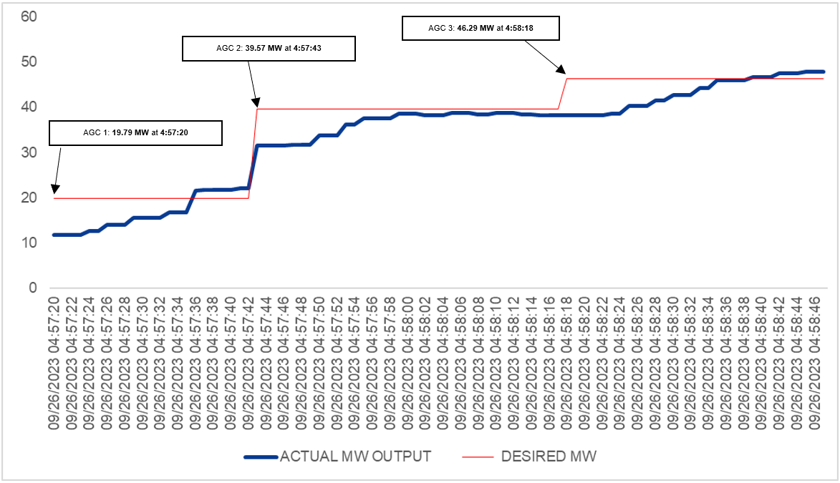
Fig 7.0 Sample series of AGC Commands

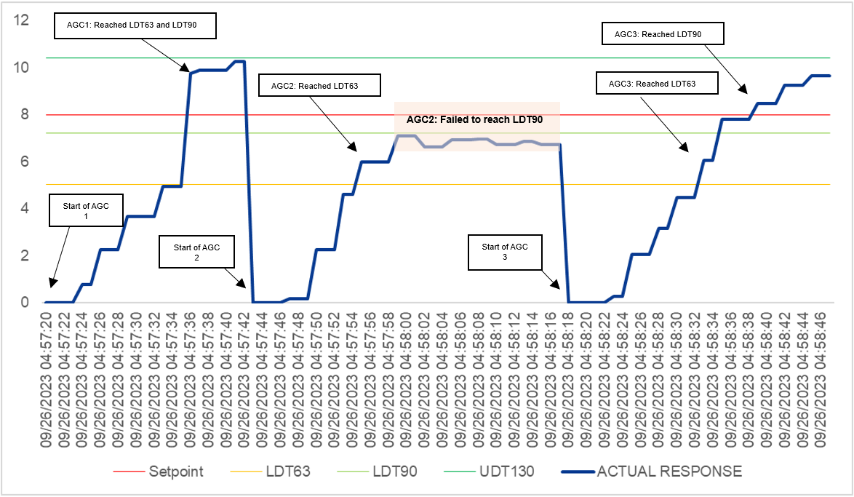
Fig 8.0 Equivalent Setpoint and Actual Response

Summary of illustration on Figure 8:
- AGC 1 LDT63 and LDT90 were reached within 16 seconds
- AGC 2 LDT63 reached within 12 seconds
- AGC 2 failed to reach LDT90
- AGC 3 LDT63 reached within 15 seconds
- AGC 3 LDT63 reached within 17 seconds
Since required levels of AGC Command 1 and AGC Command 3 have been reached within the required duration as stated in section 5.7, therefore, AGC Command 1 and AGC Command 3 are compliant

On the other hand, the generator failed to reach all the required levels of AGC Command 2, therefore, AGC Command 2 is non-compliant.

There is a total of 3 Commands in the above example

Total Commands = 3
Total Compliant Commands = 2

$$\% Compliance= \frac{No. of Compliant AGC Commands}{No. of AGC Commands} x 100 \%$$

$$\% Compliance= \frac{2}{3} x 100 \%$$$\% Compliance= 66.67 \%$ (NON COMPLIANT)

Mark-ups in black – proposed amendments approved in August 2024 (ORCP-WM-24-06); mark-ups in blue – proposed amendments approved in December 2024 (ORCP-WM-24-06B)

