ORCP-RGC-2020-11-001
Date Received by RGC: 26-Nov-2020

REQUEST FOR MARKET RULES AND MANUAL AMENDMENT

Proposals made only under this prescribed form shall be accepted and considered as submitted.

This request for amendments is being submitted to:

REM Governance Committee (RGC)
Attention: RGC Secretariat
Philippine Electricity Market Corporation
18/F Robinsons Equitable Tower
ADB Avenue, Ortigas Center
Pasig City, 1605 Philippines
Email addresses: cpc-sai@wesm.ph
Contact No: (+632) 8631-8734

Contents

1.0 PROPONENT’S INFORMATION 2
2.0 AMENDMENT INFORMATION 2
3.0 SUMMARY OF THE PROPOSED RULE CHANGE 3
4.0 BACKGROUND 3
5.0 THE PROPOSED RULE CHANGE 4
6.0 BACKGROUND AND DESCRIPTION OF TE PROPONENT 4
7.0 CONCLUSIONS AND RECOMMENDATIONS 4
8.0 REFERENCES 4
9.0 MATRIX OF PROPOSED AMENDMENT 5

PROPONENT’S INFORMATION

Name and Signature | ROGELYN T. RONQUILLO
Designation | Manager, Regulatory Affairs Department
Company | NATIONAL TRANSMISSION CORPORATION (TransCo)
Company Address | Power Center Quezon Ave. cor. BIR Rd., Diliman,
Company Address | Quezon City
Telephone No. | (02) 7902-1500
Fax. No.
Email Address | fitallcollection@transco.ph fitbilling@transco.ph

AMENDMENT INFORMATION

Proposed Amendments to the (please tick the box):
REM Rules
REM Market Manual: | [Title of the Manual and Issue No.]
Topic:

Proposed Classification of Amendments (please tick the box):
General Minor Urgent

If Urgent, reason for urgency: _____________________________________________________________

SUMMARY OF THE PROPOSED RULE CHANGE

The National Transmission Corporation (TransCo) as the FIT-All Fund Administrator proposes to revise REM Rules Clause 3.2.1.2, extending the FIT-All Fund Administrator’s timeline to provide ample time for the preparation and consolidation of reports submitted to the RE Registrar. Such revision likewise entails the necessary revision to the RE Registrar’s timeline for the REC Issuance under Clause 3.2.1.2 of the REM Rules.

BACKGROUND

Consistent with ERC issued clarificatory letter in December 2014 as to the implementation of the FIT-All, the timeline for the collection, remittance, and submission of reports relative to the FIT-All by the Collection Agents is shown below:

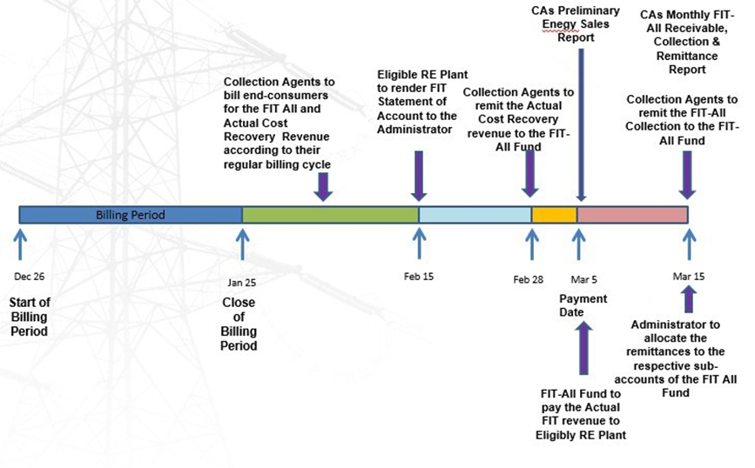

From the closing of the billing cycle up to the Collection Agents actual reporting and remittance to the FIT-All Fund (as shown above), the number of days required is already 50 days on the average.

THE PROPOSED RULE CHANGE

The National Transmission Corporation (TransCo), in its capacity as the FIT-All Fund Administrator, proposes to change Fifty (50) calendar days to Sixty Five (65) calendar days after the end of the WESM Billing Period to submit the data needed for FIT-Allocation. This is to provide ample time for the FIT-All Fund Administrator to prepare and consolidate actual reports from the Collection Agents.

To align with the TransCo’s revised timeline, it is also necessary to revise the RE Registrar’s timeline for the REC Issuance under Clause 3.2.1.2 of the REM Rules from Sixty (60) calendar days to Seventy-five (75) calendar days.

BACKGROUND AND DESCRIPTION OF TE PROPONENT

National Transmission Corporation (TransCo) is a government agency created under Republic Act No. 9136, otherwise known as the Electric Power Industry Reform Act (EPIRA) of 2001. TransCo has been tasked as the FIT-All Fund Administrator by virtue of ERC Resolution No. 15 series of 2012 issued in November 2012.

CONCLUSIONS AND RECOMMENDATIONS

The National Transmission Corporation (TransCo), in its capacity as the FIT-All Fund Administrator, recommends considering the proposed changes in the REM Rules.

REFERENCES

ERC Resolution No. 24 Series of 2013 entitled “A Resolution Adopting the Guidelines on the Collection of the Feed-In Tariff Allowance (FIT-All) and the Disbursement of the FIT-All Fund.

MATRIX OF PROPOSED AMENDMENT

  - REM RULES
- Title | - Clause | - Provision | - Proposed Amendment | - Rationale | - Comments | - Revised Wording Based on Comments Under “F”  Please follow the format below:  Original Provision Proposed Amendment | - Proponent’s Response | - RGC Decision
 |  |  |  |  | Please write your general comments here, if any.
3.2.1  Provision of Data to Enable FIT Allocation | 3.2.1.2 | “The FIT-All Fund Administrator shall submit to the Registrar the following data in respect of a WESM Billing Period no later than Fifty (50) calendar days after the end of the WESM Billing Period…” | “The FIT-All Fund Administrator shall submit to the Registrar the following data in respect of a WESM Billing Period no later than Fifty (50) Sixty-five (65) calendar days after the end of the WESM Billing Period…” | To provide ample time for the FIT-All Fund Administrator to prepare and consolidate the reportorial requirements
3.2.2  Allocation of FIT  Generation to Mandated Participants | 3.2.2.3 | The Registrar shall notify each On-Grid Mandated Participant of their Monthly FIT Generation Share and issue the corresponding RECs in respect of a WESM Billing Period no later than Sixty (60) calendar  days after the end of the WESM Billing Period. | The Registrar shall notify each On-Grid Mandated Participant of their Monthly FIT Generation Share and issue the corresponding RECs in respect of a WESM Billing Period no later than Sixty (60) Seventy-five (75) calendar days after the end of the WESM Billing Period. | To align with the proposed extension under Clause 3.2.1.2

  - REM MANUAL (INDICATE MANUAL TITLE AND ISSUE NUMBER)
Title | Clause | Provision | Proposed Amendment | Rationale
N/A | N/A | N/A | N/A | N/A

