
WESM WM (Manual) CN - ______

REQUEST FOR AMENDMENTS OR CHANGES TO THE WESM MANUALS

Proposals made only under this prescribed form shall be accepted and considered as submitted:

This request for amendments to the WESM Rules can be submitted to:

PEM Board
Attention: PEM Committee Secretariat
Philippine Electricity Market Corporation
18/F Robinsons Equitable Tower
ADB Avenue, Ortigas Center
Pasig City, 1605 Philippines
Email address: rcc@wesm.ph
Fax Number: (+632) 395-2704

- Proponent’s Information
Name | FRANCIS ALBERT S. VICENCIO
Designation | Senior Manager, Metering Services Division, OMMD /  WESM Compliance Officer
Company | National Grid Corporation of the Philippines
Company Address | Quezon Avenue corner BIR Road, Diliman, Quezon City
Telephone No. | +632-863-7166
Fax. No.
Email Address | fsvicencio@ngcp.ph

- WESM Manual Amendments Information
Title of WESM Manual being commented:
WESM MANUAL ON METERING STANDARDS AND PROCEDURES ISSUE NO. 12

Nature of Request (please indicate with x)
Addition Alteration Deletion Clarification Clerical Correction

- Proposed Amendment

Title | Section | Provision | Proposed Amendment | Rationale
Location of the Metering Point | 2.2 | The metering point shall be located at the market trading node and shall be in accordance with the WESM Rules, the Grid Code, and the Distribution Code, unless the installation of the metering equipment is physically difficult, uneconomical or not practical.  If the metering point is not located at the market trading node, an agreed site specific loss adjustment (SSLA) shall be applied to the meter data representing the energy consumed by the Customer at that metering point for determining the quantities to be settled in the WESM. | The location of the metering point shall adhere to the applicable provisions of the latest version of the WESM Rules, the Philippine Grid Code (PGC), the Philippine Distribution Code (PDC) and other relevant issuances of the Energy Regulatory Commission (ERC) and the Department of Energy (DOE).  The revenue metering point shall be located at the market trading node and shall be installed within 500 meters from the connection point between the systems of the Network Service Provider and Trading Participant.  If the installation of the metering equipment at the prescribed location is physically difficult, unsafe, uneconomical or impractical, the Trading Participant may request the approval of the Market Operator for exemption. In such case, an agreed Site-Specific Loss Adjustment (SSLA) shall be applied to the metering point metered energy data to determine the quantities to be settled in the WESM.  The metering point shall be located at the market trading node and shall be in accordance with the WESM Rules, the Grid Code, and the Distribution Code, unless the installation of the metering equipment is physically difficult, uneconomical or not practical.  If the metering point is not located at the market trading node, an agreed site specific loss adjustment (SSLA) shall be applied to the meter data representing the energy consumed by the Customer at that metering point for determining the quantities to be settled in the WESM. | - To include other relevant references such as ERC and DOE issuances.  - To be consistent with the amended definition of Market Trading Node prescribed in letters (c) and (d) of Section 1. Amendments to the WESM Rules under DOE Department Circular DC2018-05-0015, to wit,  “(c) Clause 3.2.2.1 under Market Trading Node is amended to read as -  3.2.2.1. A market trading node is designated point in the market network model where energy is bought or sold based on the prices determined by the market dispatch optimization model.  (d) Clause 3.2.2.2 under the Market Trading Node is amended to read as -  3.2.2.2 Each market trading node defined under Clause 3.2.2.1 shall  - Be assigned to a Trading Participant that intends to buy or sell energy and is capable of complying with the settlement requirements in the WESM  - Be associated with a revenue metering capable of measuring all relevant incoming and outgoing energy deliveries for the purpose of settlement in the WESM; and  - As much as possible, represent the connection point between the Network Service Provider and the Trading Participant. For this purpose, the revenue metering equipment for the market trading node shall be installed no more than 500 meters from the connection point.”  - To provide guidance with regard to installation constraints thru the derogation request and SSLA application
Meters | 2.4 | Requirements for Transmission Grid Revenue Meters  There shall be a main and a back-up revenue meter preferably of different brand (make and model). Meters installed as the main revenue meter and back-up meter shall adhere to the prevailing requirements of the Philippine Grid Code.  The current specifications are provided as Appendix L of this Manual.  Requirements for Revenue Meters for Embedded Generators Registered as WESM Participants  For Embedded Generators registered as WESM Participants, meters installed as the main revenue meter and back-up meter shall adhere to the prevailing requirements of the Philippine Grid Code.  The current specifications are provided as Appendix M of this Manual. | Requirements for Transmission Grid Revenue Meters  There shall be a main and a back-up revenue meter preferably of equivalent specifications different brand (make and model). Meters installed as the main revenue meter and back-up meter shall adhere to the prevailing requirements of the Philippine Grid Code PGC 2016 Edition.  In addition to the specifications as prescribed by the PGC 2016 Edition, the meter shall have a mass memory capable of recording the 5-minute required demand interval data for a period of at least 60 days and have communication ports for remote and manual data retrieval;  The current recommended specifications based on PGC 2016 Edition are provided as Appendix L of this Manual.  Requirements for Revenue Meters for Embedded Generators Registered as WESM Participants  For Embedded Generators registered as WESM Participants, meters installed as the main revenue meter and back-up meter shall adhere to the prevailing requirements of the Philippine Grid Code PDC 2017 Edition.  The current recommended specifications based on PDC 2017 Edition are provided as Appendix M of this Manual. | - To ensure that the specifications of the main and back-up meters are comparable which will not only support inter-operability of the two meters but will also guarantee that the back-up meter can readily serve as sufficient alternative or replacement to the main meter.  - To include provision for additional mass memory requirements  - To provide the exact version of PGC which served as basis for the specifications be provided in the Appendix L  - To be consistent with the following provision of DOE Advisory on Mandatory Registration to the WESM which prescribes that the PDC shall apply to embedded generators:  “3. Cooperate with their WESM MSP in ensuring that their metering installations, including revenue meters and instrument transformers, are installed in accordance with the specifications provided in applicable guidelines. Specifically:  - The PDC shall apply for Embedded Generators; and  - The PGC shall apply for Grid-Connected Generators.”  - To provide the exact version of PDC which served as basis for the specifications be provided in the Appendix M
Instrument Transformers | 2.5 | 2.5.1 General Requirements  Metering installations shall include instrument transformers. | 2.5.1 General Requirements  Metering installations, if applicable, shall include instrument transformers.  Requirements for Transmission Grid Instrument Transformers  Instrument Transformers used for metering of Transmission Grid Connections shall adhere to the prevailing requirements of the PGC 2016 Edition.  The recommended specifications based on PGC 2016 Edition are provided as Appendix N and Appendix O of this Manual.  Requirements for Embedded Generators Registered as WESM Participants  Instrument Transformers used for metering of Embedded Generators registered as WESM Participants shall adhere to the prevailing requirements of the Philippine Distribution Code.  The recommended specifications based on PDC 2017 Edition are provided as Appendix P and Appendix Q of this Manual. | - To consider metering installations which may not require instrument transformers  - To include additional provisions for Instrument Transformers used for metering of Transmission Customers and Embedded Generators Registered as WESM Participants  - To provide the exact versions of PGC and PDC which served as basis for the specifications be provided in the Appendices N, O, P and Q.
Instrument Transformers | 2.5 | Use of Instrument Transformers  Instrument transformers supplying the revenue meter shall be used solely for the purposes of revenue metering and not for any other purposes, including, but not limited to, the attachment of other devices.  The following schemes shall not be allowed:  - The use of an instrument transformer for meters other than the registered WESM Meters; and  - Paralleling of current transformers. | Use of Instrument Transformers  Instrument transformers supplying the revenue meter shall be used solely for the purposes of revenue metering and not for any other purposes, including, but not limited to, the attachment of other devices.  The following schemes shall not be allowed:  - The use of an instrument transformer for meters other than the registered WESM Meters except as permitted in this section; and  - Paralleling of current transformers.  The following scheme shall be temporarily permitted:  Meters covered by Energy Conversion Agreements (ECA) contracts which were already in effect prior to the operation of WESM shall be temporarily permitted to share the instrument transformers used by WESM metering until the end of the ECA cooperation period; provided that the ECA and WESM meters have separate meter enclosure/box and that the secondary terminals of the instrument transformers are properly sealed. | - To be consistent with PGC 2016 Edition 9.2.2.1 and the general guidelines in Section 2.5.2 which prescribes the exclusive use of instruments transformers for revenue metering purpose without limiting the use of instrument transformers to WESM registered meters.  (NGCP assumes that the intent of this provisions of PGC 2016 Edition and WESM Manual may have considered special cases such as metering for existing facilities covered by ECA contracts between PSALM and IPP)
Instrument Transformers | 2.5 | Selection of Current Transformer Ratios  Current transformer ratios shall be selected according to the following factors:  - The maximum sustained primary current in a current transformer shall not exceed the primary tap multiplied by the primary factor of the current transformer; and  - The minimum sustained primary current during normal operation shall not be less than 10% of the primary tap. | Selection of Current Transformer Ratios  Current transformer ratios shall be selected according to the following factors:  - The maximum sustained primary current in a current transformer shall not exceed the rated primary tap current multiplied by the primary current rating factor of the current transformer; and  - The minimum sustained primary current during normal operation shall not be less than 10% of the primary tap the lowest primary current that the current transformer can measure wherein the measurement accuracy is still guaranteed | - To be consistent with the terms used by ANSI and IEC standards  - To consider the improvements in measurement range of new designs of extended range current transformers which can already measure down to 1% of rated current at guaranteed accuracy
Instrument Transformers | 2.5 | 2.5.4.1. Current Transformers  Current transformers shall conform to the IEC 44-1 Class 0.2 or ANSI C57.13 Class 0.3 or better of any instrument transformer. | 2.5.4.1. Current Transformers  Current transformers for Generator or Load Customer Revenue Metering Facility shall conform to the IEC 44-1 Class 0.2 or ANSI C57.13 Class 0.3 or better of any instrument transformer following minimum requirements:  Notes: (1) Maximum Rated Burden  (2) Percent of Rated Burden wherein the accuracy class is guaranteed | - To be consistent with the provision of the PGC 2016 Edition  - To provide supplementary requirements for the burden range in which the CT accuracy class is required to be defined or guaranteed  - To provide the updated version of IEC Standard for Current Transformers
  Trading Participant | Accuracy Class |  | Rated Burden  (1) | Burden Range  (2)
  Trading Participant | ANSI C57.13 | IEC 61689 -  1 and 2 | Rated Burden  (1) | Burden Range  (2)
  Generator | 0.15 | 0.2s | 5VA | 0-100%
  Load | 0.3 | 0.2 | 5VA | 0-100%
Instrument Transformers | 2.5 | 2.5.4.2. Voltage Transformers  Voltage transformers shall conform to the IEC 6044-2 Class 0.2 or ANSI C57.13 Class 0.3 of any instrument transformer. | 2.5.4.2. Voltage Transformers  Voltage transformers for Generator or Load Customer Revenue Metering Facility shall conform to the IEC 6044-2 Class 0.2 or ANSI C57.13 Class 0.3 of any instrument transformer following minimum requirements:  Notes: (1) Maximum Rated Burden  (2) Percent of Rated Burden wherein the accuracy class is guaranteed | - To be consistent with the provision of the PGC 2016 Edition  - To provide supplementary requirements for the burden range in which the VT accuracy class is required to be defined or guaranteed  - To provide the updated version of IEC Standard for Voltage Transformers
  Trading Participant | Accuracy Class |  | Rated Burden  (1) | Burden Range  (2)
  Trading Participant | ANSI C57.13 | IEC 61689 -  1 and 3 | Rated Burden  (1) | Burden Range  (2)
  Generator | 0.15 | 0.2 | 75VA | 0-100%
  Load | 0.3 | 0.2 | 75VA | 0-100%
Instrument Transformers | 2.5 | Proof of Accuracy Compliance  Proof of compliance with Section 5.3.2 shall be provided in the form of factory test cards complete with serial numbers. | Proof of Accuracy Compliance  Proof of compliance with Sections 5.3.2 2.5.4.1 and 2.5.4.2 shall be provided in the form of factory routine test cards complete with reports showing the serial numbers of the instrument transformers. | - To refer to appropriate section of the WESM manual for amendment  - To be consistent with the terms used by ANSI and IEC standards
Instrument Transformers | 2.5 | 2.5.4.4. Other Requirements Relating to Accuracy  Where accuracy tests are required, they shall comply with the following requirements:  - tests shall be carried out by a third-party testing agency using equipment traceable to International Standards;  - tests shall be conducted with the suitable burdens connected to each current transformer;  - additional tests shall be conducted at other suitable burdens if the existing burden is expected to change in the future;  - tests shall include ratio and phase-angle error tests;  - ratio and phase-angle tests of current transformers shall be measured over a range of secondary current from 1% of rated primary current up to and including the maximum current as defined by the rating factor;  - test results shall provide correction factors to be applied to both active and reactive power at each test point | Other Requirements Relating to Accuracy  Where accuracy tests are required, they shall comply with the following requirements:  - tests shall be carried out by a third-party testing agency the Metering Service Provider using equipment traceable to National or International Standards of measurements;  b. tests shall be conducted with the suitable burdens connected to each current transformer;  c. additional tests shall be conducted at other suitable burdens if the existing burden is expected to change in the future;  db. tests shall include ratio and phase-angle error tests;  ec. ratio and phase-angle tests of current transformers shall be measured over a range of secondary current from 1% of rated primary current up to and including the maximum current as defined by the rating factor test currents based on the accuracy curve as defined by the applicable standards wherein the current transformer was designed;  fd. test results shall provide ratio correction factors at each test point which may be applied, if deemed necessary for WESM settlement, to both active and reactive power | - To define the responsibility of the MSP relative to maintenance of metering facility consistent with the definition of PGC 2016 Edition and following provisions of the DOE Department Circular DC2016-05-007:  “Section 1. Ownership and Accountability of Metering Installations in the WESM. In addition to the provision of the WESM Rules, Retail Rules, and Market Manuals, the Metering Services Provider (MSP) and Trading Participants shall adhere to the following guidelines:  - Irrespective of the ownership of the metering facilities, the designated MSP is responsible for the regular testing, calibration and maintenance of the Metering Installations, and shall ensure that the said requirements for Metering Installation are complied with;  - The relevant Trading Participant shall collaborate with the MSP on the conduct of the said testing, calibration, and maintenance, and shall allow the MSP to access the said Metering Installations at all times; and  - The MSP shall perform such regular testing, calibration and maintenance of the said Metering Installations subject to the metering charge to the relevant Trading Participant, provided that such charges shall be filed by the MSP with the Energy Regulatory Commission (ERC) for approval.  - To ensure that the equipment is being tested based on the standards wherein they were designed  - To provide option not to apply the correction factor when the measured errors are within acceptable limits consistent with the accuracy class wherein the equipment were designed
Instrument Transformers | 2.5 | 2.5.5.1. Burden Calculation – All Current Transformers  The burden calculation for a current transformer shall include:  - the impedance of the secondary wiring;  - the impedance of all devices connected to the current transformer;  - the apparent impedance associated with the interconnection of current transformer secondaries;  - the apparent impedance associated with the sharing of a common current path through a measuring device with another current transformer;  - the apparent impedance associated with the sharing of an approved common-return conductor;  - the apparent impedance associated with the impedance of any other current transformer(s) connected in parallel with subject instrument transformer;  - burden under balanced power system conditions; and  - worst-case unbalance, including single-phase power | 2.5.5.1. Burden Calculation Measurement – All Current Transformers  The actual connected burden calculation for a current transformer shall include be measured using a CT burden measuring instrument. If manual calculation will be employed, the calculation shall consider the following:  - the impedance of the secondary wiring;  - the impedance of all devices connected to the current transformer;  c. the apparent impedance associated with the interconnection of current transformer secondaries;  d. the apparent impedance associated with the sharing of a common current path through a measuring device with another current transformer;  e. the apparent impedance associated with the sharing of an approved common-return conductor;  f. the apparent impedance associated with the impedance of any other current transformer(s) connected in parallel with subject instrument transformer;  g. burden under balanced power system conditions; and  h. worst-case unbalance, including single-phase power | - To recommend an alternative and easier method in determining the connected burden using test equipment  - Items c-h are recommended for deletion as most of the conditions are no longer present in existing metering facilities i.e., common return conductor, parallel connected CT etc. Also, for consistency with Section 2.7.3.7. of this WESM Manual prescribing separate conductors for each secondary terminal of each instrument transformer
Instrument Transformers | 2.5 | 2.5.5.2. Not to Exceed Nameplate Ratings  The measurement of calculation sshall verify that actual burdens in service do not exceed the nameplate rated burden limits for the IEC 44-1 Class 0.2 or ANSI C57.13 Class 0.3 of any instrument transformer. | 2.5.5.2. Not to Exceed Nameplate Ratings  The measurement of calculation sshall verify that actual burdens in service do not exceed the nameplate rated burden limits for the IEC 44-1 Class 0.2 or ANSI C57.13 Class 0.3 of any instrument transformer specified under Section 2.5.4.1. | - To refer the appropriate section of the WESM manual for amendment
Instrument Transformers | 2.5 | 2.5.5.3. Burden Calculations – All Voltage Transformers  The burden calculation for a voltage transformer shall include the apparent power and power factor at the secondary terminals of the instrument transformer. | 2.5.5.3. Burden Calculations Measurement – All Voltage Transformers  The actual connected burden calculation for a voltage transformer shall include the be measured using a VT burden measuring instrument. If manual calculation will be employed, the calculation shall consider the following:  - the apparent power and power factor at the secondary terminals of the instrument transformers. | - To have an alternative and easier option in determining the connected burden using test equipment
Instrument Transformers | 2.5 | 2.5.5.4. Not to Exceed Nameplate Ratings  The measurement of calculation shall verify that actual burdens in service do not exceed the nameplate rated burden limits for IEC 6044-2 Class 0.2 or ANSI C57.13 Class 0.3 of any instrument transformer. | 2.5.5.4. Not to Exceed Nameplate Ratings  The measurement of calculation shall verify that actual burdens in service do not exceed the nameplate rated burden limits for IEC 6044-2 Class 0.2 or ANSI C57.13 Class 0.3 of any instrument transformer specified under Section 2.5.4.1. | - To refer the appropriate section of the WESM manual for amendment
Instrument Transformers | 2.5 | 2.5.6. General Requirements for Grounding System  2.5.6.1. The installation shall be in accordance but not limited to the following provisions of the Philippine Electrical Code:  a. …  b. …  c. …  d. …  e. …  f. The minimum size of copper conductor to be used for metering grounding shall be 8 mm2.  g. Connections to all bonded parts shall be made in accordance to Article 2.50.1.8 of the Philippine Electrical Code 2009 Part 1. | 2.5.6. General Requirements for Grounding System  2.5.6.1. The installation shall be in accordance but not limited to the following provisions of the Philippine Electrical Code:  a. …  b. …  c. …  d. …  e. …  f. For voltage level 69kV and higher, the minimum size of copper conductor to be used for metering instrument transformer grounding shall be 8 125 mm2.  g. For voltage lower than 69kV the minimum size of copper conductor to be used for metering instrument transformer grounding shall be 70 mm2.  h. The minimum size of copper conductor to be used for the secondary circuits of instrument transformers shall be 3.5mm2.  gi. Connections to all bonded parts shall be made in accordance to Article 2.50.1.8 of the Philippine Electrical Code 2009 Part 1. | - To provide clarity on the application of the requirements for minimum size of equipment grounding.  (The selected values were based on the prescribed minimum size in the Philippine Electrical Code. PEC in no case requires the equipment grounding conductor to be larger than the circuit conductors supplying the equipment)
Instrument Transformers | 2.5 | 2.5.7. Current Transformer Requirements  Current Transformers installed as the main metering shall adhere to the prevailing requirements of the Philippine Grid Code.  The current specifications are provided as Appendix N of this Manual. | 2.5.7. Current Transformer Requirements  Current Transformers installed as the main metering shall adhere to the prevailing requirements of the Philippine Grid Code.  The current specifications are provided as Appendix N of this Manual. | - The revision is being proposed since it will be replaced by additional provision under Section 2.5.1.1
Instrument Transformers | 2.5 | 2.5.8. Voltage Transformer Requirements  Voltage Transformers installed as the main metering shall adhere to the prevailing requirements of the Philippine Grid Code.  The current specifications are provided as Appendix O of this Manual. | 2.5.8. Voltage Transformer Requirements  Voltage Transformers installed as the main metering shall adhere to the prevailing requirements of the Philippine Grid Code.  The current specifications are provided as Appendix O of this Manual. | - The revision is being proposed since it will be replaced by additional provision under Section 2.5.1.1
Instrument Transformers | 2.5 | 2.5.9. Surge Arrester  2.5.9.1. Surge Arresters installed (if necessary) at the main metering, shall meet the minimum requirements listed below:  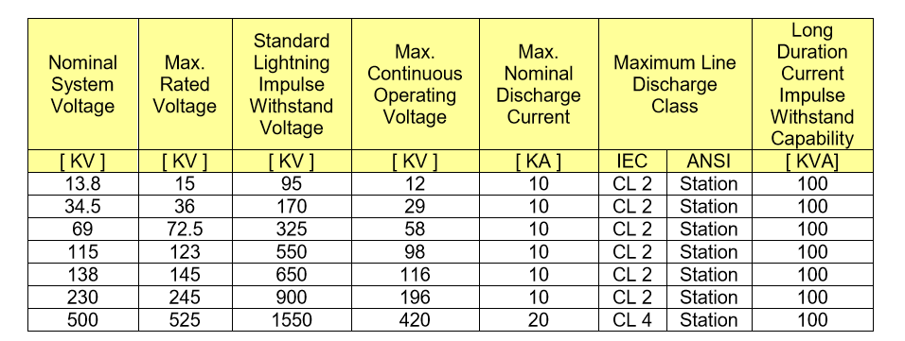 | 2.5.9. Surge Arrester  2.5.9.1. Surge Arresters installed (if necessary) at the WESM metering installation, shall meet the minimum requirements listed below:  If there are already existing Surge Arresters in the facility where the Metering Installation is located which already provides the protection as required by this WESM Manual, installation of additional metering Surge Arresters is no longer necessary. | - To clarify that the requirements applies to WESM Metering in general  - To clarify that there is no more need for redundant Surge Arresters for the metering facility if there are already Surge Arresters in the facility which can provide the same required protection
Primary Connections | 2.6 | 2.6.1. Location of Primary Terminals of Current Transformer  The primary terminals of each current transformer shall be located as close as practicable to the Metering Point. | 2.6.1. Location of Primary Terminals of Current Transformer  The primary terminals of each current transformer shall be located as close as practicable to the prescribed Connection Metering Point. | - To designate the prescribed connection point of the metered facility as reference
Primary Connections | 2.6 | 2.6.2. Location of Primary Terminals of Voltage Transformer  The primary terminals of each voltage transformer shall be located as close as practicable to the Metering Point. | 2.6.2. Location of Primary Terminals of Voltage Transformer  The primary terminals of each voltage transformer shall be located as close as practicable to the prescribed Connection Metering Point. | - To designate the prescribed connection point of the metered facility as reference
Secondary Connections for Instrument Transformers | 2.7 | 2.7.1.1. Size of Secondary Cabling  The secondary cabling between the current transformers and the meter test switch/block shall be of a sufficient size that the rated burden for the IEC 0.2 or ANSI 0.3 accuracy class is not exceeded when current, equivalent to the rated current, flows in the secondary winding. | 2.7.1.1. Size of Secondary Cabling  The secondary cabling between the current transformers and the meter test switch/block shall be of a sufficient size that the rated burden for the IEC 0.2 or ANSI 0.3 specified in Sec. 2.5.4.1 accuracy class is not exceeded when current, equivalent to the rated current, flows in the secondary winding. | - The revision is being proposed to refer appropriate section of the WESM manual for amendment
Secondary Connections for Instrument Transformers | 2.7 | 2.7.3. Codes and Conditions  Instrument transformer secondary cabling and cabling accessories shall comply with the following codes and conditions:  2.7.3.1. the Philippine Electrical Code;  2.7.3.2. the main meter shall be supplied from dedicated current transformers used for no other purpose;  2.7.3.3. voltage transformers with one secondary winding shall be dedicated to the main metering and used for no other purpose;  2.7.3.4. voltage transformers with more than one secondary winding shall have one winding dedicated to the main metering and shall be used for no other purpose;  2.7.3.5. electrical connection to the instrument transformer secondary terminals shall not be outside of the meter box;  2.7.3.6. cabling from the instrument transformers to the meter enclosure shall be routed in dedicated conduit, and the route shall be visually traceable; and  2.7.3.7. each secondary terminal of each instrument transformer shall be brought to the test block on a separate conductor. | 2.7.3. Codes and Conditions  Instrument transformer secondary cabling and cabling accessories shall comply with the following codes and conditions:  2.7.3.1. the Philippine Electrical Code;  2.7.3.2. the main revenue meters shall be supplied from provided with dedicated current and voltage transformers used for no purpose other than WESM Metering, except as permitted in Section 2.5.2;  2.7.3.3. voltage transformers with one secondary winding shall be dedicated to the main metering and used for no other purpose;  2.7.3.4. voltage transformers with more than one secondary winding shall have one winding dedicated to the main metering and shall be used for no other purpose;  2.7.3.3 current transformers may be supplied with more than one secondary core. However, no secondary core other than those intended for metering may be provided;  2.7.3.4. voltage transformer may be supplied with more than one secondary windings intended for the revenue meters and used for no other purpose;  2.7.3.5. electrical connection to the instrument transformer secondary terminals shall not be outside of the meter box;  2.7.3.6. cabling from the instrument transformers to the meter enclosure shall be routed in dedicated conduit, and the route shall be visually traceable; and  2.7.3.7. each secondary terminal of each instrument transformer shall be brought to the test block on a separate conductor. | - To be consistent with the provision of this WESM Manual that a core of a current transformer and a winding of a voltage transformer may be shared by the WESM registered main and back-up meters as the minimum requirements for redundancy. (Sections 2.7.3.3 and 2.7.3.4 for deletion of Issue 12.0)  - To recommend that all cores available shall be metering cores to avoid unnecessary inclusion of non-metering cores i.e., protection cores and for consistency with PGC 2016 GRM 9.2.3.2 d
Security of Metering Installation and Data | 2.9 | 2.9.1.1.Instrument transformers connections  Secondary cabling shall be secure, tamper-resistant and compliant with the PGC requirements on security of registered revenue metering Installations and metering data. | 2.9.1.1. Instrument transformers connections  Primary and secondary cablings and connections shall be secure, tamper-resistant and compliant with the PGC requirements on security of registered revenue metering Installations and metering data. Any ratio-tap changing facility which cannot be secured using security seal or its equivalent shall not be permitted | - To include primary terminals in the security provision.  - To emphasize the need for securing the ratio tap changing facility with security seals or equivalent
Security of Metering Installation and Data | 2.9 | 2.9.1.7. Metering Perimeter  The Metering Installation shall be secured by a perimeter fence similar to Figure 7 if applicable and its gate properly padlocked, sealed and secured. Metering perimeter shall also be well lighted and free from any unwanted materials, equipment, vegetation, etc. (refer Table 7) | 2.9.1.7. Metering Perimeter  The Metering Installation shall be secured by a perimeter fence similar to Figure 7 if applicable and its gate properly padlocked, sealed and secured. If the Metering Installation is located inside a perimeter which already provides equivalent security as required by this WESM Manual, installation of additional perimeter fence is no longer necessary.  Metering perimeter shall also be well lighted and free from any unwanted materials, equipment, vegetation, etc. (refer Table 7) | - To clarify that there is no more need for redundant perimeter fence dedicated for the metering facility if it is located in a property which already provides the required protection such as inside MSP or TP owned substations
Redundant Metering Installation | 2.10 | 2.10.1. A redundant Metering Installation can be achieved in one of two ways:  - Dual metering using two independent sets of instrument transformers approved by the Market Operator, where the main instrument transformers are connected to the main meter, the alternate instrument transformers are connected to the alternate meter; or  - Partial redundant metering using a single set of instrument transformers approved by the Market Operator where both the main and alternate meters are connected to either common or separate core  2.10.2. The minimum requirement is partial redundant metering using a single set of instrument transformers where the main and back-up meters are in series or in parallel and connected to a common core.  2.10.3. The metering data recorded by the main and back-up Meters must not deviate by more than 0.6% of the monthly average values recorded by the meters for three (3) consecutive billing periods. In the event that the deviation exceeds this value, the MSP must investigate and correct the causes of such deviations not later than three (3) months from discovery. | 2.10.1 A redundant Metering Installation can be achieved using a single set of instrument transformers approved by the Market Operator where the main and alternate meters are connected to either common or separate core. in one of two ways:  - Dual metering using two independent sets of instrument transformers approved by the Market Operator, where the main instrument transformers are connected to the main meter, the alternate instrument transformers are connected to the alternate meter; or  - Partial redundant metering using a single set of instrument transformers approved by the Market Operator where both the main and alternate meters are connected to either common or separate core  2.10.2. The minimum requirement is partial for redundant metering is using a single set of instrument transformers wherein the main and back-up meters are in series-parallel and connected to a common core.  2.10.3. The metering metered energy (kWH) and demand (kW) data recorded by the main and back-up Meters must not deviate by more than 0.6% of the monthly average values recorded by the meters for three (3) consecutive billing periods. In the event that the deviation exceeds this value, the MSP must investigate and correct the causes of such deviations not later than three (3) months from discovery. | - To recommend the deletion of the provision for Dual Metering wherein two independent sets of instrument transformers are required due to high capital investment requirements (i.e. equipment, space). The existing partial redundant metering implemented in practically all WESM metering facilities has been proven sufficient in providing the requirements for redundancy.  - To provide specific parameters for comparison i.e. KW and KWH
Metering Installation - Existing | 2.11 | An existing Metering Installation that does not fully comply with the requirement of this standard will be permitted by the Market Operator to remain in service subject to the following conditions:  - The meter shall have a mass memory capable of recording the 5-minute required demand interval data for a period of at least 60 days and have communication ports for remote and manual data retrieval;  - ERC has tested/verified and sealed the meter;  - All non-compliant meters shall be replaced within six (6) months from the effectivity of registration in the WESM;  - All non-compliant instrument transformers shall be replaced within the period of two (2) years from the effectivity of registration in the WESM.  Continued non-compliance of metering installations shall be subject to sanctions or penalties. | An existing Metering Installation that does not fully comply with the requirement of this standard will be permitted by the Market Operator to remain in service subject to the following conditions:  a. The meter shall have a mass memory capable of recording the 5-minute required demand interval data for a period of at least 60 days and have communication ports for remote and manual data retrieval;  ba. ERC has tested/verified and sealed the meter;  cb. All non-compliant meters to Section 2.4 of this manual, unless the only non-compliance is the mass memory requirements, shall be replaced within six (6) months from the effectivity of this version of WESM Manual on Metering;  c. Existing meters which are non-compliant to the mass memory requirements shall be permitted to remain in service until they become defective or until they reach the end of their economic life.  d. All existing non-compliant instrument transformers shall be replaced within the period of two (2) years from the effectivity of this version of WESM Manual on Metering.  Continued non-compliance of metering installations shall be subject to sanctions or penalties. | - To recommend deletion of section 2.11a which is being recommended for transfer to section 2.4  - To insert a provision allowing a different transitory period for replacement of meters wherein the non-compliance is only related to mass memory in consideration of the large capital investments for the metering equipment
Site Equipment Identification | Section 3 | Section 3 Site Equipment Identification (SEIN) | Section 3. Site Equipment Identification Label (SEILN) | - To change SEIN to SEIL, in all affected clause, as standard term for labelling Metering equipment, where L stands for Label. N stands for Number
Site Equipment Identification | 3.2 | General Procedures  The assignment of the Site Equipment Identification Number (SEIN) shall be done by the Metering Service Provider. For embedded generators and load customers to be registered in the WESM, the responsibility to assign the SEIN is with the Market Operator. | General Procedures  The assignment of the Site Equipment Identification Label Number (SEILN), in general, shall be done by the Metering Service Provider. However, for embedded generators and load customers to be registered in the WESM, with the concerned DU as their MSP, the responsibility to assign the SEILN is with the Market Operator. | - To clarify responsibility in the assignment of SEIL.  - To recommend the use of SEIL instead of SEIN
Requirements for Registration of Metering Installations | 4.3 | 4.3.2. To initiate the registration of a metering installation, the WESM Metering Services Provider, on behalf of its Trading Participant, shall submit the following to the Market Operator:  a. Accomplished Metering Installation Form signed by both the Metering Service Provider and the Trading Participant;  b. …  c. …  d. …  e. …  f. …  g. …  h. …  i. …  j. …  k. …  l. …  Note: All drawings, plans, wiring diagrams shall be signed by a Professional Electrical Engineer (PEE). | 4.3.2. To initiate the registration of a metering installation, the WESM Metering Services Provider, on behalf of its Trading Participant, shall submit the following to the Market Operator:  - Accomplished Metering Installation Form signed by both the MSP and the Trading Participant, or;  b. Registration of metering installation by the MSP confirmed by the Trading Participant through Central Registration and Settlement System (CRSS) of the Market Operator  c. …  d. …  e. …  f. …  g. …  h. …  i. …  j. …  k. …  l. …  Note: All drawings, plans, wiring diagrams shall be signed by a Professional Electrical Engineer (PEE). | - To harmonize with the new procedure of the Market Operator in the registration of metering installation thru CRSS  - Signed Metering Installation Registration Form is no longer required in the CRSS since confirmation of the details of metering information by the Trading Participant is performed online  - To delete the requirements for PEE to sign drawing, plans and wiring diagrams as the required Diagrams for WESM Registration are merely documentations of what has already been implemented.  No design calculations are included in the registration documents which require the review and signature of a PEE.
Requirements for Registration of Metering Installations | 4.3 |  | 4.3.5. All requests of the Trading Participant for clarifications and/or reconsideration concerning the approval of registration of metering facility shall be addressed to the Market Operator for resolution. | - To provide additional provision to clarify the roles of the MSP and MO in the registration of a metering facility to the WESM  While the Metering Service Provider is responsible for the assessment and certification of readiness of a WESM Metering Facility, the approval of registration is within the jurisdiction and function of the Market Operator.
Procedural steps for Registration of Metering Installation | 4.5 | Task Detail  Submit the application form with the following documents: Electrical Diagram, Metering Installation Specification and Documents, Metering point Locations, Drawings, Load (Demand) Forecast of Metering Installation, Transformer Data, Agreement between MSP and TP (if any), Pictures of the Installation, Payment of Application Fee (submittals shall be signed by a PEE) | Task Detail  Submit the application form with the following documents: Electrical Diagram, Metering Installation Specification and Documents, Metering point Locations, Drawings, Load (Demand) Forecast of Metering Installation, Transformer Data, Agreement between MSP and TP (if any), Pictures of the Installation, Payment of Application Fee (submittals shall be signed by a PEE). | - To exclude the requirements for PEE to sign submittals as the required Diagrams for WESM Registration are merely documentations of what has already been implemented i.e., the as built drawings.  No design calculations are included in the registration documents which require the review and signature of a PEE.
Collection and Submission Procedure | 5.3.1 | Requirements  - Data  The metering data shall contain the following:  - …  - The metering data in kWh (Active Energy), kvarh (reactive energy), voltage per phase and current per phase in their assigned channel  - …  - Resolution (every 15 minute) | Requirements  - Data  The metering data shall contain the following:  - …  - The metering data in kWh (Active Energy), kvarh (reactive energy), voltage per phase and current per phase in their assigned channel (for daily meter data delivery)  - …  - Resolution (every 15 minute) | - To clarify that the provision in item ii applies to the daily meter data delivery only.  - To be consistent with the DC No. 2017-05-0009 section 4.5, 4.6 & 5.1 on the implementation of the 5-minute interval resolution of the meter which was mandated by the DOE.
Collection and Submission Procedure | 5.3.2 | Daily Process  - All collected meter data shall be submitted by the Metering Services Provider to the Market Operator's Meter Data Warehouse starting 0400H until 0800H of the succeeding trading day. The Metering Services Provider shall not make, cause or allow any alteration to the original stored meter data as retrieved in the metering installation | Daily Process  - All collected meter data shall be submitted by the Metering Services Provider to the Market Operator's Meter Data Warehouse starting 0400H until to 0800H of the succeeding trading day. However, for MPs with failed communication, MSP can attempt for remote meter data retrieval and submit to the MO not later than 1600H of the same day. The Metering Services Provider shall not make, cause or allow any alteration to the original stored meter data as retrieved in the metering installation | - To consider that if no meter data received by 0800H due to external factors, i.e. TELCO problem which is beyond the control of the MSP, MO shall consider the initial submission of meter data at 12NN and final submission of data up to 4pm.
Collection and Submission Procedure | 5.3.3 | Monthly Process  - Not later than three (3) business days after the end of the billing period, the Metering Services Provider shall submit, via a compact disk, monthly preliminary metering data of all metering points of its associated Trading Participants. In addition, Metering Services Provider shall submit a transmittal letter that includes a tabulation of all associated metering points and their corresponding total metered quantity for the billing period. The Metering Services Provider shall also report to the Market Operator all discrepancies between the monthly metering data and the daily metering data values with justifications for the discrepancies  b. …  - Not later than two (2) business days after the issuance of the Meter Trouble Report, the Metering Services Provider shall correct the metering data in accordance with the procedures set forth in Section 6.4.3 of this Manual. | Monthly Process  - Not later than three (3) business days after the end of the billing period, the Metering Services Provider shall submit, via a compact disk Digital Video Disk (DVD) or File Transfer Protocol (FTP), monthly preliminary metering data of all metering points of its associated Trading Participants. In addition, Metering Services Provider shall submit a transmittal letter that includes a tabulation of all associated metering points and their corresponding total metered quantity for the billing period. The Metering Services Provider shall also report to the Market Operator all discrepancies between the monthly metering data and the daily metering data values with justifications for the discrepancies  - …..  - Not later than two (2) business ten (10) calendar days after the issuance of the Meter Trouble Report, the Metering Services Provider shall correct the metering data in accordance with the procedures set forth in Section 6.4.3 of this Manual. | - To change the compact disk to digital video disk (DVD) since CD is no longer widely available in the market today.  - To recommend the submission of data can also be through File Transfer Protocol (FTP).  - To recommend the deletion of this provision since the daily MTR is sufficient to comply with the required report on discrepancies between the monthly and daily metering data values.  - To recommend the change after the issuance of MTR from two (2) days to 10 days since the correction of meter data of the affected Metering Point/s needs ample time for investigation, inspection and troubleshooting considering also the geographical location of the MPs in the remote and critical area/s.
VEE – Essential Indicators | 6.4.3 | Meter Data Estimation and Editing  - When validation indicates that the data from the main meter are missing or have an invalid data, the values shall be estimated and substituted by the Metering Services Provider for Settlement purposes.  The following shall be hierarchy of methods to be used by the Metering Services Provider for meter data estimation and editing:  - …  - Meter Data from Back-up Meter  If more than four (4) intervals of main meter are missing or have invalid data, the values from the back-up meter may directly be substituted to the main meter provided that the data passed the validation based on the checks performed on Section 6.3.1.2. If the average deviation between the main and back-up meter is greater than 0.2% but not to exceed 0.6%, a correction factor shall be applied.  - Use of Average Phase Voltage or Average Phase Current  If there is a loss of a phase current or phase voltage, the estimation shall be computed by the Metering Services Provider, in coordination with the Market Operator and concerned Trading Participant, in accordance with the following formula:  𝑇𝑜𝑡𝑎𝑙 𝑃𝑜𝑤𝑒𝑟 = [(𝑉_{𝑎𝑛} ∗ 𝐼_{𝑎}) + (𝑉_{𝑏𝑛} ∗ 𝐼_{𝑏}) + (𝑉_{𝑐𝑛} ∗ 𝐼_{𝑐})] ∗ cos 𝜃 ∗ 𝑀  where:  𝐼_{𝑎} - computed phase A  𝐼_{𝑏}, 𝐼_{𝑐 -} actual recorded per phase current  𝑉_{𝑎𝑛}, 𝑉_{𝑏𝑛}, 𝑉_{𝑐𝑛} - actual recorded per phase voltage  cos 𝜃 - average power factor  𝑀 - multiplier | Meter Data Estimation and Editing  - When validation indicates that the data from the main meter are missing or have an invalid data, the values shall be estimated and substituted by the Metering Services Provider for Settlement purposes.  The following shall be hierarchy of methods to be used by the Metering Services Provider for meter data estimation and editing:  - …  - Meter Data from Back-up Meter  If more than four (4) twelve (12) intervals of main meter are missing or have invalid data, the values from the back-up meter may directly be substituted to the main meter provided that the data passed the validation based on the checks performed on Section 6.3.1.2. If the average deviation between the main and back-up meter is greater than 0.2% but not to exceed 0.6%, a correction factor shall be applied.  - Use of Average Computed Phase Voltage and or Average Phase Current using % Phase Voltage or % Phase Current method  If there is a loss of a phase current or phase voltage, the estimation shall be computed by the Metering Services Provider, in coordination with the Market Operator and concerned Trading Participant, in accordance with the following formula:  𝑇𝑜𝑡𝑎𝑙 𝑃𝑜𝑤𝑒𝑟 = [(𝑉_{𝑎𝑛} ∗ 𝐼_{𝑎}) + (𝑉_{𝑏𝑛} ∗ 𝐼_{𝑏}) + (𝑉_{𝑐𝑛} ∗ 𝐼_{𝑐})] ∗ cos 𝜃 ∗ 𝑀  Missing Ia:  % Ia = Ia / (Ia + Ib + Ic)  Total % Ia = sum of % Ia of all intervals  Average % Ia = Total %Ia / No. of intervals  Note:  Computation is the same with other phases.  Missing Van:  % Van = Van / Van + Vbn + Vcn)  Total % Van = sum of % Van of all intervals  Average % Van = Total %Van / No. of intervals  Note:  Computation is the same with other phases.  where:  𝐼_{𝑎} - computed phase A  𝐼_{𝑏}, 𝐼_{𝑐 -} actual recorded per phase current  𝑉_{𝑎𝑛}, 𝑉_{𝑏𝑛}, 𝑉_{𝑐𝑛} - actual recorded per phase voltage  cos 𝜃 - average power factor  𝑀 - multiplier  Additional to the Hierarchy of methods to be used by MSP for meter data estimation and substitution:  - i. Parallel lines  6.4.3 j. Temporary Use of correction factor In multiplier for Instrument Transformer in service that failed in accuracy limit. Final corrective action is replacement. | - To clarify that this is only applicable to the 15-minute programming. With the planned implementation of the 5-minute programming, the four (4) intervals of main meter shall now become 12 intervals.  - To recommend the use of % phase voltage or % phase current method which is more realistic in determining the computed phase voltage or phase current. It is the actual value per data interval of good data.  - To document the current practice of WESM MSP on the estimation and substitution of meter data with defects.  For parallel lines, hierarchy from a, to c should be done first.
Meter Trouble Report | 7.2 | Initiation  A Meter Trouble Report may be initiated due to the following:  a….  b……  - Improving Efficiency in Resolving MTRs  In case of outages, a Trading Participant and/or its Metering Services Provider shall notify the Market Operator within 24 hours after its occurrence. Trading Participants may use the Metering Outages Form to notify their Metering Services Provider and the Market Operator of any outages that may affect the metering data. The Metering Services Provider will use this information to resolve MTRs that have been issued. A sample of the form and instructions for completion may be found in the Appendices. | Initiation  A Meter Trouble Report may be initiated due to the following:  a….  b…  c. Issuance of MTR shall be suspended by the MO in cases where a massive communication link failure affects large areas due to force majeure and TELCO related problems which are beyond the control of the MSP. In cases that MSP still failed to deliver the meter data of the remaining Metering Point/s to MO, MO shall consider the estimation of meter data of the affected MPs until such time that the MSP had collected the meter data remotely or manually and transmitted to MO. In such cases, the MO shall inform the affected customer of the temporary estimation made by the MSP.  - Improving Efficiency in Resolving MTRs  In case of outages, a Trading Participant and/or its Metering Services Provider shall notify the Market Operator and Metering Service Provider within 24 hours after its occurrence. Trading Participants may use the Metering Outages Form to notify their Metering Services Provider and the Market Operator of any outages that may affect the metering data. The Metering Services Provider will use this information to resolve MTRs that have been issued. A sample of the form and instructions for completion may be found in the Appendices. | - To recommend additional clause on the suspension of the issuance of MTR in cases where a massive communication link failure affects large areas due to force majeure and TELCO related problems which are beyond the control of the MSP.  - The MSP should be included in the notification by the TP within 24 hours. This information is significant to the MSP in resolving MTRs that may arise due to an outage.
Meter Trouble Report | 7.3 | Issuance  7.3.1 Timeline  Upon receipt of the Meter Trouble Report, the Metering Services Provider shall submit the correct metering data to the Market Operator within two (2) business days.  7.3.2 Unresolved Meter Trouble Reports  - Estimation  If a Meter Trouble Report is still unresolved after the designated timeline in Section 7.3.1, the Market Operator shall implement the estimation and editing of metering data in accordance with Section 6 of this Manual  b. Late Resolution  The Metering Services Provider may still resolve a Meter Trouble Report and provide metering data acceptable to the Market Operator after the deadline set in Section 7.3.1. For late resolutions, the deadline to be reflected in the final settlement statement is four (4) business days prior to the issuance of the final settlement statement of the affected trading day.  c. …  - Certification  The Metering Services Provider shall provide a certification on the adjusted metering data showing the agreement of all affected parties and the Market Operator.  - … | Issuance  7.3.1 Timeline  Upon receipt of the Meter Trouble Report, the Metering Services Provider shall submit the correct metering data to the Market Operator within two (2) ten (10) business days.  - Unresolved Meter Trouble Reports  - Estimation  If a Meter Trouble Report is still unresolved after the designated timeline in Section 7.3.1, the Market Operator shall implement the estimation and editing of metering data in accordance with Section 6 of this Manual  b. Late Resolution  The Metering Services Provider may still resolve a Meter Trouble Report and provide metering data acceptable to the Market Operator after the deadline set in Section 7.3.1. For late resolutions, the deadline to be reflected in the final settlement statement is four (4) two (2) business days prior to the issuance of the final settlement statement of the affected trading day.  c. …  - Certification  The Metering Service Provider Market Operator shall provide a certification on the adjusted metering data showing the agreement of all affected parties and the Market Operator Metering Services Provider.  e.… | - To clarify that the two (2) business days is not practical in submitting the corrected meter data considering the geographical location of the MPs especially in the Visayas and Mindanao if onsite meter data retrieval is required. Ten (10) business days is reasonable.  - To clarify that the two (2) days prior to the issuance of the final settlement statement of the affected trading day is reasonable considering that the corrected meter data needs to be reconciled and agreed upon by the affected parties and MO.  - To be consistent with 7.3.2.a. Estimation, the Certification on the adjusted metering data should be prepared by the MO with concurrence of the MSP and TP.
Site – Specific Loss Adjustment | 8.6 | 8.6. Roles and Responsibilities  The involvement of the Metering Services Provider, Network Service Providers and Trading Participants are as follows:  8.6.1. Network Service Provider:  8.6.1.1. The Network Service Provider shall submit to the Market Operator every six months all significant conductor and power transformer data between the metering point and the market trading node and as often as it implements significant changes in the actual physical configuration of the conductor and power transformer between the metering point and the market trading node.  a. Conductor Data  i. Conductor size  ii. Conductor Type  iii. Number of conductors per circuit  iv. Line Length (km)  v. Line Voltage  vi. Line Configuration  b. Power Transformer Data  i. Rated kVA  ii. Core Loss (Open Circuit Test result)  iii. Full-load Copper Loss (Short-Circuit Test result)  iv. Percent Impedance (% Z)  v. 𝑥𝑟 ratio  8.6.1.2. In coordination with the Metering Services Provider, single-line diagrams that show the significant changes in the actual physical configuration of the conductor and power transformer shall also be submitted by the Network Service Provider(s) to the Market Operator.  Significant changes refer to any changes in the network data as provided in Section 8.6.1.1. | 8.6. Roles and Responsibilities  The involvement of the Metering Services Provider, Network Service Providers and Trading Participants are as follows:  8.6.1. Network Service Provider:  …  8.6.2. Metering Service Provider  8.6.2.1 The Metering Service Provider shall submit to the Market Operator all significant line and transformer parameters between the metering point and the connection point upon registration of the Metering Installation.  - Transformer Resistance, R  - Transformer Reactance, X  - Transmission Line Circuit Branch Resistance, R  - Transmission Line Circuit Branch Reactance, X  - Transmission Line Circuit Total Branch Susceptance, B  8.6.2.2 The Metering Service Provider shall submit to the Market Operator the meter data containing the daily energy consumption or delivery of all Trading Participants | - The revision is being proposed to harmonize with the requirement of Market Network Model Development and Maintenance – Criteria and Procedures Issue 4.0
Metering Services Provider Performance Measurement | 9.4 | Performance Measures  9.4.1 Service Delivery  - Data Meter Data Delivery  Daily Meter Data Delivery or Meter Retrieval Success is the ratio of number of metering installation successfully communicated to the total number of registered metering installations. Required average daily result shall be greater than or equal to 95% as reported.  - Integrity of Metering Data  Integrity of Metering Data is the valid meter data that passed the validation process as set forth by WESM. This measures the ratio of the number of metering installations for which the data passes the validation process to the total number of metering installation successfully retrieved (communicated). Required average daily result shall be greater than or equal to 95% as reported.  - Timeliness and Percentage Resolution to the Daily Meter Trouble Report  This measure the percentage of the total number of metering installation for which a daily meter trouble reports (MTR) is issued, that has been resolved or corrected in 10 calendar days. Required average daily result shall be greater than or equal to 90% as reported.  - Timeliness and Percentage Resolution to the Monthly  The MTR issued (for each metering installation) based on the submitted monthly compact disc containing all meter data for the billing period shall be resolved and corrected within 2 business days. Required result shall be greater than or equal to 90% as reported. | Performance Measures  9.4.1 Service Delivery  9.4.1.1. Data Meter Data Delivery  Daily Meter Data Delivery or Meter Retrieval Success is the ratio of number of metering installation successfully communicated to the total number of active registered metering installations. Required average daily result shall be greater than or equal to 95% as reported in Luzon and Visayas and 85% Mindanao.  9.4.1.2. Integrity of Metering Data  Integrity of Metering Data is the valid meter data that passed the validation process as set forth by WESM. This measures the ratio of the number of metering installations for which the data passes the validation process to the total number of metering installation successfully retrieved (communicated) excluding suspended MP and with no meter data. Required average daily result shall be greater than or equal to 95% as reported in Luzon and Visayas and 85% Mindanao.  - Timeliness and Percentage Resolution to the Daily Meter Trouble Report  This measure the percentage of the total number of metering installation for which a daily meter trouble reports (MTR) is issued, that has been resolved or corrected in 10 calendar days. Required average daily result shall be greater than or equal to 90% as reported.  - Timeliness and Percentage Resolution to the Monthly  The MTR issued (for each metering installation) based on the submitted monthly compact disc containing all meter data or via File Transfer Protocol (FTP) for the billing period shall be resolved and corrected within 2 business days. Required result shall be greater than or equal to 90% as reported. | - To clarify that the metering point on shutdown or suspended should not be included in the total number of registered metering installations.  MPs with TELCO network problem should not be considered in the computation, since this is beyond the control of the MSP.  - The average of 85% is proposed to be used in Mindanao. This is due to the fact that there are areas that are critical with security issues and identified with weak to intermittent network coverage of TELCO service providers. Historically, the retrieval rate in Mindanao ranges from 83% to 87% only.  - To recommend that the estimation of daily meter data of affected MPs of external factors should be considered as temporary meter data until such time that the prevailing condition has been resolved.  - To recommend that the submission of data can also be through File Transfer Protocol (FTP)
Performance Standards | 9.5 | Performance Standards | Performance Standards | - The revision is being proposed to provide a more reflective measure of the important deliverables of the MSP as far as monthly billing and settlement in the WESM is concerned.  The re-allocation in the percent weight would provide more emphasis on the parameters which are relatively significant in the billing and settlement process which is the end goal of an effective metering services.
  Performance Indicator | Category | Performance Measures | Percent Weight | Percent Passing
  Service Delivery | Daily Meter Data Delivery | Number of metering installations successfully retrieved | 25 | 95
   | Integrity of Meter Data | Meter Data that passed the validation processes | 25 | 95
   | Timeliness and Percentage Resolution to the Daily Meter Trouble Report | Resolution to the Meter Trouble Report within 10 calendar days | 15 | 90
   | Timeliness and Percentage Resolution to the  Monthly Meter Trouble Report | Resolution to the Meter Trouble Report within 2  business days | 10 | 90
   | Timeliness of Monthly Meter Data Delivery | Complete delivery of all meter data within 3 calendar days after the billing period. | 15 | 100
  Performance Indicator | Category | Performance Measures | Percent Weight | Percent Passing
  Service Delivery | Daily Meter Data Delivery | Number of metering installations successfully retrieved | 2515 | 95
   | Integrity of Meter Data | Meter Data that passed the validation processes | 2515 | 95
   | Timeliness and Percentage Resolution to the Daily Meter Trouble Report | Resolution to the Meter Trouble Report within 10 calendar days | 15 | 90
   | Timeliness and Percentage Resolution to the  Monthly Meter Trouble Report | Resolution to the Meter Trouble Report within 2  business days | 1020 | 90
   | Timeliness of Monthly Meter Data Delivery | Complete delivery of all meter data within 3 calendar days after the billing period. | 1525 | 100
Metering De-registration | 10.0 | 10.3 Timeline for De-Registration  The Metering Service Provider shall issue a notification to the Market Operator when de-registering a metering installation within the 15-day period before its actual disconnection.  The Market Operator shall facilitate the processing of the deregistered metering installation and shall also inform the responsible groups of the de-registration of the same. | 10.3 Timeline for De-Registration  The Metering Service Provider shall issue a notification to the Market Operator when de-registering a metering installation within the 15-day period before its scheduled de-registration and/or actual disconnection.  The Market Operator shall facilitate the processing of the deregistered metering installation and shall also inform the responsible groups of the de-registration of the same. | - The revision is being proposed for the inclusion of de-registration in the provision since not all de-registration requires actual disconnection  In the case of totalization of metering facilities, the metered trading participants have the option to retain the downstream metering facilities, subject to MSP charge, to serve as check metering facilities.
Metering De-registration | 10.0 | 10.5 Workflow for De-Registration of Metering Installation  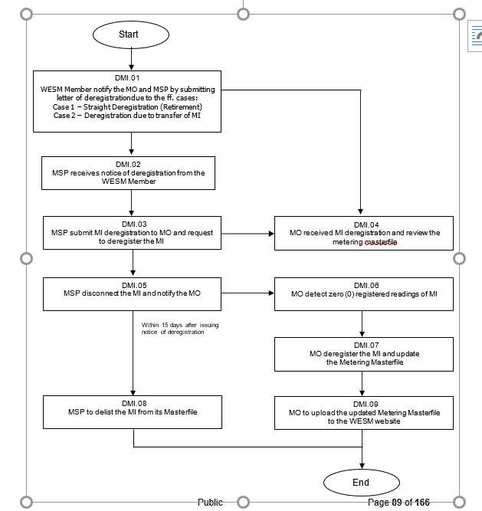 | 10.5 Workflow for De-Registration of Metering Installation  (See attached Workflow) | - To recommend deletion of steps involving the WESM Member initiating request for de-registration of MI. The MSP shall represent the WESM Member in the de-registration process (same as in the registration process in Section 4)  Transactions between the WESM Member and the MSP is covered by Metering Service Agreements (MSA).
Metering De-registration | 10.0 | 10.6 Procedural Steps for De-Registration of Metering Installation  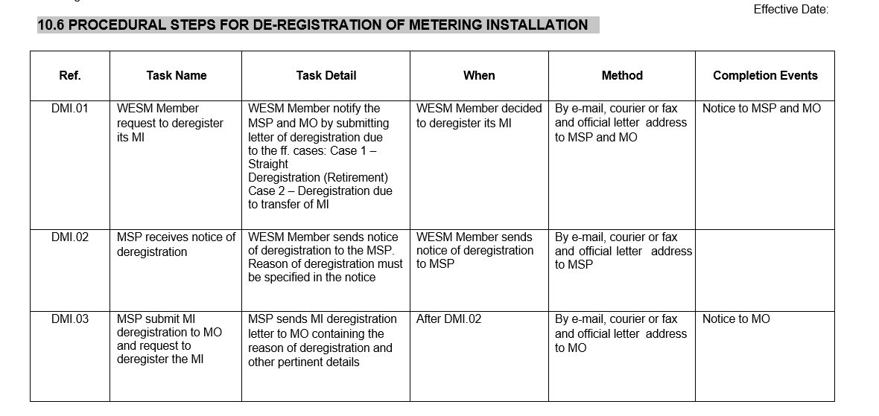  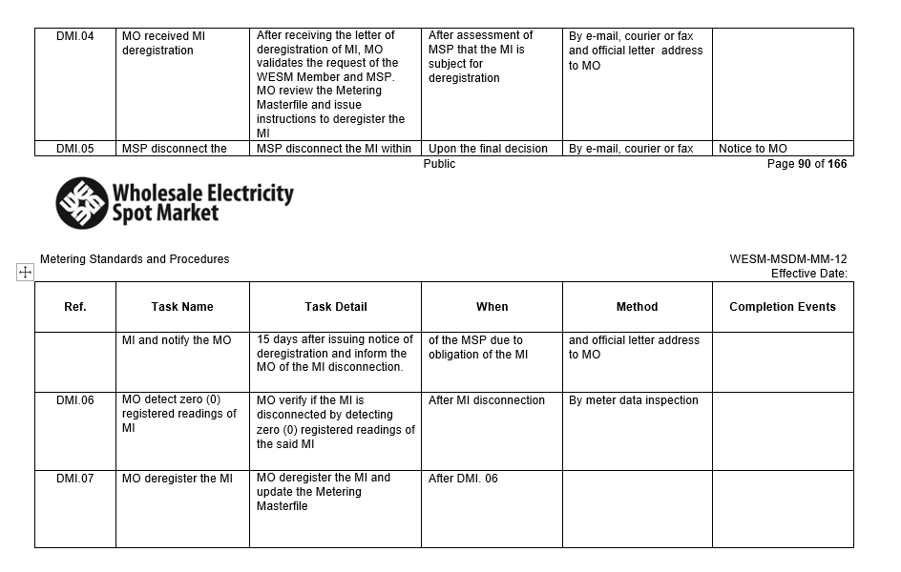  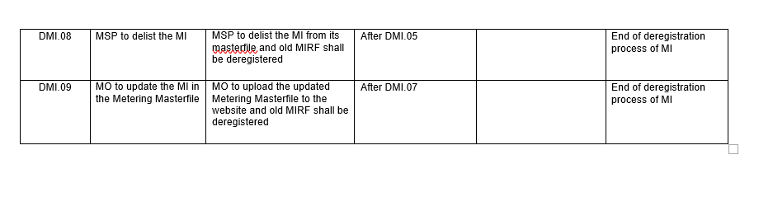 | 10.6 Procedural Steps for De-Registration of Metering Installation  (See attached Procedural Steps) | - To provide detailed steps consistent with the proposed revisions on the workflow for de-registration
Appendices | Appendix C | Clause 4.4.3 If a Trading Participant is a Customer and also a Network Service Provider, the Trading Participant may register as a Metering Services Provider only for connection points that it does not own. | Clause 4.4.3 If a Trading Participant is a Customer and also a Network Service Provider, the Trading Participant may register as a Metering Services Provider only for connection points that it does not own.  If there are no other party interested, capable and legally authorized to assume the role of the Metering Services Provider, the Network Service Provider may be permitted to act as the MSP provided that it has a valid Certificate of Authority as WESM MSP granted by the ERC | - To provide an option in case there are no willing, capable and ERC Certified MSP which can assume the role
Appendices | Appendix D | Metering Service Agreement  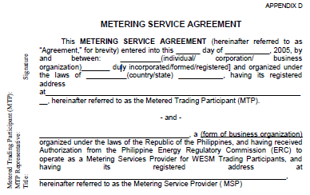 | To adopt the existing MSA Form of the Metering Service Provider (see Appendix D) | - To adopt the existing MSA Form of the Metering Service Provider.
Appendices | Appendix F | Meter Trouble Report Form  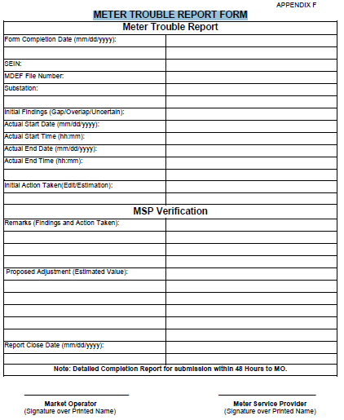 | (see attached Appendix F) | - To update the old Meter Trouble Report Form
Appendices | Appendix L | Specifications for Transmission Revenue Meters | Specifications for Transmission Revenue Meters  (see attached revised Appendix L) | - To harmonize with the Chapter GRM 9.2.3.3 of the PGC 2016 Edition
Appendices | Appendix N | Specifications for Current Transformers | Accuracy Class: IEC 44-1 Class 0.2/ ANSI C57.13 Class 0.3 or better  See section 2.5.4.1  Burden: shall not exceed the rated burden limit of 12.5 VA for the IEC 44-1 Class 0.2/ANSI c57.13 Class 0.3 (see Table 1)  See section 2.5.4.1  (see attached revised Appendix N) | - To refer section 2.5.4.1 of the proposed amendments of WESM Manuals
Appendices | Appendix O | Specifications for Voltage Transformers | Accuracy Class: IEC 6044-2 Class 0.2/ANSI C57.13 Class 0.3 or better  See section 2.5.4.2  Burden: Shall not exceed the rated burden limit for the IEC 6044-2 Class 0.2/ANSI C57.13 Class 0.3 or better  See section 2.5.4.2  Termination: Line to Ground  (see attached revised Appendix O) | - To refer section 2.5.4.2 of the proposed amendments of WESM Manuals
Appendices | Appendix P |  | (see attached Appendix P) | - To provide detailed technical specifications requirement for current transformers of Embedded Generators in the WESM Metering Manual
Appendices | Appendix Q |  | (see attached Appendix Q) | - To provide detailed technical specifications requirement for voltage transformers of Embedded Generators in the WESM Metering Manual
Figure | Figure 5 | 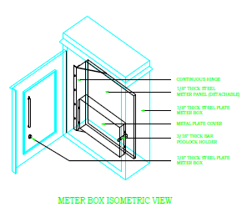 | 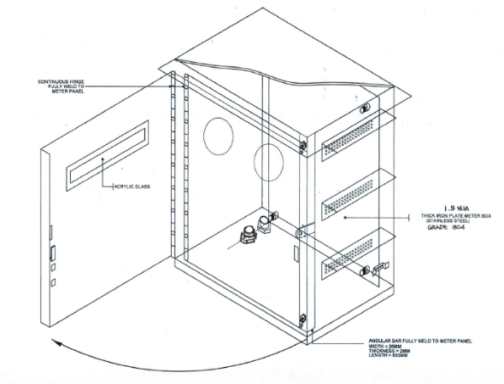 | - The revision is being proposed to provide revised design which can accommodate two meters (main and alternate) provided with security facilities consistent with PGC 2016 GRM 9.2.2.4 (a)
Tables | Table 5 | 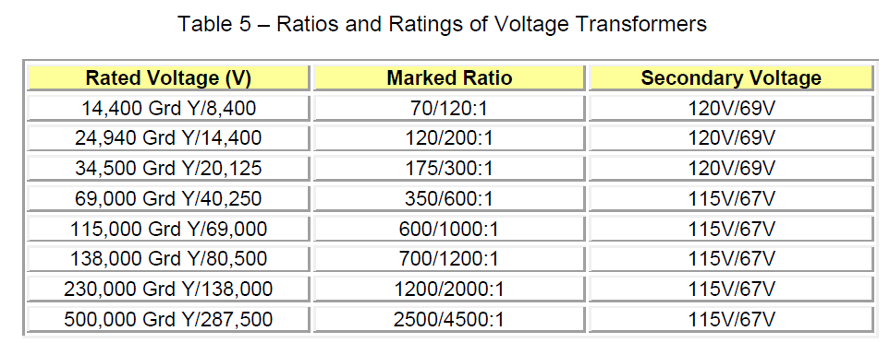 | 34.5kV Secondary Voltage 120V 115V  (See attached revised Table 5) | - To achieve whole Nominal Voltage Ratio (GRM 9.2.3.1 (c) of PGC 2016)
Tables | Table 11 | 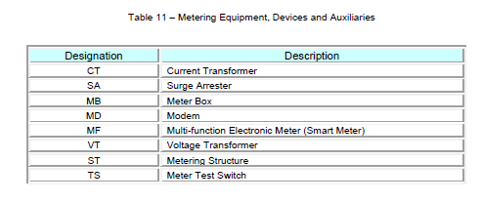 | FROM:  VT – Voltage Transformer  SA – Surge Arrester  TO:  PT – Potential Transformer  LA – Lightning Arrester  Additional: | - To be consistent with the SEIN used in existing registration documents of metering installations submitted to the Market Operator  - To include SEIL of Combined Instrument Transformer (CI) in the list of Metering Equipment
  Designation | Description
  CI | Combined Instrument Transformer
Note: For convenience, please underline and put in bold letters the proposed changes to the WESM Manual.

- Proposed Scheme to Monitor the Effectiveness of the Proposed Changes to the WESM Manual

Monthly monitoring of MSP performance rating
Periodic Metering Arrangement Review

- Referral

MAG Date Received: ________________________

Proposed Amendment: Urgent Minor General

- For Urgent Amendment (For the use of PEMC President only)
Date Referred to PEMC President | Yes No
Certifies as urgent | Yes No
Convene the RCC within 48 hrs.
Remarks:

- For Minor and General Amendment (For the use of RCC only)
Date Referred to RCC:
Remarks:

Action taken:
Request for comments: |  | Yes No
Request written comments from:

DRG MSC PA MO

ECO RCC TC

Other PEM Board Committees

Other Interested Parties
For further review of the Technical Sub-Committee: |  | Yes  Assigned to:  SO Sub-Committee  MO Sub-Committee  Metering Sub-Committee  Billing and Settlement Sub-Committee  Legal and Regulatory Sub-Committee
 |  | No
For public consultation: |  | Yes No
RCC Resolution: |  | Approved Disapproved
RCC Resolution No.:
Date of Resolution:
RCC Meeting No.
Date of endorsement to the PEM Board:

Adopting Further Amendments to the Wholesale Electricity Spot Market (WESM) Rules and Market Manuals for the Implementation of Enhancements to WESM Design and Operations (Provisions for Metering, Market Trading Node and Scheduling Point)
Issued on 22 November 2018
Providing Policies for Further Improvements of the Operations and Metering Installations of the Metering Services Providers (MSPs) in the Wholesale Electricity Spot Market (WESM) and Retail Market

